

**Nombre de alumno:**

**Nombre del profesor:**



**Nombre del trabajo: Weekly Activity #2 Unit 4**

**Materia:**

**Grado:**

**Grupo:**

Comitán de Domínguez Chiapas a 27 de julio de 2020.

**VOCABULARY - Food**

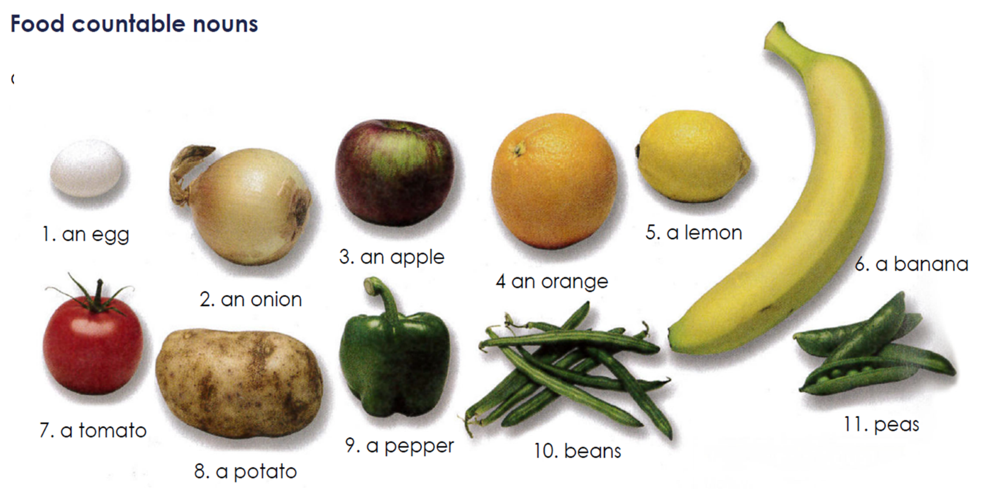

**Exercise #1.** Translate the vocabulary above. (Traduce el vocabulario de la parte de arriba)

1.

2.

3.

4.

5.

6.

7.

8.

9.

10.

11.

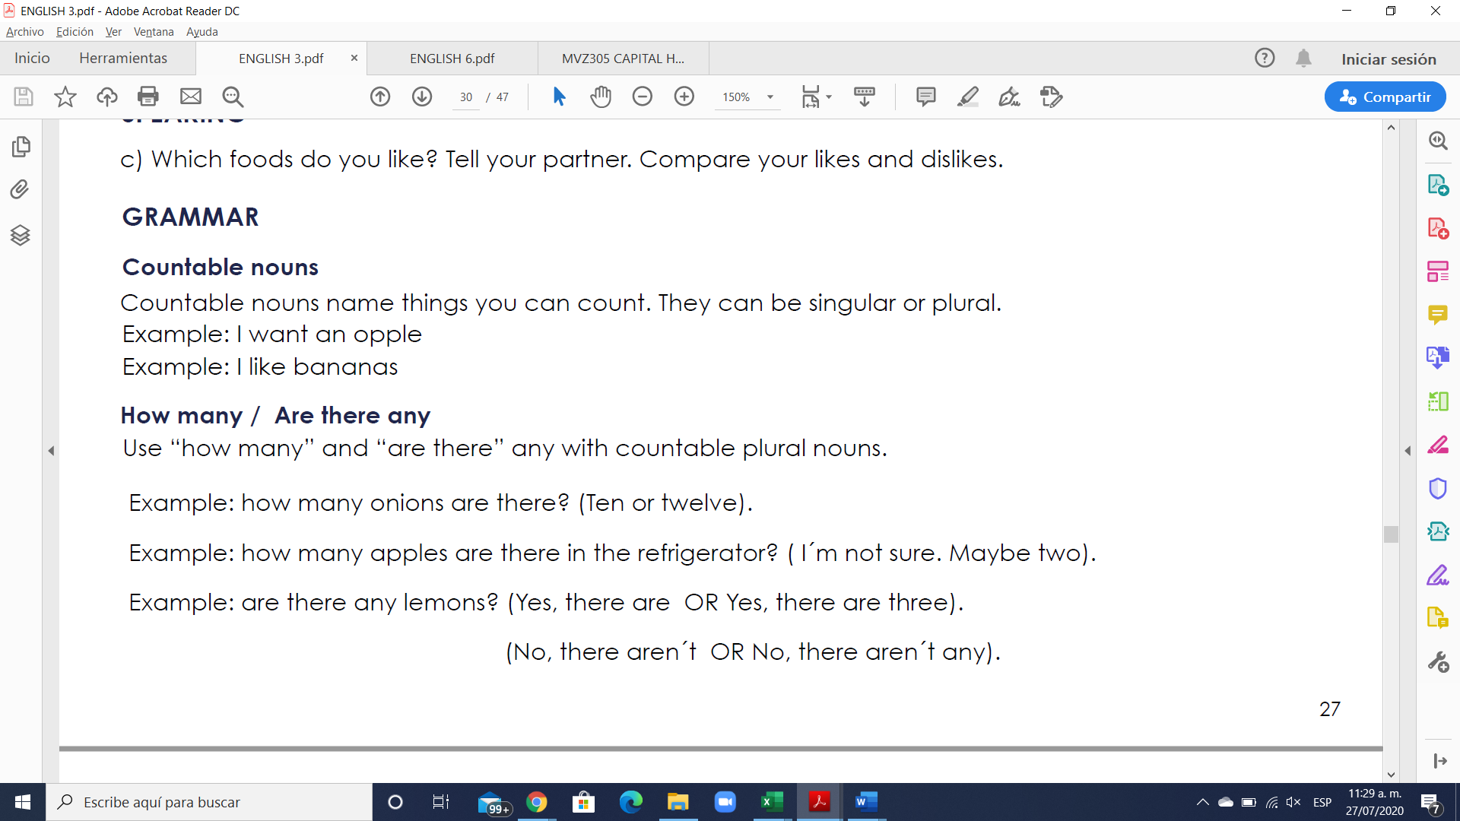

**Los countable nouns** son aquellos elementos que pueden ser contados de uno en uno utilizando los números.

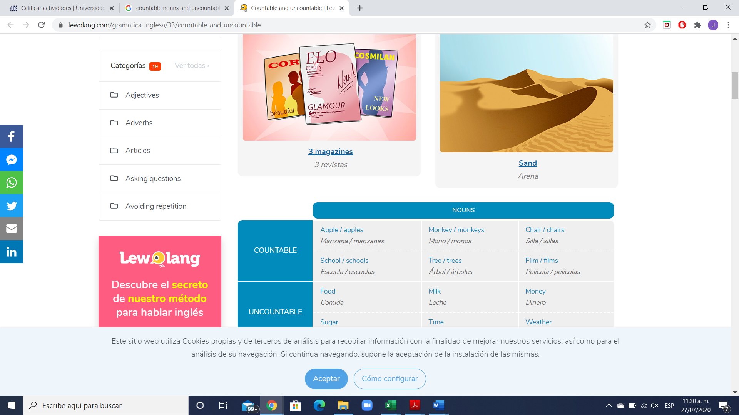

**Los nombres contables** tienen forma de singular y plural. Cuando nos referimos a los nombres contables en singular, estos pueden ir precedidos por el artículo indeterminado **a/an.**

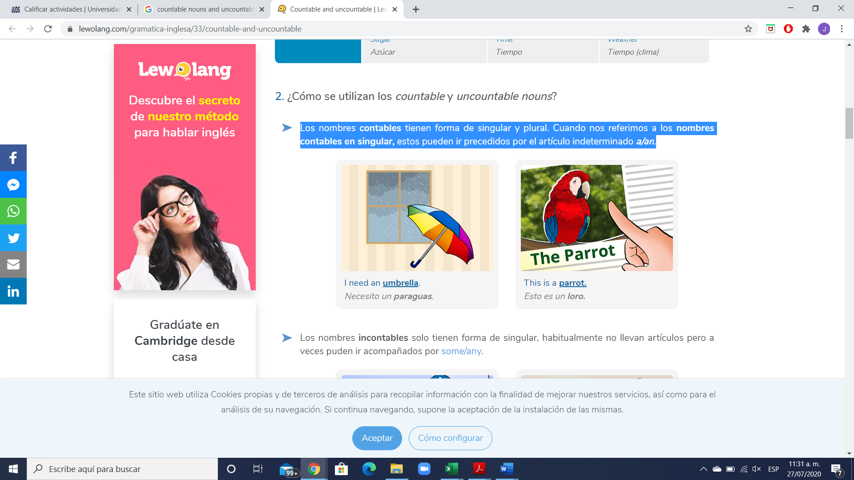

**Exercise #2.** Write 5 sentences using countable nouns. Escribe 5 oraciones usando nombres contables.

1.

2.

3.

4.

5.

**GRAMMAR**



**How many** = Cuantos… ? (se usa solo para nombres contables)

**Are there any** = Hay algunos…? (se usa solo para nombres contables)

There are any + plural noun = Are there any + plural noun?

Example: “Are there any trains to London this morning?”

**Exercise #3.** Write 6 sentences using How many / Are there any. Escribe 5 oraciones.

1.

2.

3.

4.

5.

6.

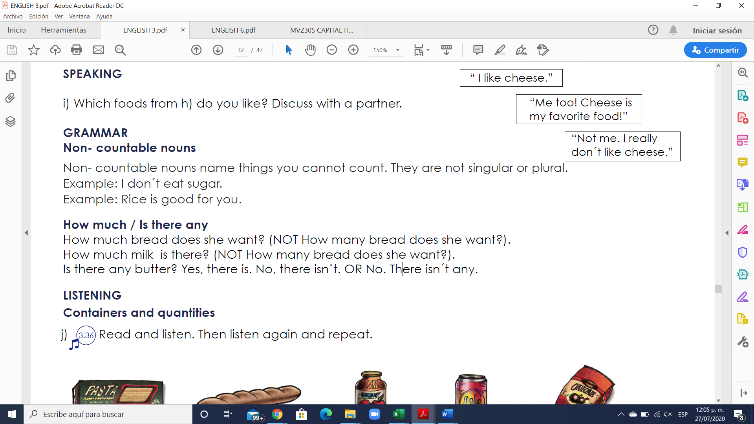

Los **uncountable nouns** son aquellos elementos que no podemos contar usando números, pero sí utilizando cuantificadores o partitivos.

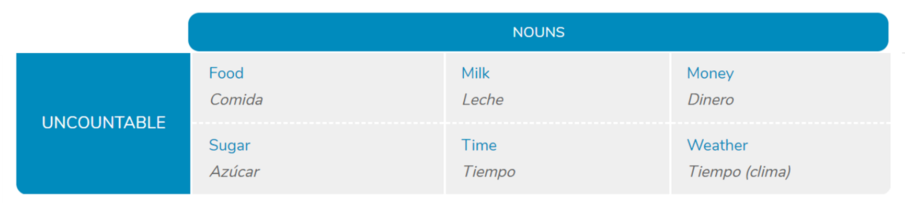

**Los nombres incontables** solo tienen forma de singular, habitualmente no llevan artículos, pero a veces pueden ir acompañados por **some/any**.

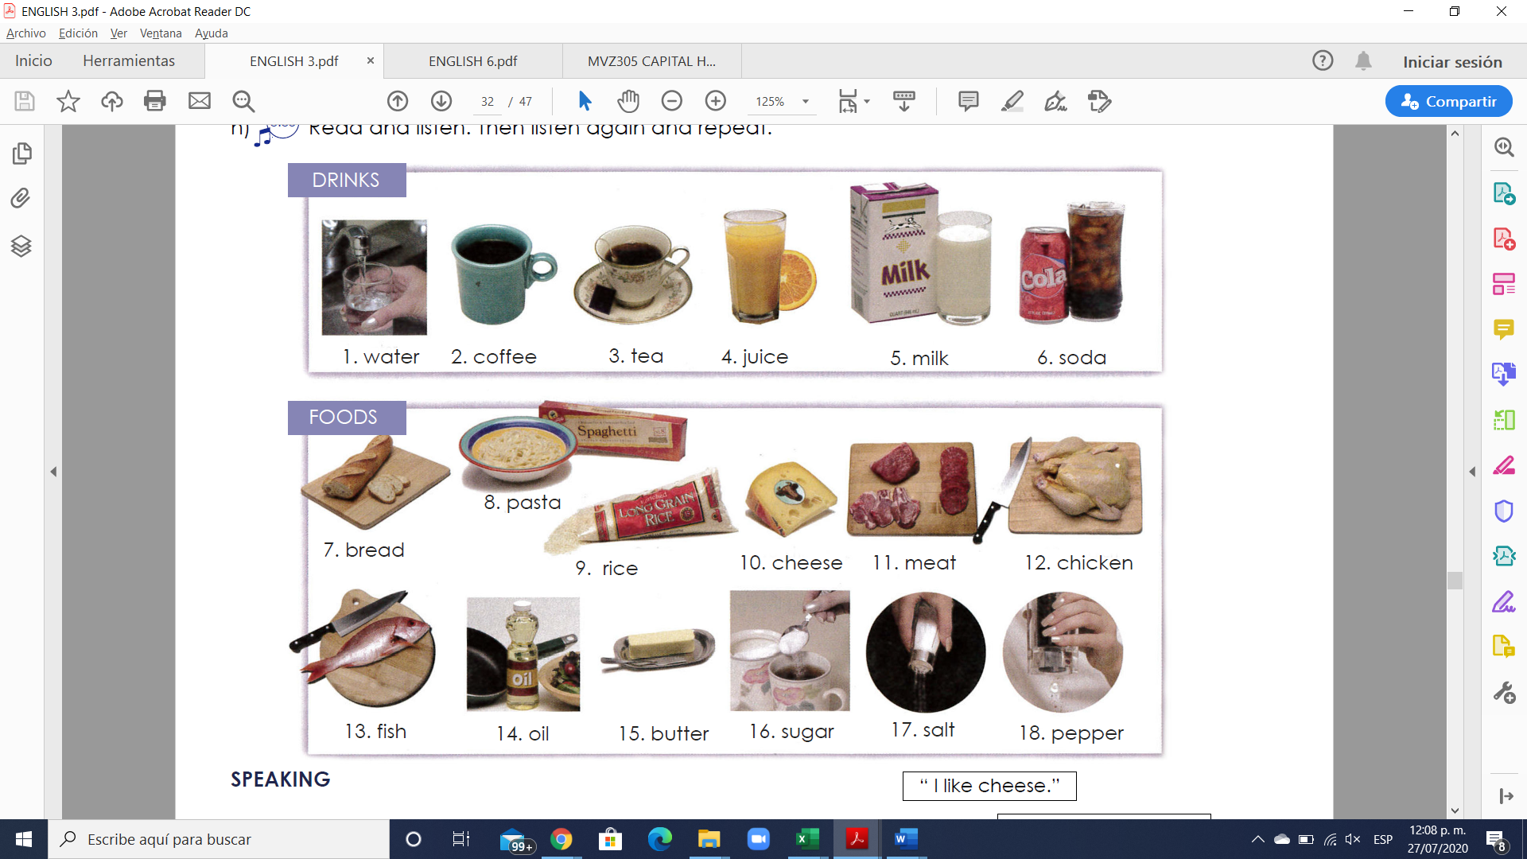

**Exercise #4.** Write 5 sentences using uncountable nouns. Escribe 5 oraciones usando nombres incontables.

1.

2.

3.

4.

5.

**GRAMMAR**

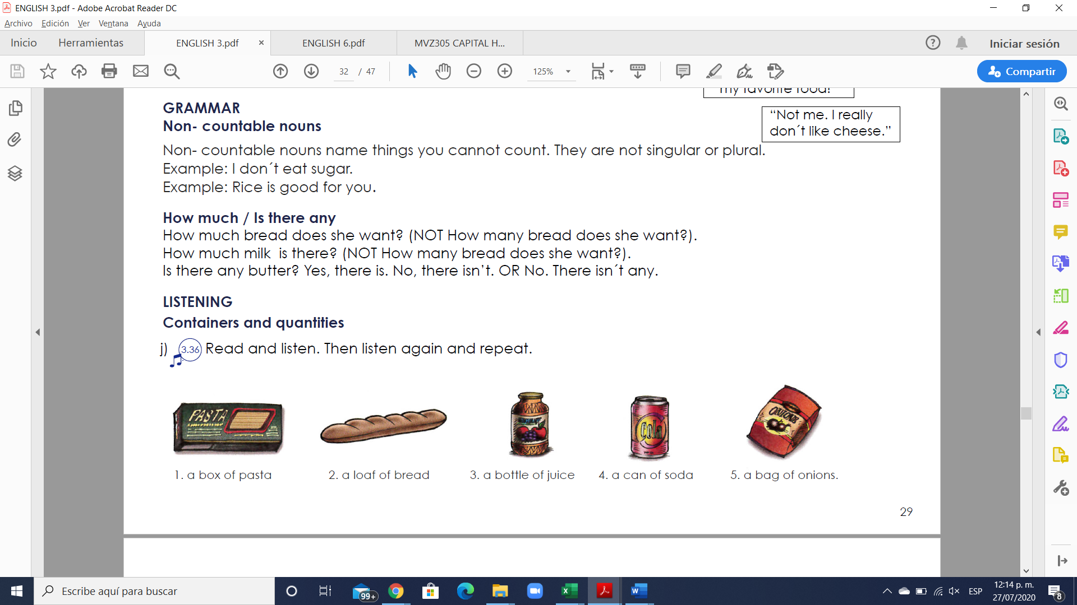

**How much** = Cuantos… ? (se usa solo para nombres incontables)

**Are there any** = Hay algunos…? (se usa solo para nombres incontables)

There is any + uncountable noun = Is there any + uncountable noun?

Example: “Is there any time to go shopping?”

**Exercise #5.** Write 6 sentences using How much / Is there any. Escribe 5 oraciones.

1.

2.

3.

4.

5.

6.

**Exercise #6.** Complete the questions with “how much” or “how many”.

1. __________ loaves of bread do you need?

2. __________ bags of potatoes do we have?

3. __________ cheese is there in the fridge?

4. __________ sugar do you want in your tea?

5. __________ eggs are there for the potato pancakes?

6. ___________ cans of tomatoes are there on the shelf?

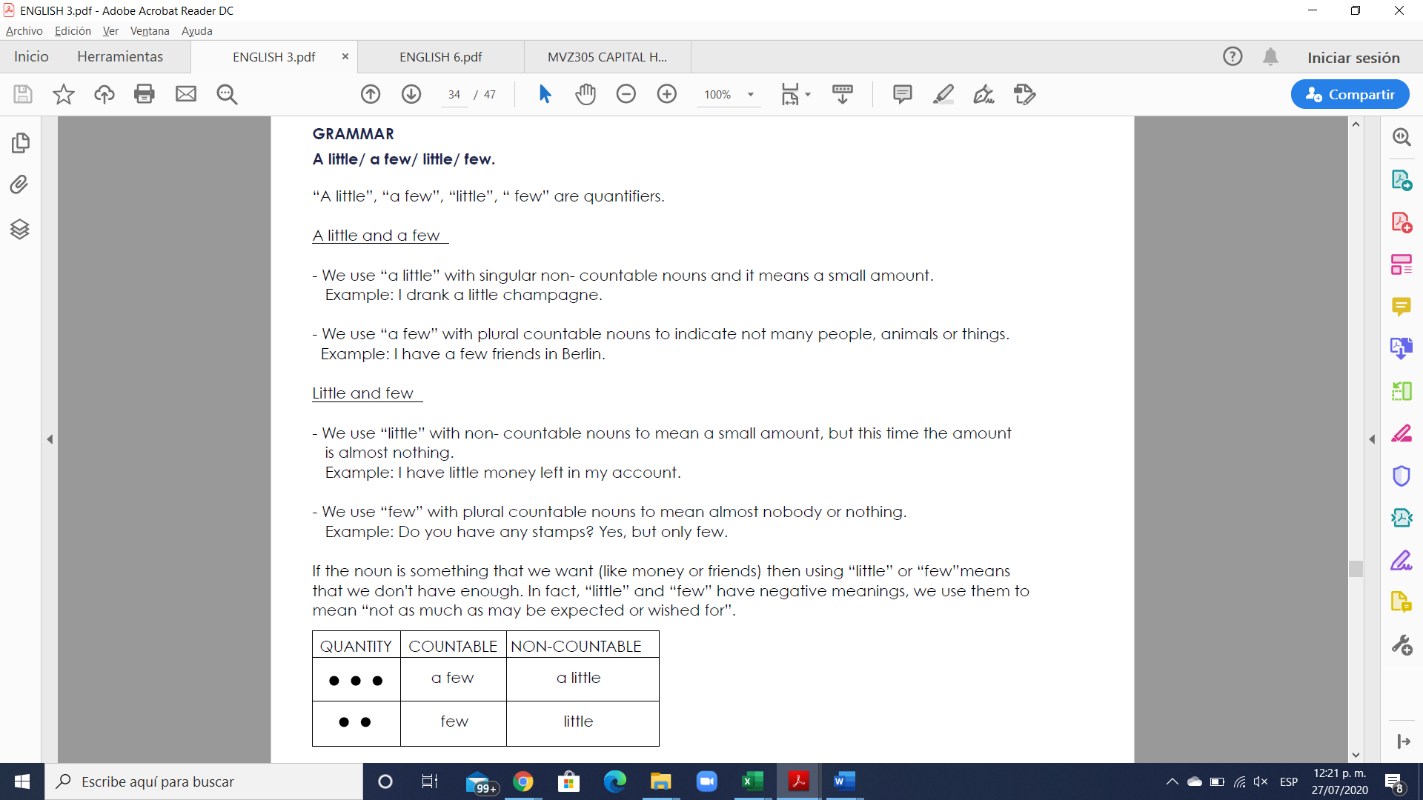

**Exercise #7.** Rewrite the sentences using few/ little.

1. We don`t have much bread left. ______We have a few bread__________________

2. The twins don’t eat many vegetables. ________________________________________

3. These students don’t ask many questions. _____________________________________

4. They don’t have much opportunity to talk with him. ___________________________

5. The guests aren’t drinking much wine with their meal. __________________________

6. Not many people come here. ________________________________________________

**Exercise #8.** Answer the questions using “a few”/ “a little.

1. Have you visited many churches? Only a few.

2. Does she make many mistakes in English? ______________________________________

3. Do you have many friends in your building? ____________________________________

4. Do you have any money left? _________________________________________________

5. Would you like something to eat? ______________________________________________

6. Do you speak German? _______________________________________________________