**Unit Activity #1 – U4**

*Nombre del Alumno:*

*Nombre del tema: Unit I1I*

*Parcial: Fourth*

*Nombre de la Materia: English III*

*Nombre del profesor: Juan Manuel Jaime Díaz*

*Nombre de la carrera:*

*Cuatrimestre: 3*

*Lugar y Fecha de elaboración*

Comitán de Domínguez Chiapas a 04 de diciembre de 2023.

**VOCABULARY - Types of clothing and shoes**

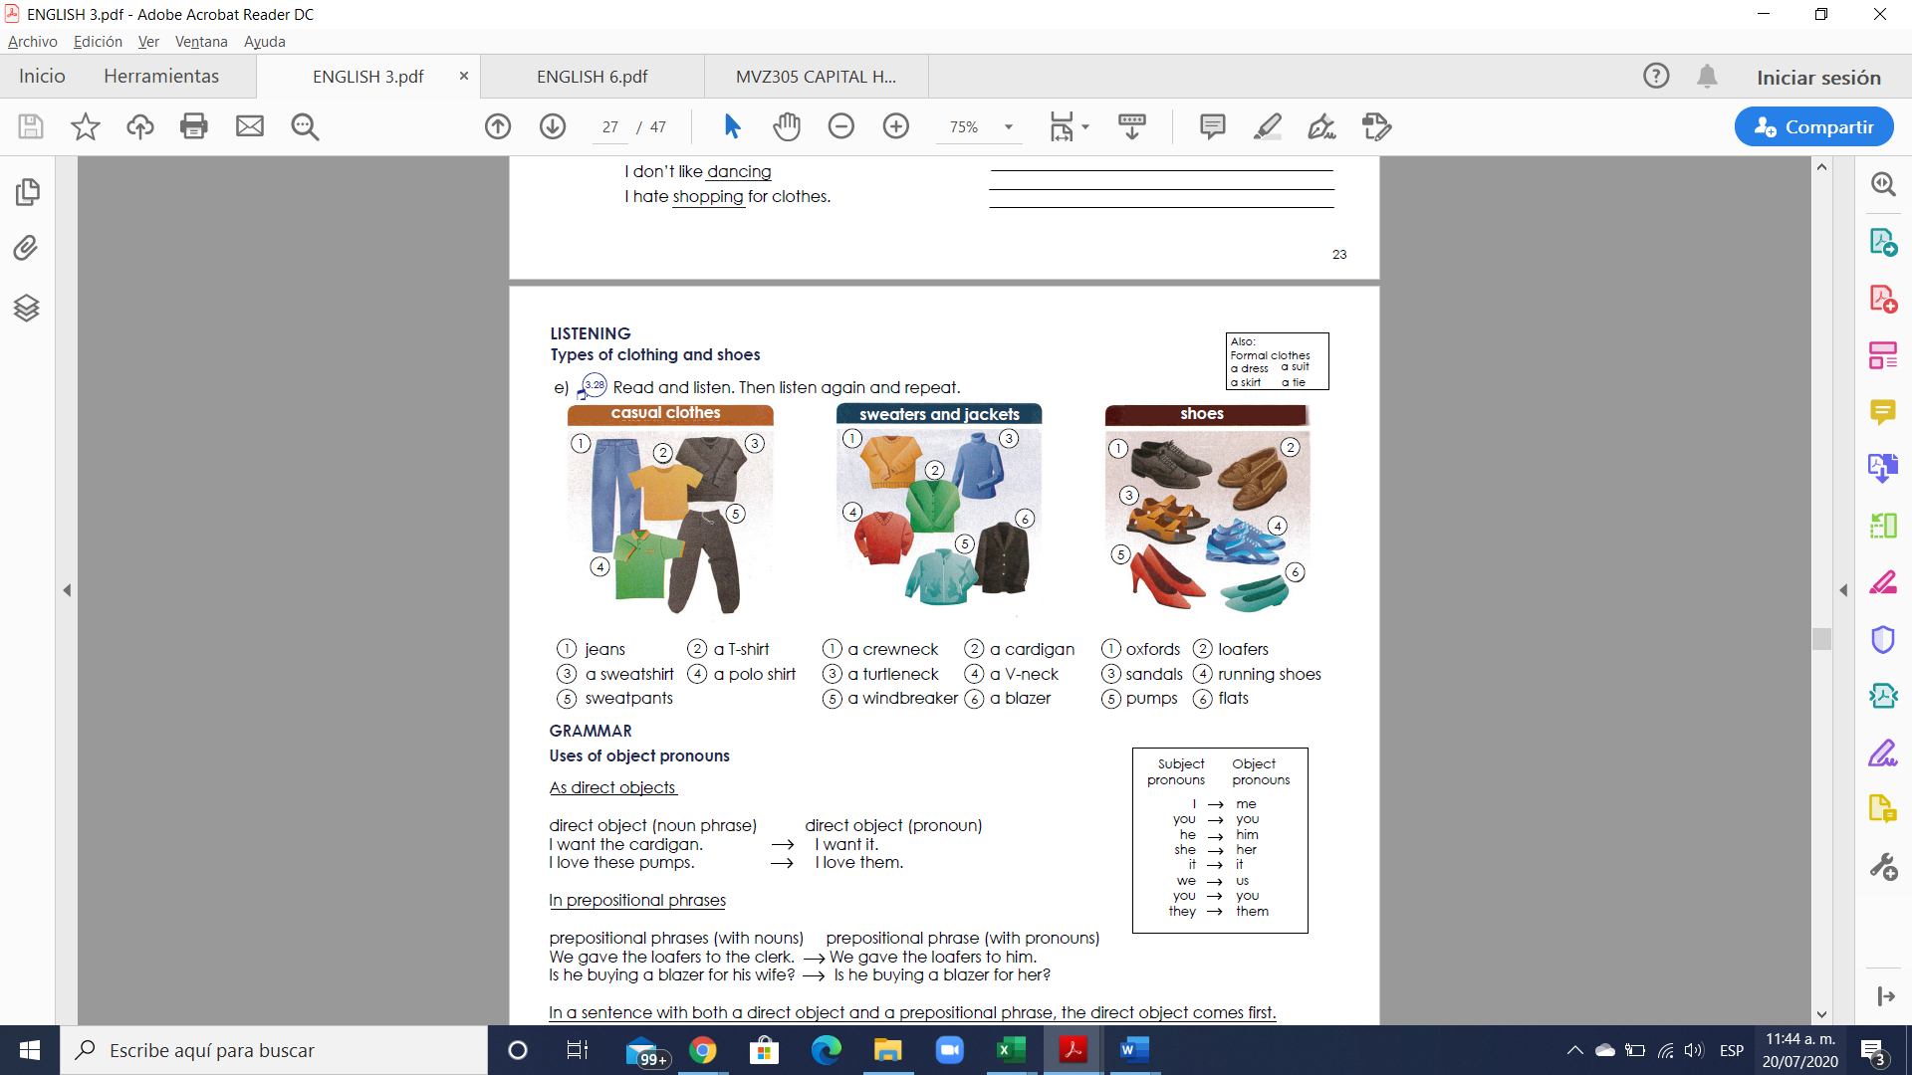

**Exercise 1.** Translate the vocabulary. (Traduce el vocabulario de la parte de arriba)

Casual clothes

1.

2.

3.

4.

5.

Sweaters and jackets Shoes

1. 1.

2. 2.

3. 3.

4. 4.

5. 5.

6. 6.

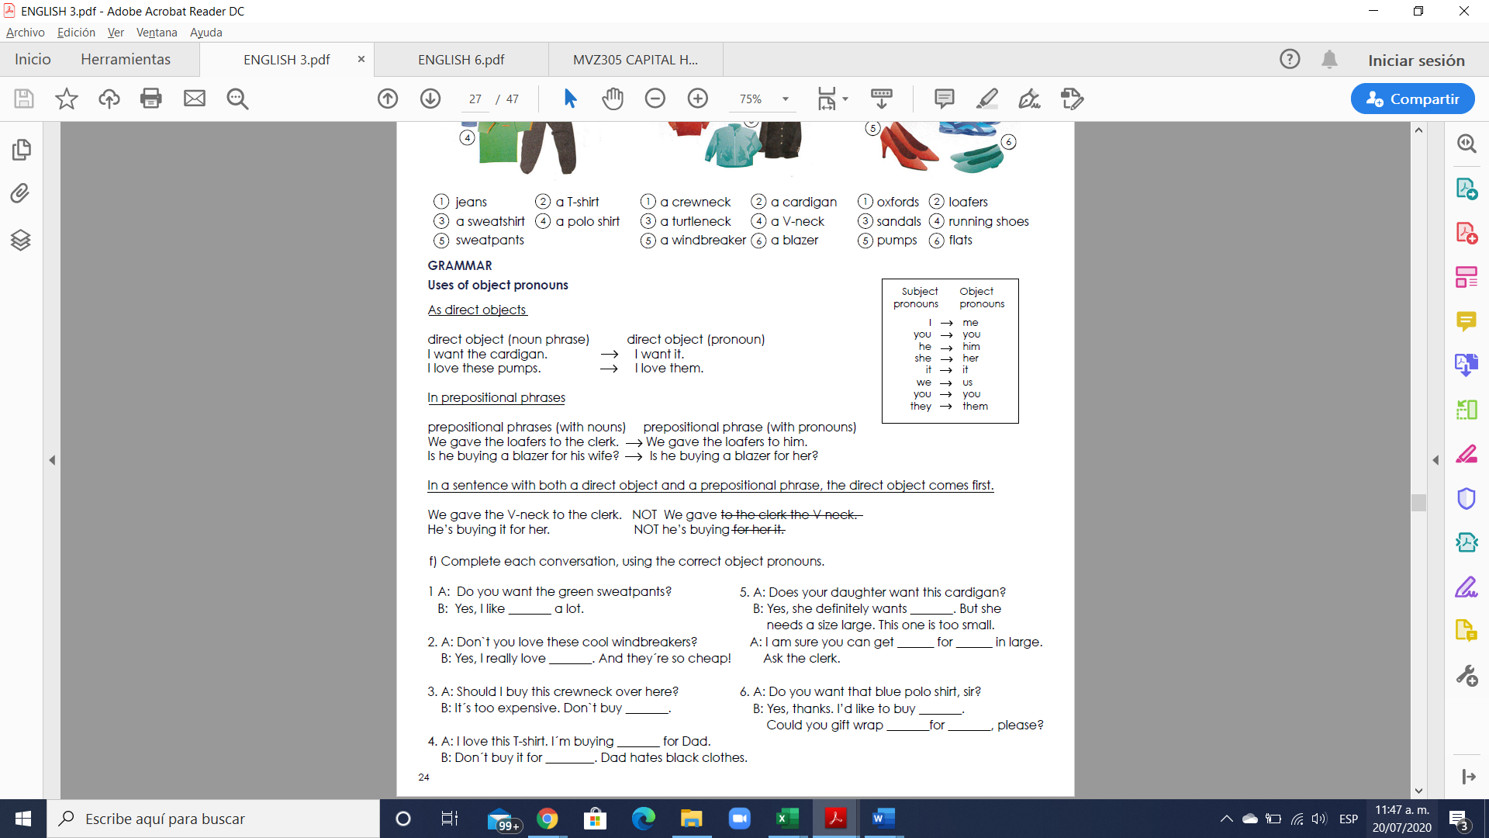

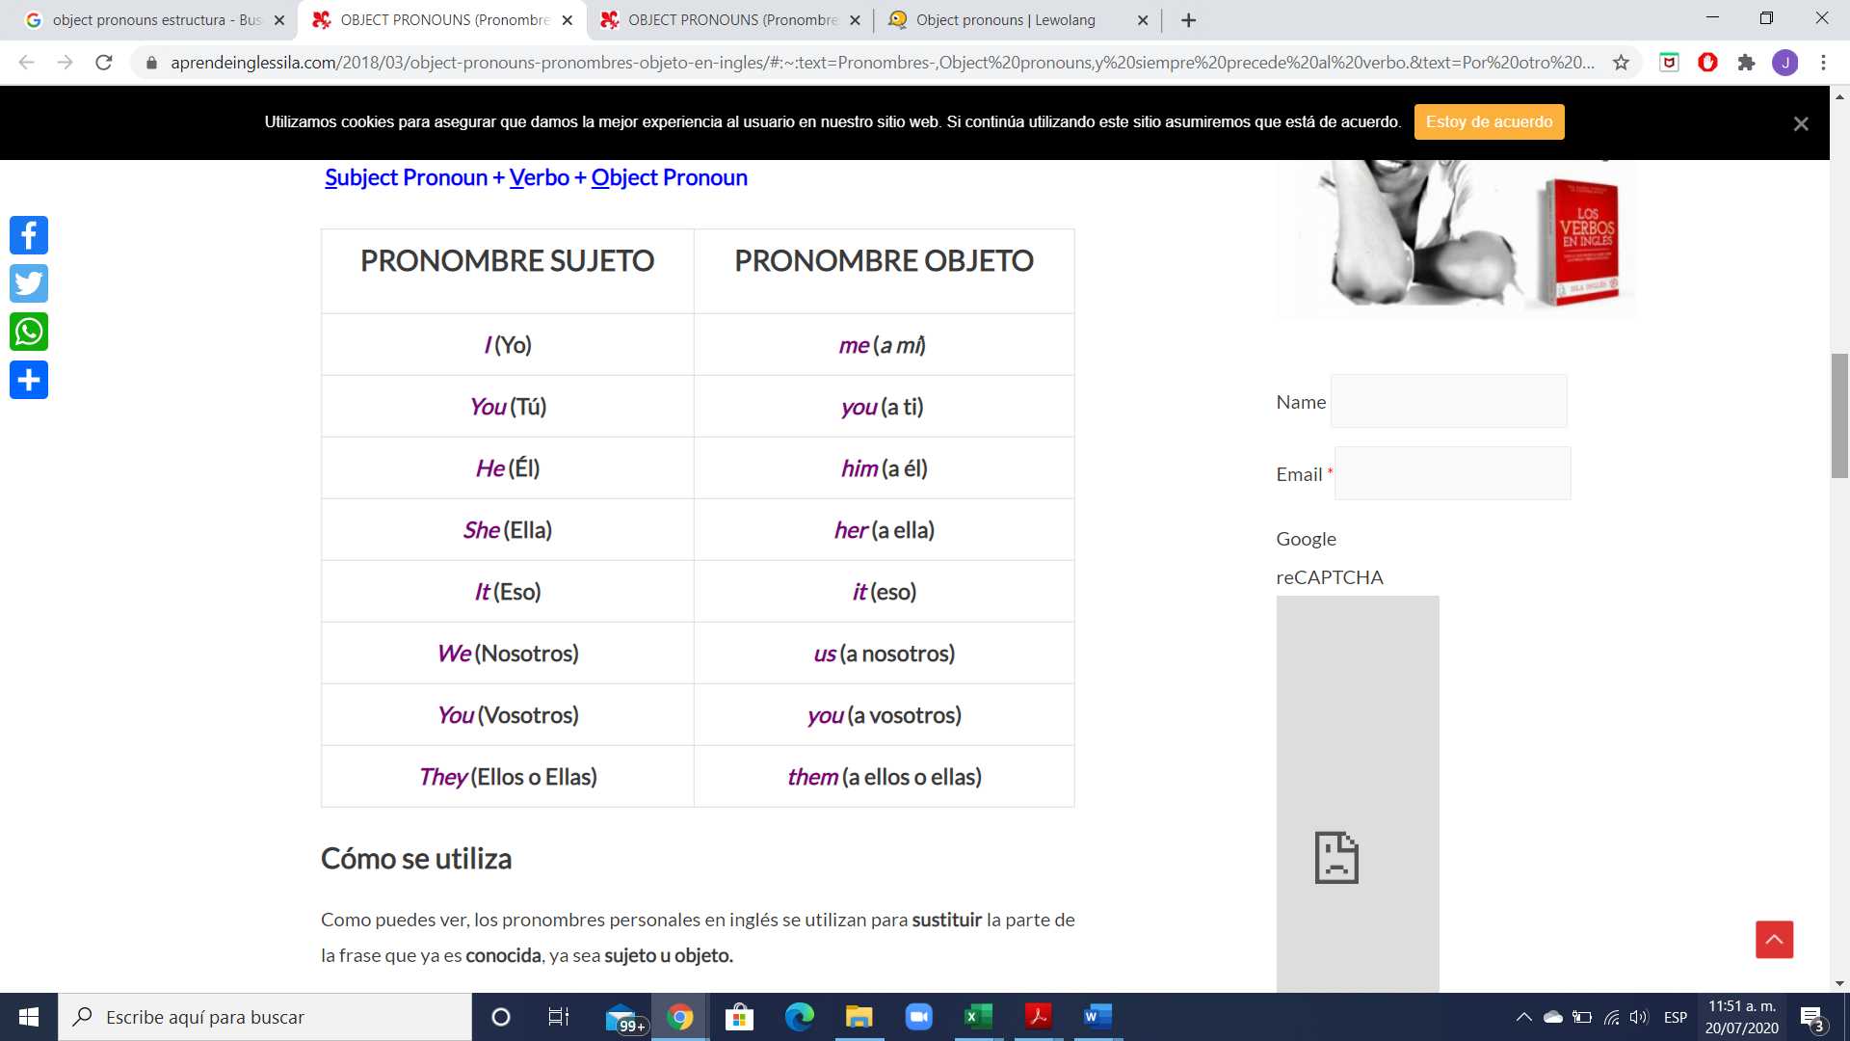

Los personal object pronouns son palabras que se utilizan para sustituir a un nombre y así evitar repeticiones. La principal diferencia entre los personal pronouns y los personal object prononuns es que mientras que los primeros reemplazan a un nombre que hace la función de sujeto, los segundos sustituyen a un nombre que no hace función de sujeto.

Una de las principales características de los personal object pronouns es que se sitúan detrás del verbo o bien detrás de una preposición (at, for, with, etc.)

Los personal object pronouns sustituyen a los nombres que hacen función de objeto, es decir, a la persona, animal o cosa que recibe directa o indirectamente la acción expresada por el verbo. Siempre se colocan detrás de un verbo o una preposición.

**Exercise 2.** Complete each conversation, using the correct object pronouns

1 A: Do you want the green sweatpants?

B: Yes, I like __them___ a lot.

2. A: Don`t you love these cool windbreakers?

B: Yes, I really love _______. And they´re so cheap!

3. A: Should I buy this crewneck over here?

B: It´s too expensive. Don`t buy _______.

4. A: I love this T-shirt. I´m buying _______ for Dad.

B: Don´t buy it for ________. Dad hates black clothes.

5. A: Does your daughter want this cardigan?

B: Yes, she definitely wants _______. But she needs a size large. This one is too small.

A: I am sure you can get ______ for ______ in large. Ask the clerk.

6. A: Do you want that blue polo shirt, sir?

B: Yes, thanks. I’d like to buy _______. Could you gift wrap _______for _______, please?

**Exercise 3.** Fill in the gaps with object pronouns.

1. A: Do you like studying English?

B: Yes, I love __it___ .

2. A: Do you like Lady Gaga?

B: Yes, I like ________ a lot.

3. A: Do you like getting up early?

B: No, I hate ________.

4. A: Do you like Johnny Depp?

B: Yes, I love ________ !

5. A: Do you like soap operas?

B: No, I hate ________.

6. A: Do you like dogs?

B: Yes, but they don´t like ________!

**Exercise 4.** Select the correct answer**.**

1. The teacher wants to talk to ________ about your homework.

a) him

b) her

c) you

2. Be careful; he lied to _______ before and he may do it again.

a) us

b) they

c) we

3. Where are Andres and Maria? Didn´t invite _______.

a) us

b) them

c) we

4. The spider bit ______ on my ankle.

a) us

b) they

c) me

5.The movie was great!! We really liked ______.

a) him

b) them

c) it

**Exercise 5.** Write 5 sentences using the object pronouns.

1.

2.

3.

4.

5.

**VOCABULARY - Food**

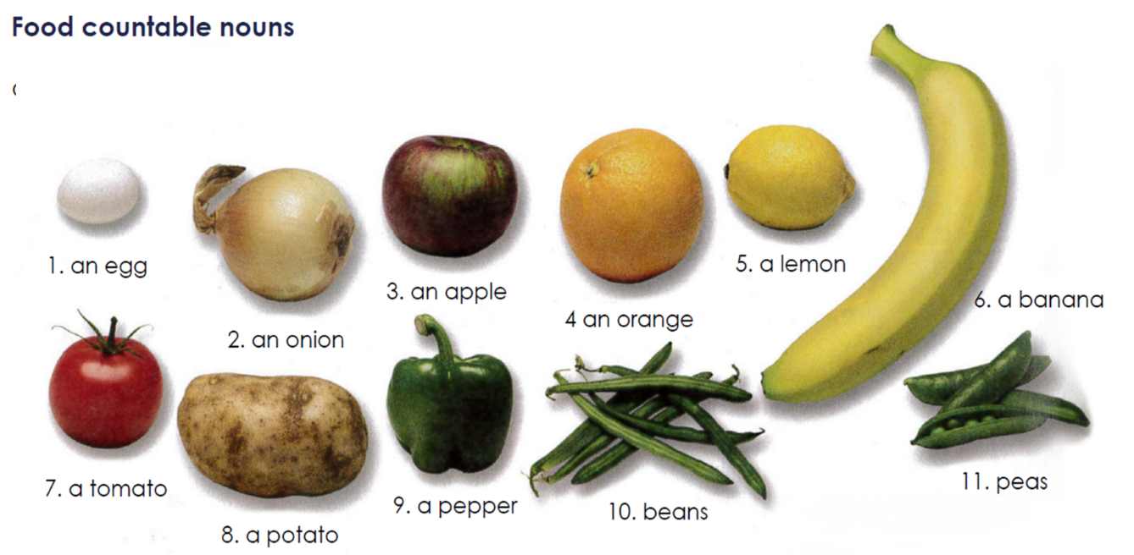

**Exercise #6.** Translate the vocabulary above. (Traduce el vocabulario de la parte de arriba)

1.

2.

3.

4.

5.

6.

7.

8.

9.

10.

11.

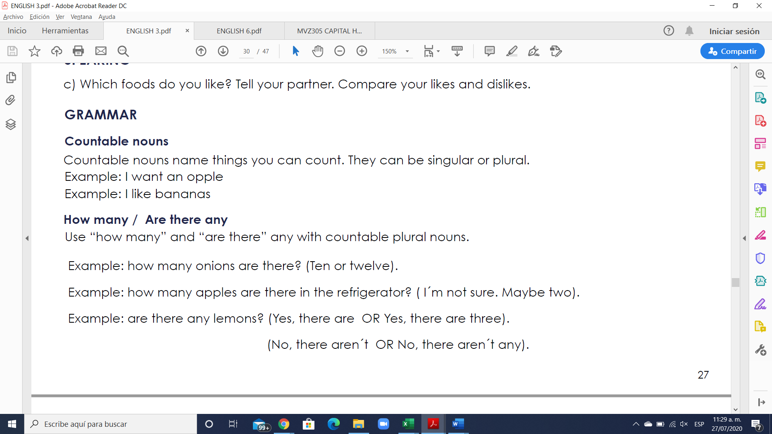

**Los countable nouns** son aquellos elementos que pueden ser contados de uno en uno utilizando los números.

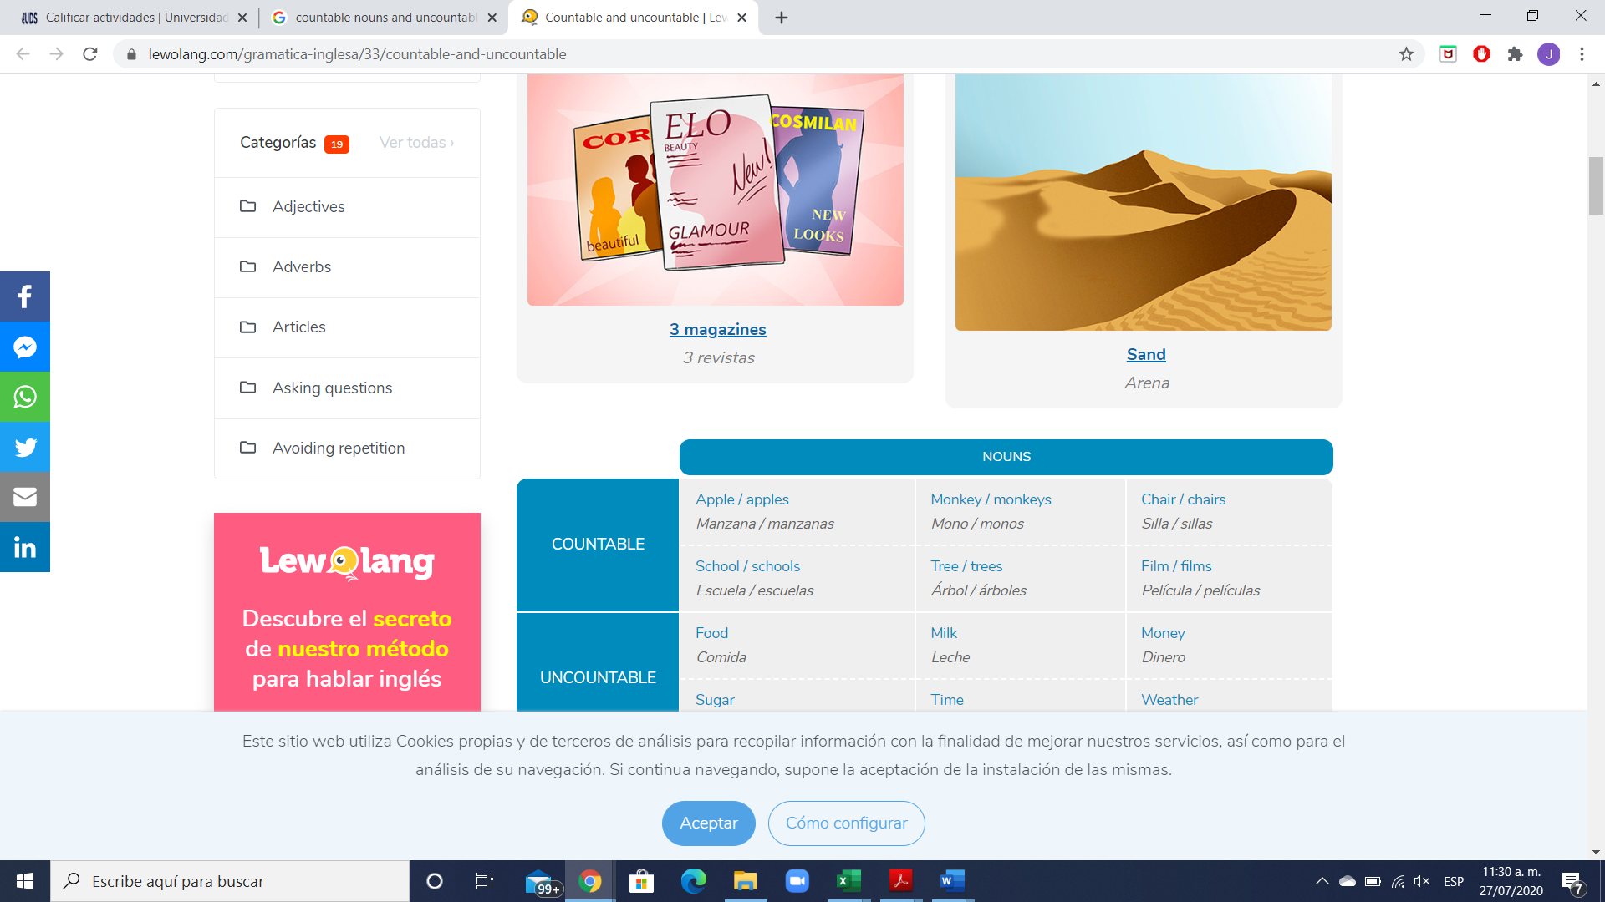

**Los nombres contables** tienen forma de singular y plural. Cuando nos referimos a los nombres contables en singular, estos pueden ir precedidos por el artículo indeterminado **a/an.**

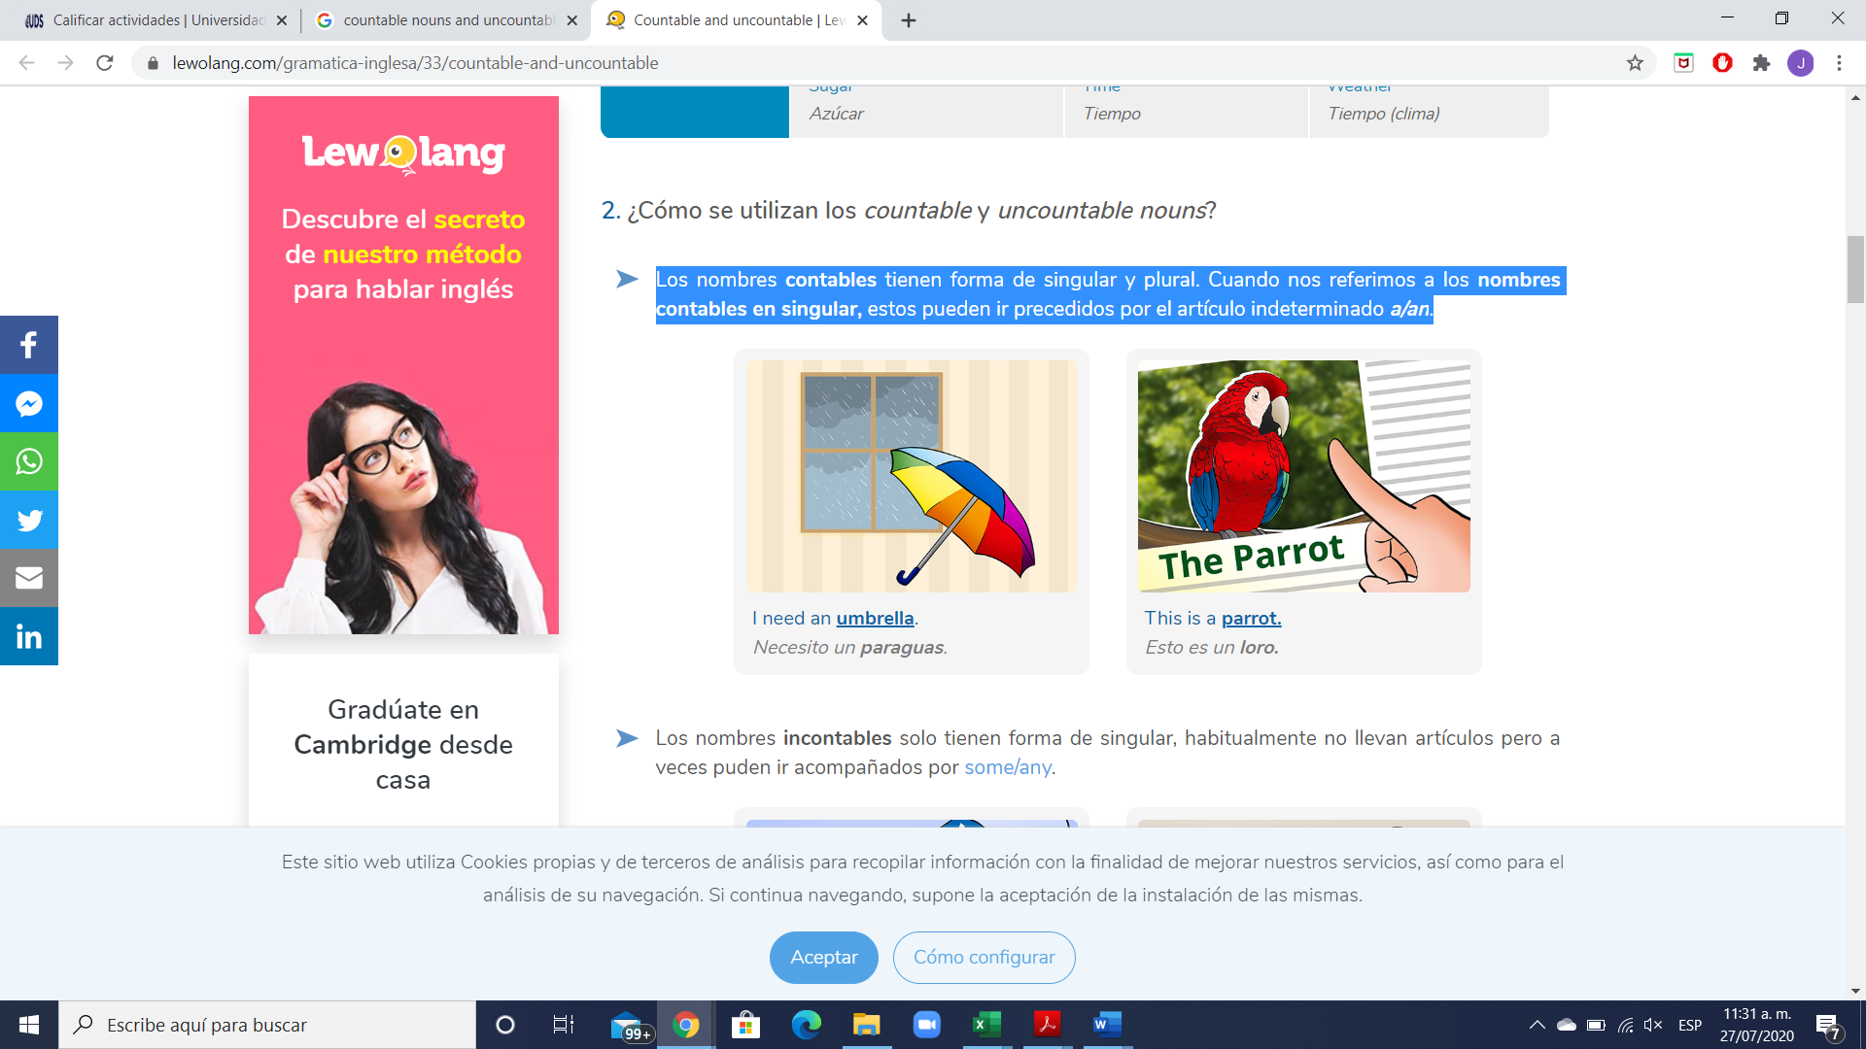

**Exercise #7.** Write 5 sentences using countable nouns. Escribe 5 oraciones usando nombres contables.

1.

2.

3.

4.

5.

**GRAMMAR**



**How many** = Cuantos… ? (se usa solo para nombres contables)

**Are there any** = Hay algunos…? (se usa solo para nombres contables)

There are any + plural noun = Are there any + plural noun?

Example: “Are there any trains to London this morning?”

**Exercise #8.** Write 6 sentences using How many / Are there any. Escribe 5 oraciones.

1.

2.

3.

4.

5.

6.

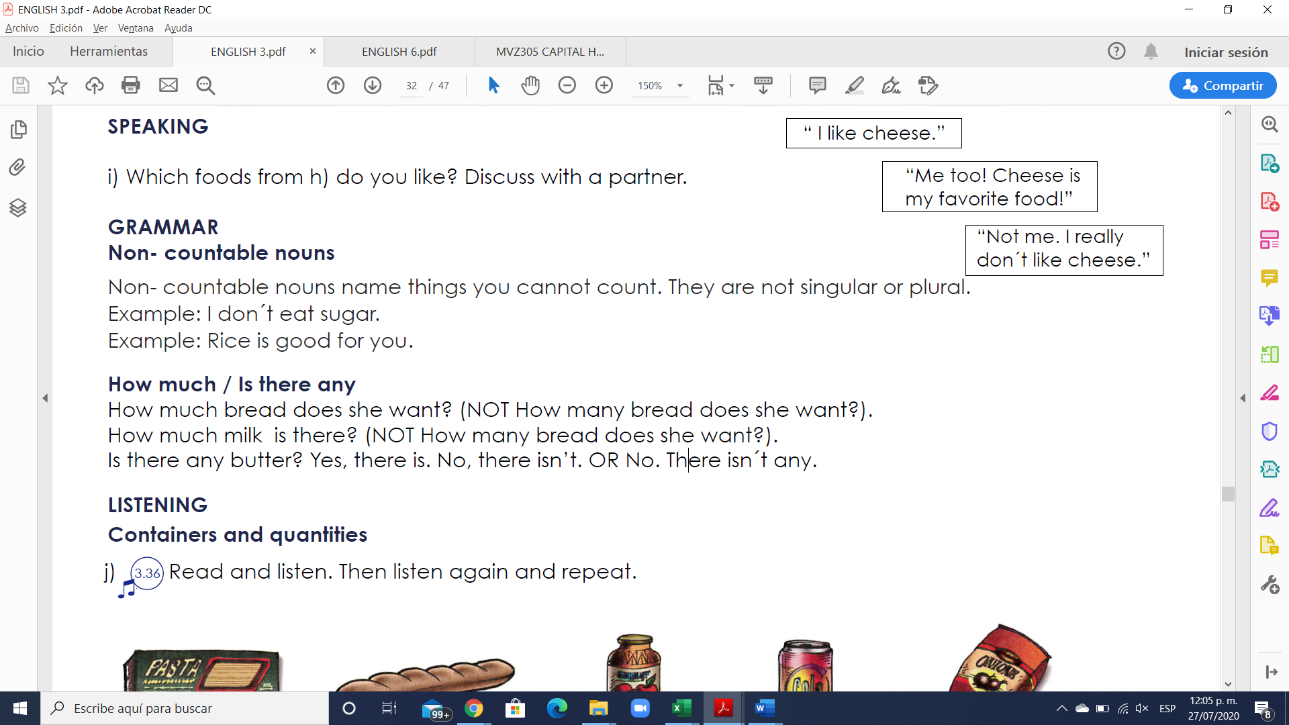

Los **uncountable nouns** son aquellos elementos que no podemos contar usando números, pero sí utilizando cuantificadores o partitivos.

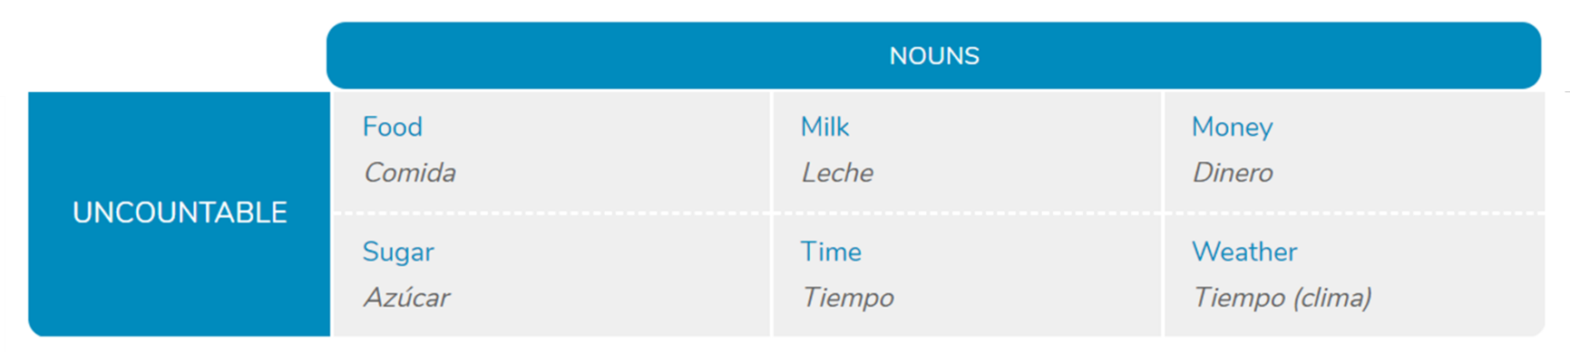

**Los nombres incontables** solo tienen forma de singular, habitualmente no llevan artículos, pero a veces pueden ir acompañados por **some/any**.

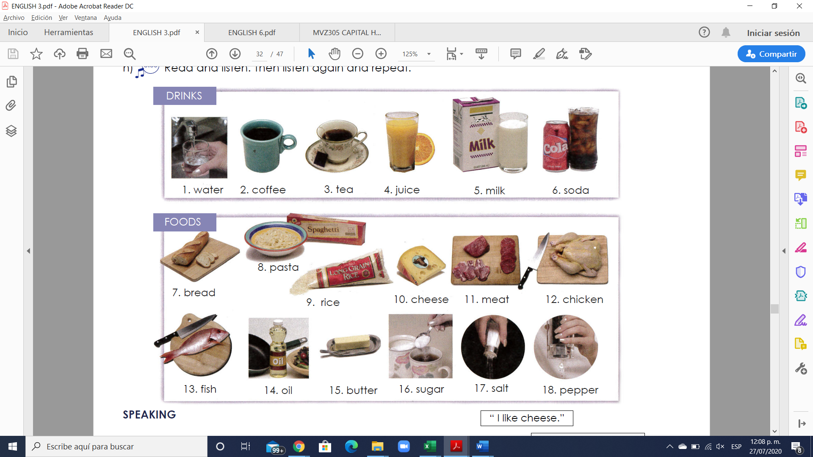

**Exercise #9.** Write 5 sentences using uncountable nouns. Escribe 5 oraciones usando nombres incontables.

1.

2.

3.

4.

5.

**GRAMMAR**

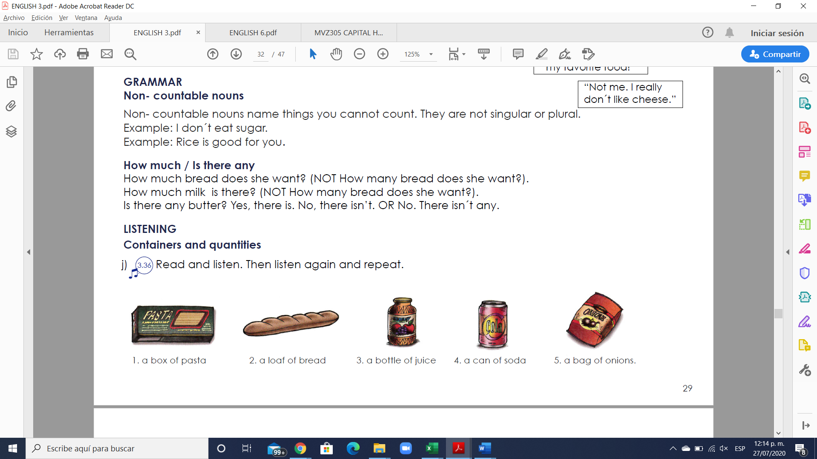

**How much** = Cuantos… ? (se usa solo para nombres incontables)

**Are there any** = Hay algunos…? (se usa solo para nombres incontables)

There is any + uncountable noun = Is there any + uncountable noun?

Example: “Is there any time to go shopping?”

**Exercise #10.** Write 6 sentences using How much / Is there any. Escribe 5 oraciones.

1.

2.

3.

4.

5.

6.

**Exercise #11.** Complete the questions with “how much” or “how many”.

1. __________ loaves of bread do you need?

2. __________ bags of potatoes do we have?

3. __________ cheese is there in the fridge?

4. __________ sugar do you want in your tea?

5. __________ eggs are there for the potato pancakes?

6. ___________ cans of tomatoes are there on the shelf?

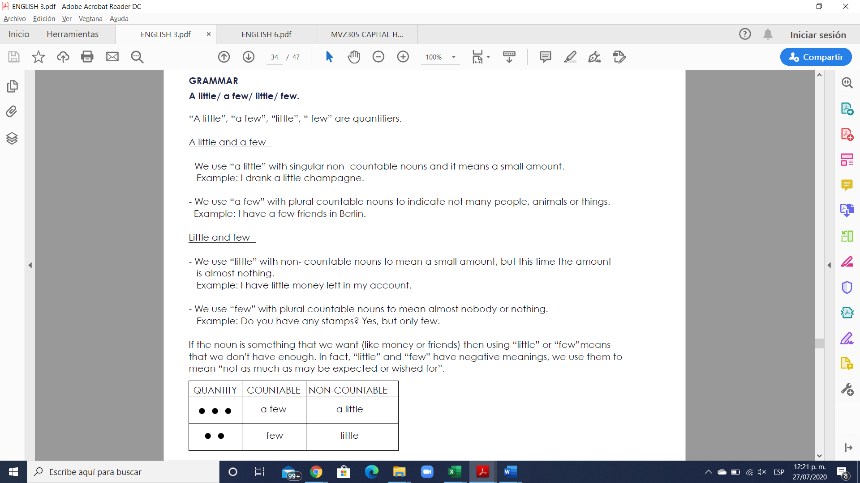

**Exercise #12.** Rewrite the sentences using few/ little.

1. We don`t have much bread left. ______We have a few bread__________________

2. The twins don’t eat many vegetables. ________________________________________

3. These students don’t ask many questions. _____________________________________

4. They don’t have much opportunity to talk with him. ___________________________

5. The guests aren’t drinking much wine with their meal. __________________________

6. Not many people come here. ________________________________________________

**Exercise #13.** Answer the questions using “a few”/ “a little.

1. Have you visited many churches? Only a few.

2. Does she make many mistakes in English? ______________________________________

3. Do you have many friends in your building? ____________________________________

4. Do you have any money left? _________________________________________________

5. Would you like something to eat? ______________________________________________

6. Do you speak German? _______________________________________________________