

**Nombre de alumno:**

**Nombre del profesor:**



**Nombre del trabajo: Weekly Activity #1 Unit 2**

**Materia:**

**Grado:**

**Grupo:**

Comitán de Domínguez Chiapas a 21 de septiembre de 2020.

**TAKING TRANSPORTATION**

**VOCABULARY**

**Exercise 1.** Translate the next vocabulary to Spanish – Traduce el siguiente vocabulario al español.

1. Destination -
2. Frequency -
3. Departure -
4. Arrival -
5. Stops bus -
6. Terminal –
7. Daily –
8. Travel time –
9. Air Conditioning –
10. Flight No. (Flight Number) –
11. Aircraft Type –
12. From / to –

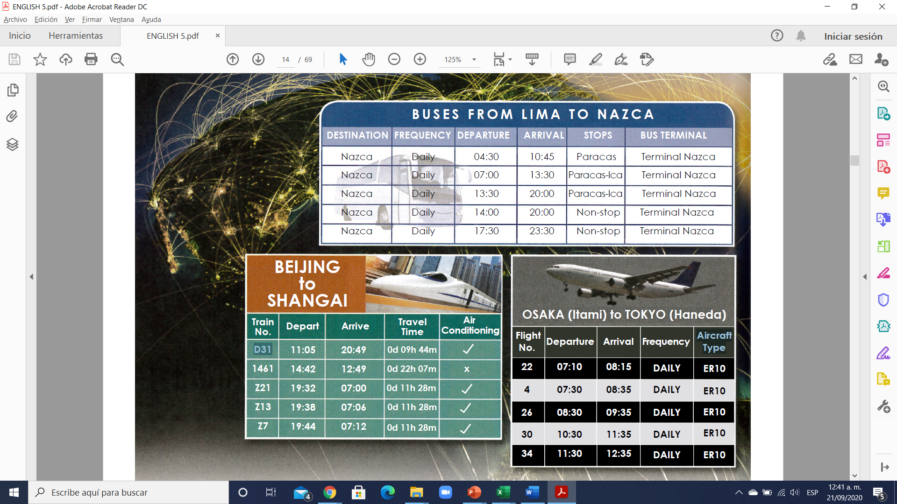

**Exercise 2.** Read the schedules. Use them to find the answers to the questions. Lee los horarios de la imagen de arriba y contesta las siguientes preguntas.

1. It’s now 10:00 A.M. When is the next bus to Nazca? ____________________________

2. When is the next non-stop bus to Nazca? __________________________________

3. How much time does it take to get from Beijing to Shangai on train 1461? _______________

4. Which train is faster, train 1461 or train D31? _______________________________________

5. What time does flight 26 depart for Tokyo? When does it arrive?_______________

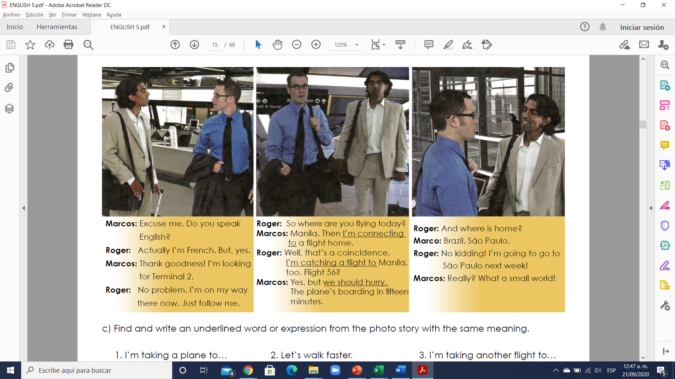

**Exercise 3.** Circle T (true), F (false) or NI (no information). Then explain each answer.

T F NI 1. Flight 56 leaves from Terminal 2.

T F NI 2. Roger lives in France.

T F NI 3. Roger and Marcos are both flying to Manila

T F NI 4. Marcos is staying in Manila.

T F NI 5. Roger is staying in Manila

T F NI 6. The two men get to the flight on time.

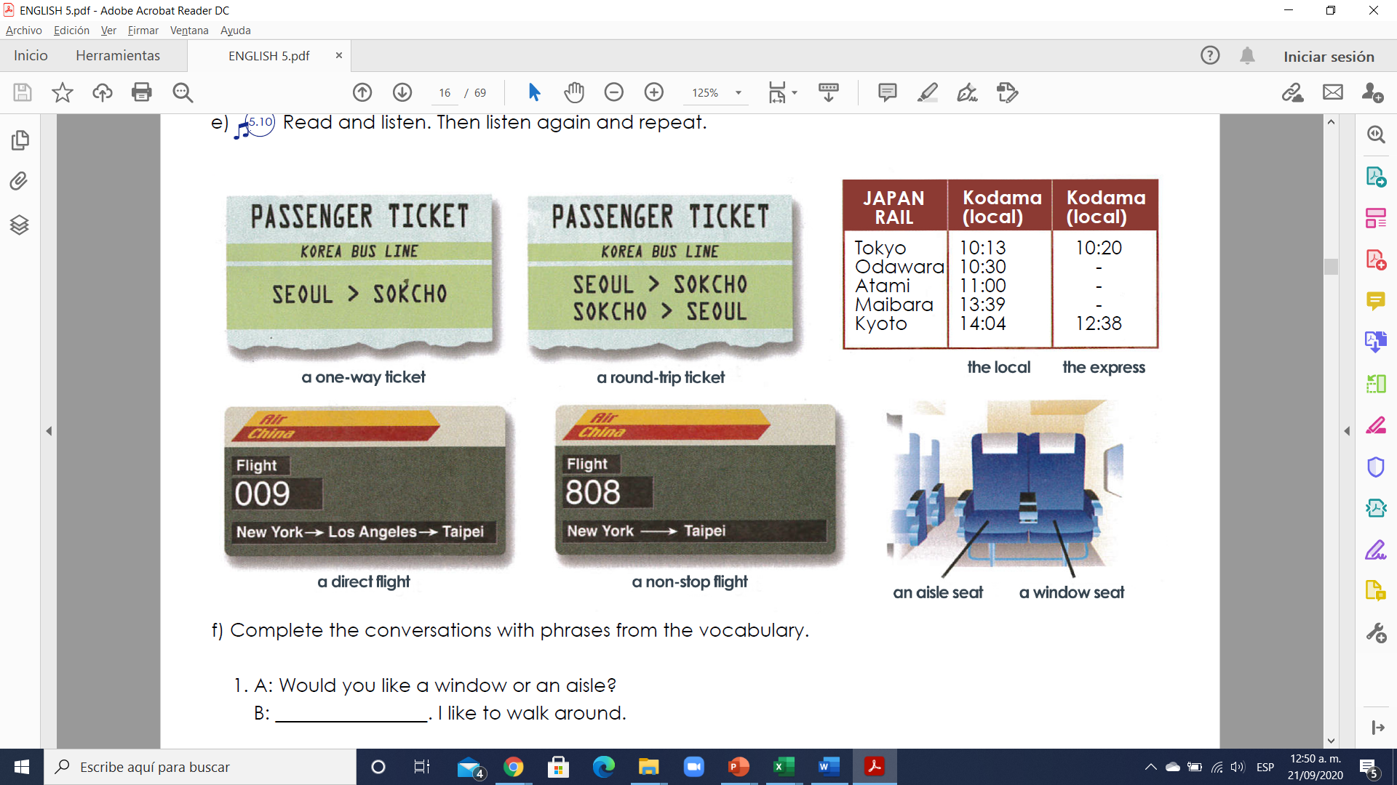

**Exercise 4.** Translate the next vocabulary to Spanish – Traduce el siguiente vocabulario al español.

1. A one-way ticket -
2. A round-trip ticket -
3. A direct flight -
4. A non-stop flight -
5. The local -
6. The express –
7. An aisle seat –
8. A window seat -

**Exercise 5.** Complete the conversations with phrases from the vocabulary. Completa las conversaciones con las frases del vocabulario.

1. A: Would you like a window or an aisle?

B: ________________. I like to walk around.

2. A: Is Flight 3 a ________________ flight?

B: No. It’s a ________________ flight. It makes a stop,

but you don’t have to change planes.

3. A: Do you want a ________________ ticket to Rome?

B: Actually, I need a ________________

I’m not coming back!

4. A: I’m sorry. It’s too late to make the ________________

B: Well, I’ll take the ________________ I’m not in a hurry.

**GRAMMAR**

**Modals: “should” and “could”**

**Should**

We use “should” + the base form of a verb to give advice or to make a strong suggestion.

Example: You shouldn’t take that flight. You should take the non-stop.

Example: Should they take the bus? (Yes, they should. / No, they shouldn’t).

“Should” es usado para dar consejos, una sugerencia fuerte, hablar de situaciones posibles en el tiempo presente y en el futuro. Este puede ser reemplazado por “ought to” sin tener un cambio en el significado.

- Mom, you should check your email. **(consejo)**

- Lorena should be in the office now. **(situación posible en el presente)**

- You guys should get the job; your presentation was the best. **(situación posible en el futuro)**

**Could**

We use “could” + the base form of a verb to offer alternatives or to make a weak suggestion.

Example: The express bus is full, but you could take the local.

Example: Could I take the 2:20? (Yes, you could / No, you couldn’t).

Este se utiliza para hablar de habilidades en el pasado, cosas que no podíamos realizar en el pasado, solicitudes, ofrecer una alternativa, hacer una sugerencia débil, etc.

- I could speak Italian when I was in elementary school. **(habilidad en el pasado)**

- I couldn’t leave the house after 10pm when I lived with my parents. **(imposibilidad en el pasado)**

- Could you send me the copy by noon? **(solicitud)**

**Exercise 6.** Complete each statement or question with a form of “should” or “could”. Completa la oración o la pregunta usando la forma “should” or “could”. Ver ejemplo.

1. ___He should take________ (he/take) the express. The local arrives too late.

2. They said ________________ (we/have) two aisles seats or an aisle and a window seat.

3. ________________ (you/not get) a one-way ticket. It’s much more expensive each way.

4. Which train ________________(we/take) ? We absolutely have to be there on time.

5. ________________ (they/buy) a ticket at the station or on the train. It’s doesn’t matter.

**Exercise 7.** Usa la tabla debajo y escribe 6 oraciones usando should (3) y and could(3)

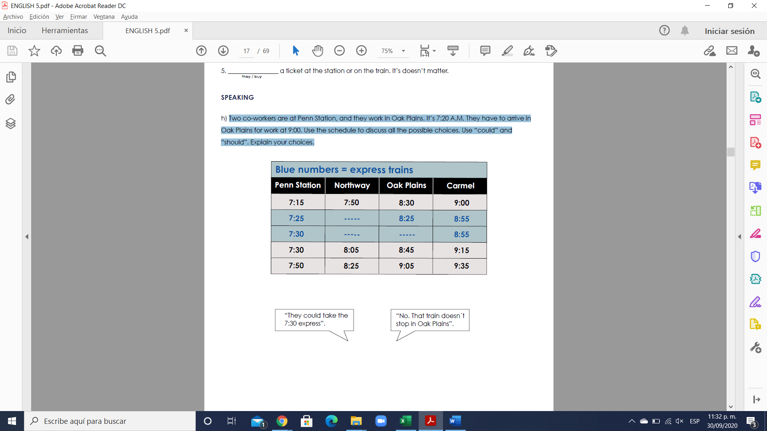

Should

Example: He should wake up early to take the express at Penn Station.

1.

2.

3.

Could

Example: They could take the 7:30 express”.

4.

5.

6.

**Exercise 8.** Underline the correct phrases to complete the sentences. (Subraya la respuesta correcta)

1. Who (should buy / should to buy) the tickets?

2. Where ( I can find / can I find a hotel)?

3. You (could to walk / could walk) or (take / taking) the bus.

4. (I should to call / Should I call) you when I arrive?

5. We (can to not take / can’t take) the bus; it left.

6. When (should you giving / should you give) the agent your boarding pass?

7. Which trains (can get / can getting) me there soon?

**FUTURE PLANS**

**GRAMMAR**

**“Be going to” + base form to express the future.**

- We use “be going to” to talk about future plans and intentions.

Example: She’s going to be a professional dancer when she grows up.

- We use “be going to” to predict something that we think is certain to happen because we have evidence.

Example: It’s going to rain (the speaker can see dark clouds in the sky).

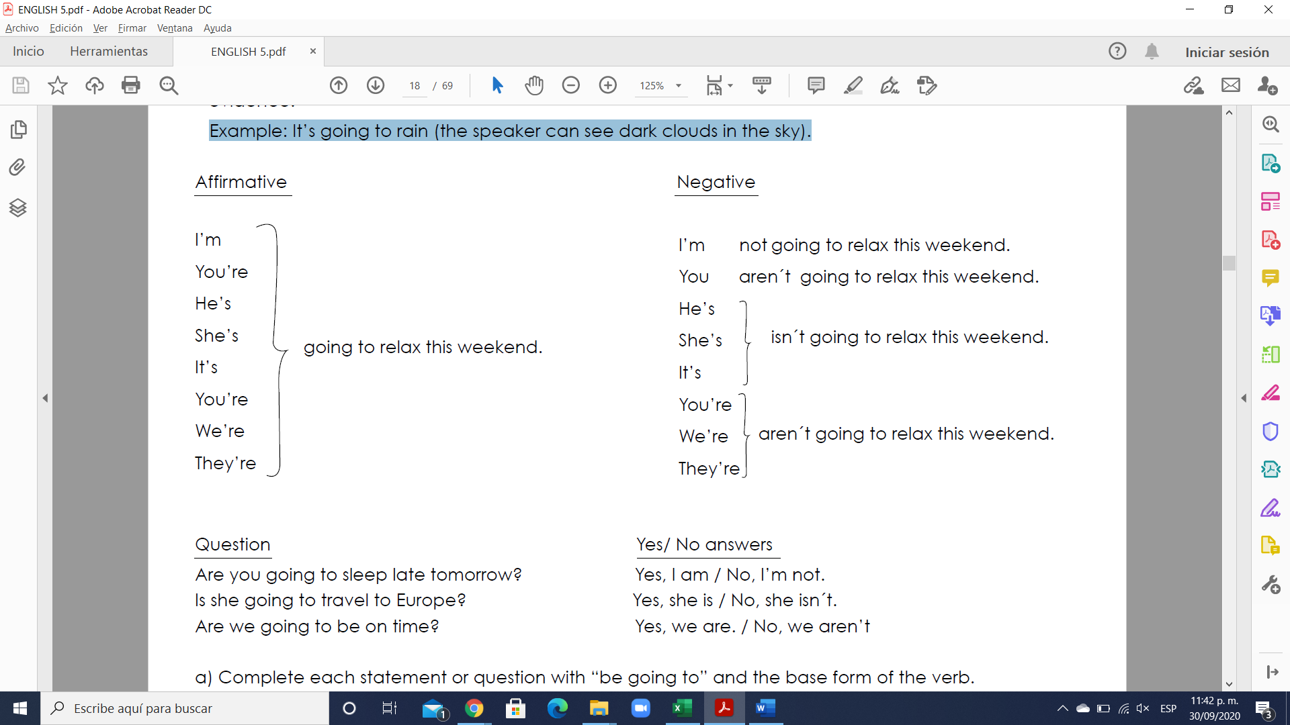

**“Be going to” + base form to express the future.**

El verbo "to be going to" equivale a "**ir a hacer algo**". Su estructura en la oración es:

El verbo que se conjuga es "to be" y tiene que concordar en tiempo y persona con el sujeto.

**To be + going + to + Verbo (en infinitivo)**

**Estructura**

Todas las formas de este tiempo verbal requieren el uso del verbo “to be” en sus tres conjugaciones (am, is, are) dependiendo del sujeto. De esta forma:

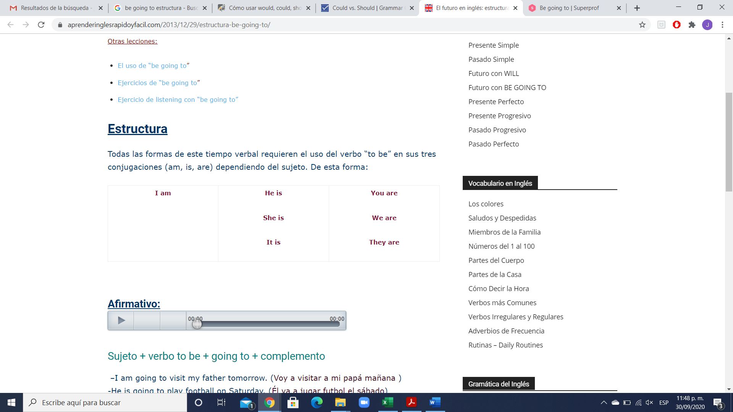

**Afirmativo:**

**Sujeto + verbo to be + going to + complemento**

–I am going to visit my father tomorrow. (Voy a visitar a mi papá mañana )

-He is going to play football on Saturday. (Él va a jugar futbol el sábado)

-We are going to listen to music tonight. (Vamos a escuchar música esta noche)

**Negativo:**

**Sujeto + verbo to be en negativo + going to + complemento**

–I am not going to eat tonight. (No voy a comer esta noche)

-It is not going to rain. (No va a llover)

-They are going to buy a house. (Van a comprar una casa)

**Interrogativo:**

1. Preguntas de sí o no y respuestas:

-Is she going to drive your car? (¿Ella va a conducir tu carro/auto?)

Yes, she is. (Sí) No, She isn’t. (No)

-Are you going to write the report tonight? (¿Vas a escribir el reporte esta noche?)

Yes, I am. (Sí) No, I am not. (No)

2. WH-questions:

–What are he going to do tomorrow? (¿Qué va a hacer ella mañana?)

-Where are they going to sleep? (¿Dónde van a dormir?)

**Nota:**

En ocasiones, sobre todo en el inglés hablado informalmente, se suele reducir el forma **“going to” a “gonna”.** Escucha la pronunciación de “**gonna**”:

**Exercise 9.** Complete each statement or question with “be going to” and the base form of the verb. Completa la oración o la pregunta.

1. ____They are not going to buy_______ (the / not buy) tickets for the express.

2. When _________________________________ (she / leave) for the airport?

3. ______________________________________ (you / ask for) an aisle seat?

4. Who _________________________________(take) him to the train station?

5. Who _________________________________ (he / call) in Chicago?

6. Where __________________________________ (Dad / be) when I arrive?

**Exercise 10.** Write a question with “be going to” for each answer. Don’t use the verb “do”.

Escribe la pregunta usando”be going to” para cada respuesta, no uses el verbo do.

1. Are you going to go to the movies tonight? ________

Yes. I’m going to go to the movies tonight.

2. ______________________________________________________

Yes. They’re going to eat in a restaurant after the concert.

3. ______________________________________________________

Yes. Carla’s brother is going to go fishing with her.

4. ______________________________________________________

Yes. I’m going to go to work tomorrow.

5. ______________________________________________________

No. He’s not going to graduate this year.

6. ______________________________________________________

Yes. They’re going to take the bus to school.

**Exercise 11.** Complete the e-mail. Underline the correct verb forms. Subraya la forma correcta del verbo.

Here’s my travel information: I (1 go to leaving/ ‘m going to leave) Mexico City at 4:45 P.M. on Atlas Airlines flight 6702, and I’m arriving in Chicago at 9:50 P.M. Mara’s flight (2 is going to get there/ going to get there) ten minutes later, so we (3´re go meeting/ ´re going to meet) at the taxi stand downstairs. That’s too late for you to come to the airport, so we can take the express bus from O’Hare to the city. Mara (4 goes to spend/ is going to spend) the night at our apartment. Her flight to Tokyo isn’t leaving until the next day, and she and I (5 are going to spend / going to spend) the whole day shopping!