

**Nombre de alumno:**

**Nombre del profesor:**



**Nombre del trabajo: Unit Activity #1 – U2 2BRH**

**Materia:**

**Grado:**

**Grupo:**

Comitán de Domínguez Chiapas a 31 de enero de 2022.

**DESCRIBE CITIES**

**VOCABULARY**

**Exercise 1.** Match the adjectives to pictures a-h. (Escribe la letra de la figura que concuerda con la palabra)

( ) - good.

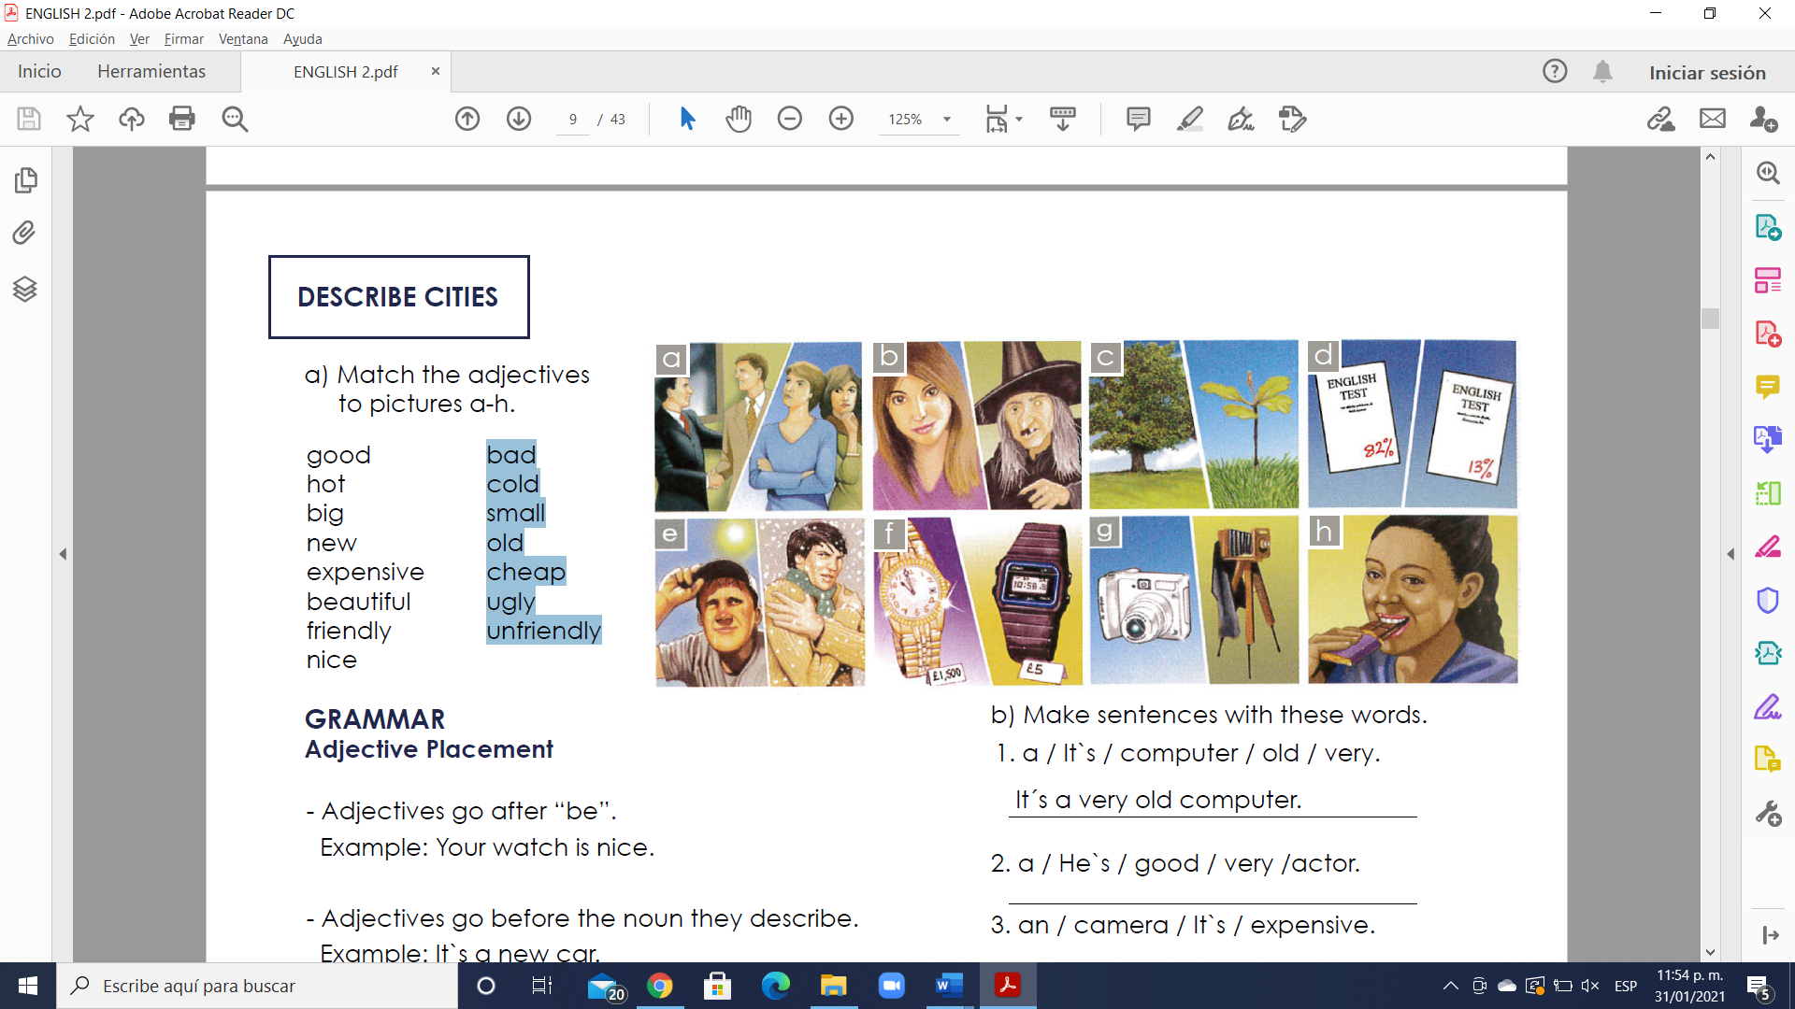() - hot.

( ) - big

( ) - new

( ) - expensive

( ) - beautiful

( ) - friendly

( ) - nice

( ) - bad

( ) - cold

( ) - small

( ) - old

( ) - cheap

( ) - ugly

( ) - unfriendly

**GRAMMAR**

**Adjective Placement**

- Adjectives go after “be”.

Example: Your watch is nice.

- Adjectives go before the noun they describe.

Example: It`s a new car.

- Adjectives are not plural with plural nouns.

They´re good friends.

Example: They´re good friends.

NOT ~~They´re goods friends.~~

**Exercise 2.** Make sentences with these words. (Realiza las oraciones ordenando las palabras)

1. a / It`s / computer / old / very.

A: It´s a very old computer.

2. a / He`s / good / very /actor.

A:

3. an / camera / It`s / expensive.

A:

4. very / nice / friends / are / His.

A:

5. good / musician / a / She`s.

A:

6. is / very / house / beautiful / Her.

A:

7. a / It`s / night / cold / very.

A:

8. friendly / children / Your / very / are.

A:

**GRAMMAR - Present Simple ( I, you, we, they)**

- We use the Present Simple when something is generally or always true.

Example: People need food.

- We use the Present Simple for a situation that we think is more or less permanent.

Example: She works in a bank.

- We use the Present Simple for habits or things that we do regularly. We often use adverbs of frequency, such as “often”, “always”, “sometimes”.

Example: I always play tennis on Tuesday.

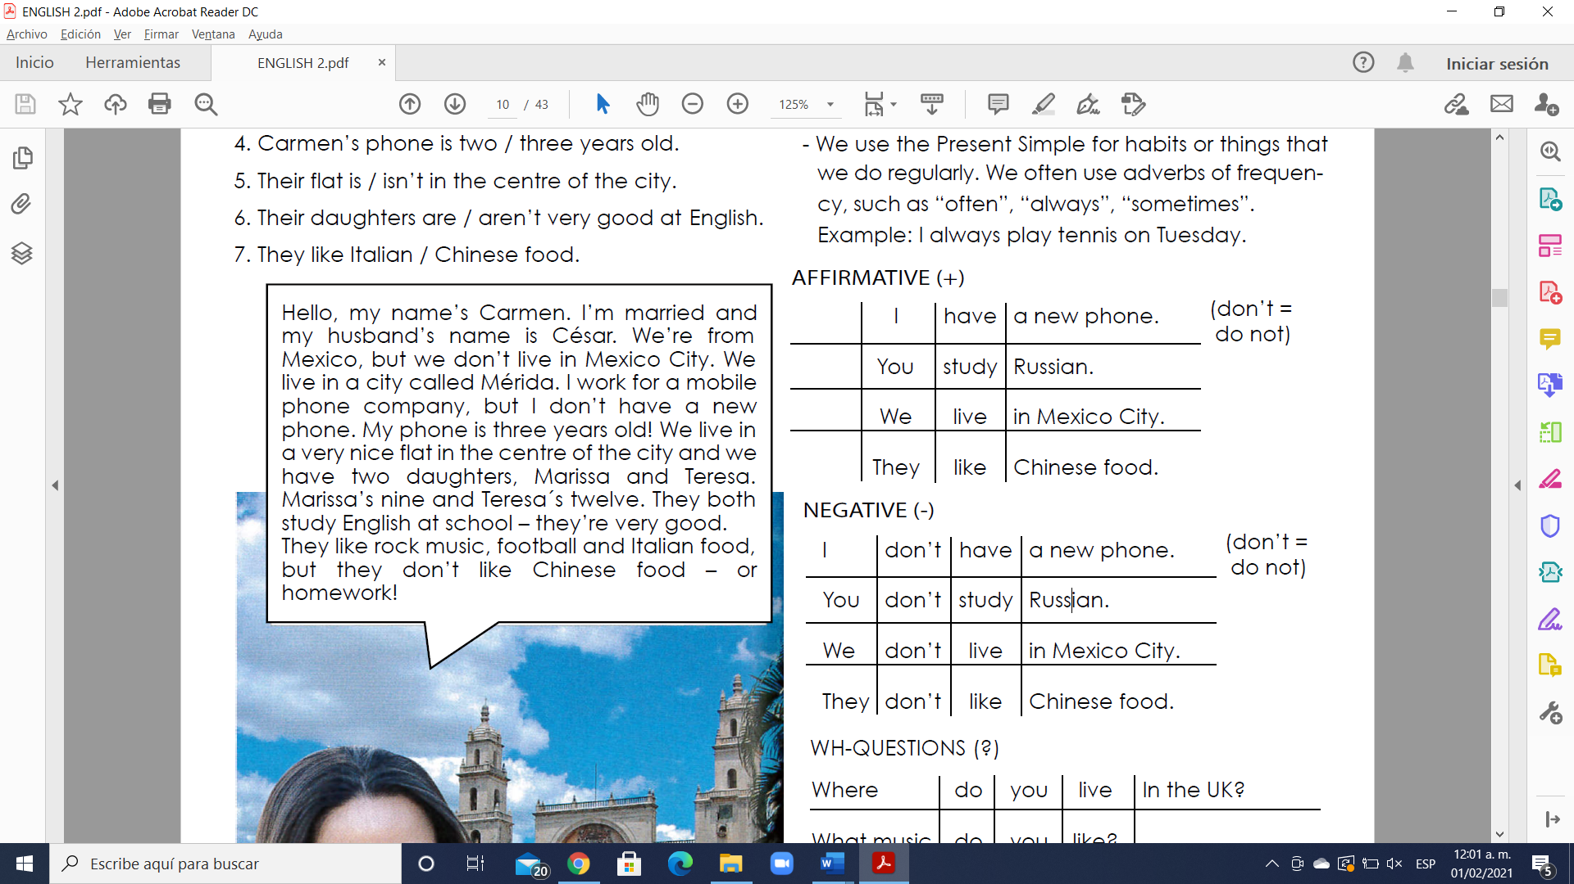 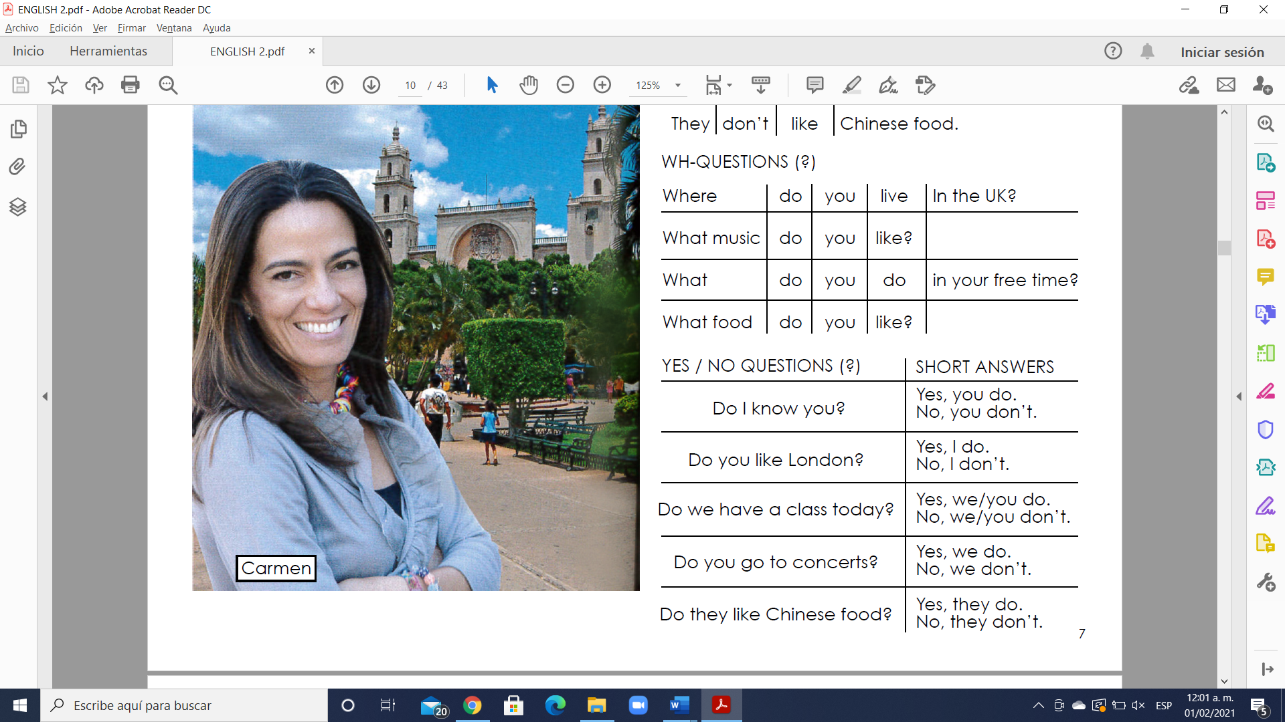

**Simple present**

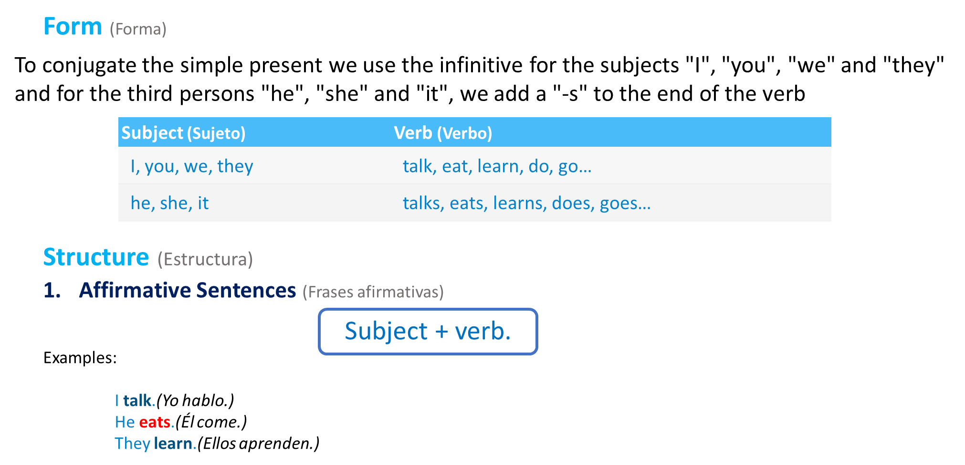

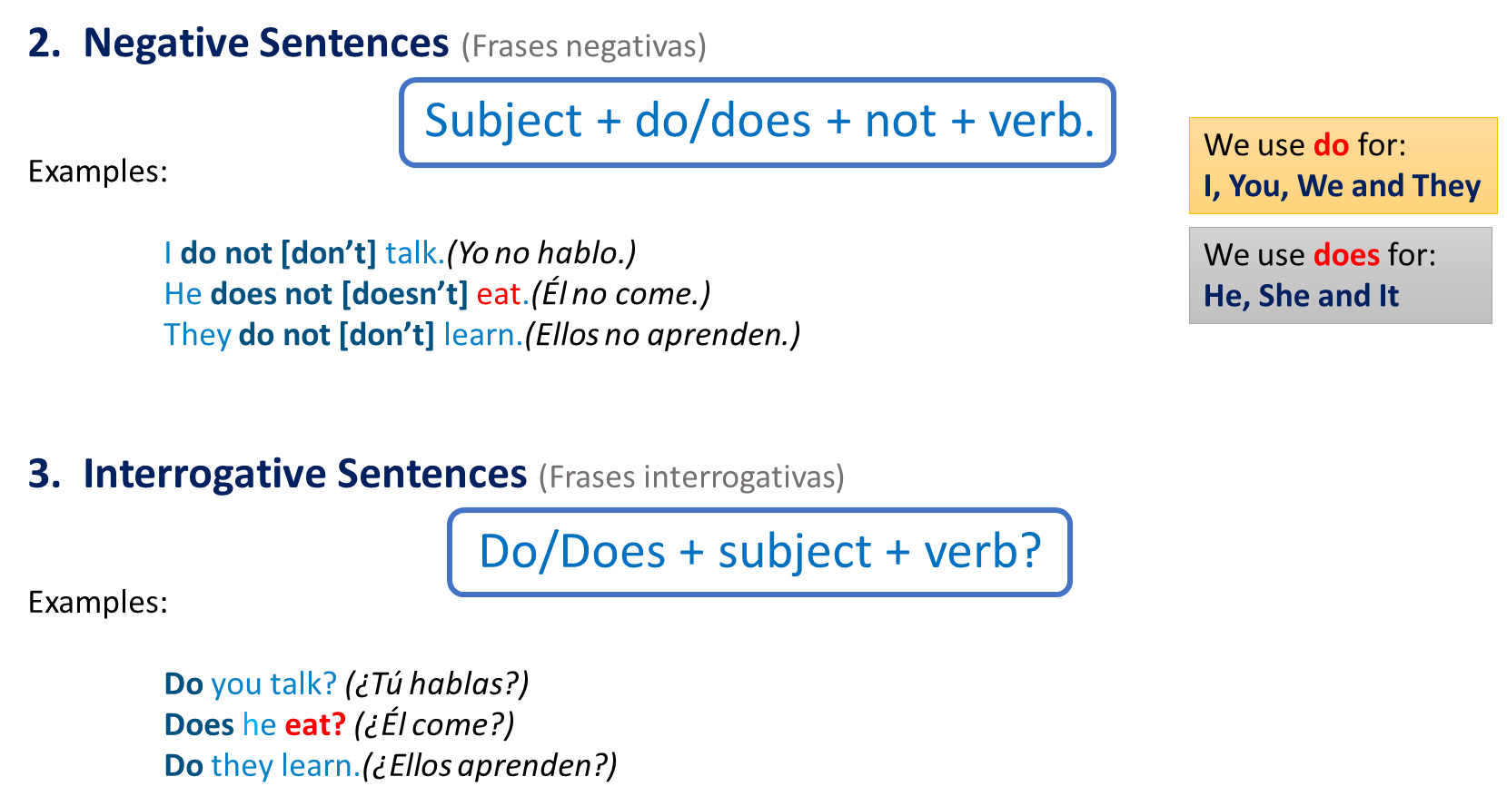

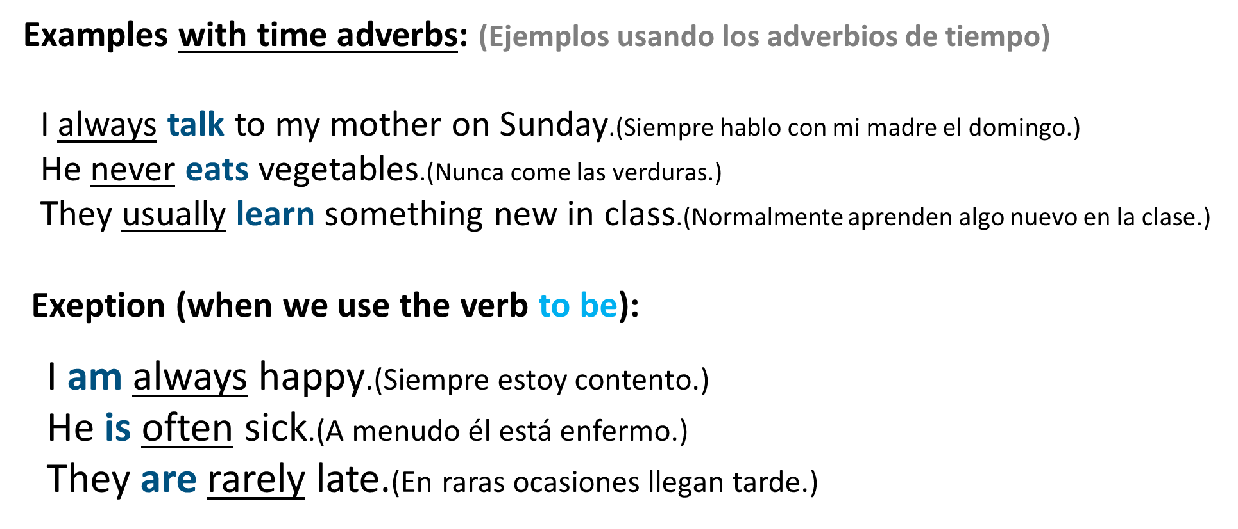

**Exercise 3.** Change the sentences to negative and question. (Cambia la oración afirmativa a oraciones negativas y preguntas)

1. I live in the center of the city.

N. I don´t live in the center of the city

Q. Do you live in the center of the city?

2. I work in an office.

N.

Q.

3. Robert likes Italian food.

N.

Q.

4. Anna likes rock music.

N.

Q.

5. They have a new computer.

N.

Q.

6. You have a sister.

N.

Q.

7. We study English.

N.

Q.

8. She lives in a small house.

N.

Q.

9. He works for an American company.

N.

Q.