

**Nombre de alumno:**

**Nombre del profesor:**



**Nombre del trabajo: Unit Activity #1 - Unit 3**

**Materia:**

**Grado:**

**Grupo:**

Comitán de Domínguez Chiapas a 25 de octubre de 2021.

**GRAMMAR - The comparatives**

Comparatives are used to compare two things and to highlight the superiority, inferiority or equality of one term to another.

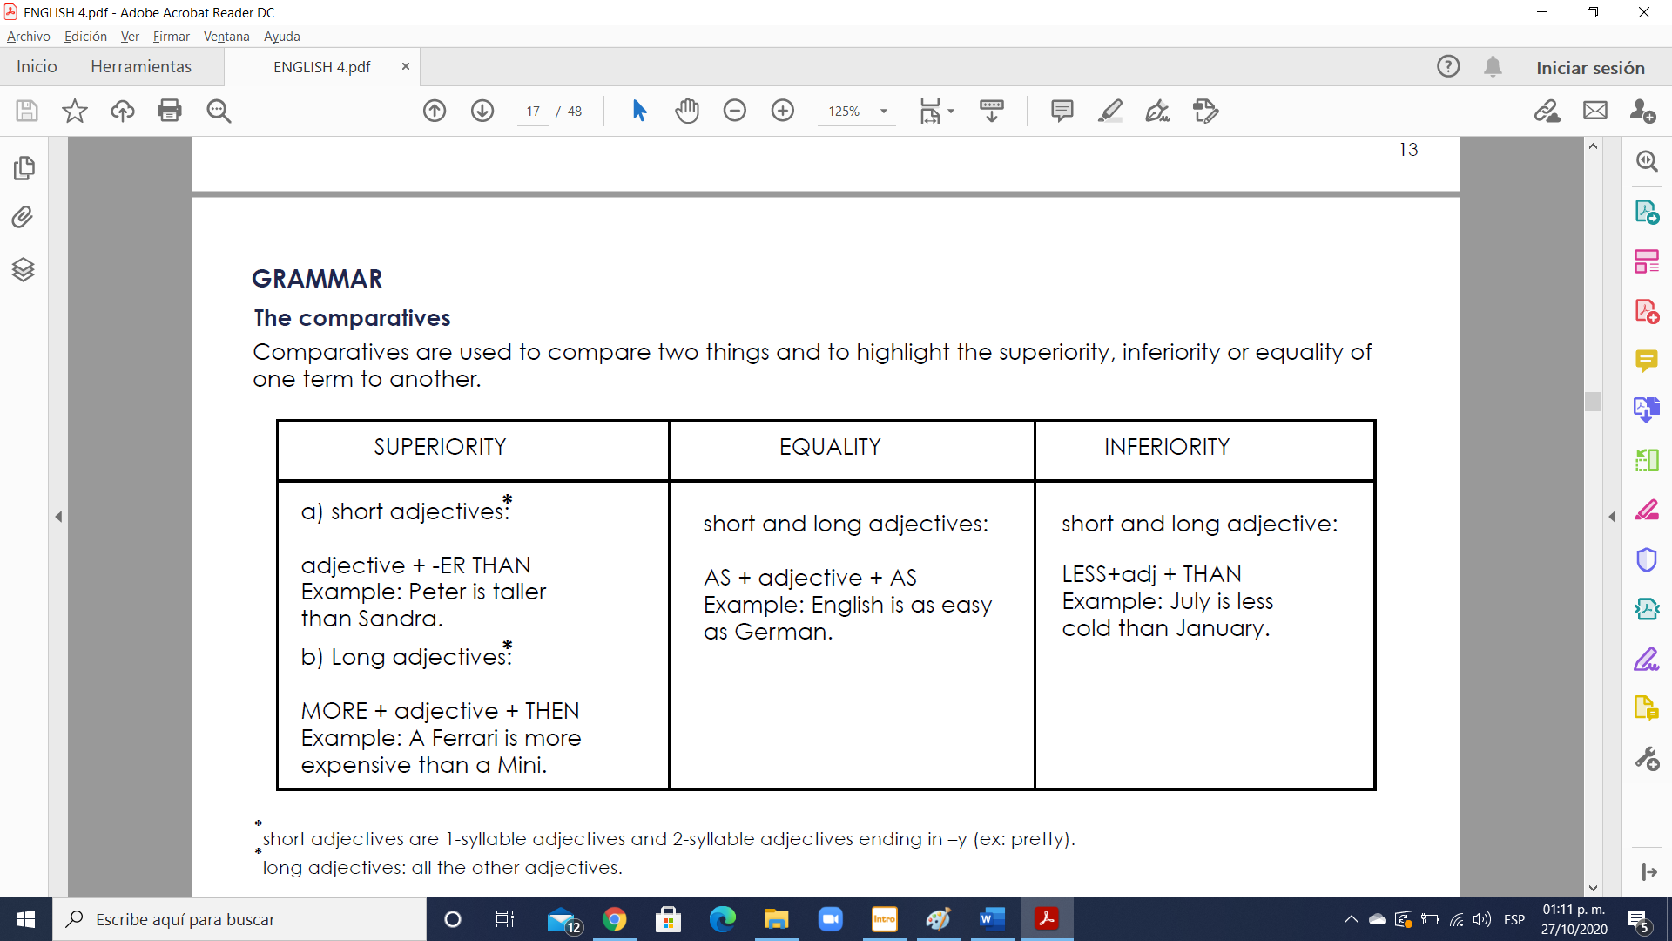

* **short adjectives**: are 1-syllable adjectives and 2-syllable adjectives ending in **–y (ex: pretty).**

* **long adjectives:** all the other adjectives.

**Orthographic changes:**

- If the adjective ends in **“y”** the **“y”** becomes **“i”**: **heavy- heavier.**

- If the adjective ends in **“e”** only an **“r”** is needed: **wise- wiser.**

- If the adjective ends with a **“single vowel + consonant”** the consonant is doubled and you add **“er”**: **big-bigger.**

**Irregular forms:**

These adjectives and adverbs have irregular comparative forms.

- **Good/ well- better**. Example: the garden looks better now.

- **Bad/ badly- worse**. Example: is your teacher better? No, she is worse.

- **Far/ further**. Example: It’s a long walk form here to the station. Further than I think.

* further= can also mean **“more”** or **“additional”**. Example: for further information check the website.

**Exercise 1.** Complete the sentences using a comparative form.

1. It’s too noisy here. Can we go somewhere (quiet) ___quieter___?

2. The coffee is very weak. I like it a bit (strong) ________________.

3. The hotel is surprisingly big. I expected it to be (small) ________________.

4. The hotel is surprisingly cheap. I expected it to be (expensive) ________________.

5. The weather is too cold in this country. I’d like to live somewhere (warm) ________________.

6. My job is a bit boring sometimes. I’d like to do something (exciting) ________________.

7. I’m surprised how easy it is to use the computer. I thought it would be (difficult) ________________.

8. Your work isn’t very good. I’m sure you can do (good) ________________.

9. Don’t worry. The situation isn’t so bad. It could be (bad) ________________.

10. I’m surprised we got here so quickly. I expected the journey to take (long) ________________.

11. You’re talking very loudly. Can you speak a bit (quietly) ________________?

12. You’re standing too near the camera. Can you move a bit (far) ________________ away?

13. You were a bit depressed but you look (happy) ________________ today.

**Exercise 2.** Complete the sentences using as…as.

1. I’m quite tall but you are taller. I’m not **___as tall as___** you.

2. My salary is high but yours is higher. My salary isn’t _______________________________.

3. You know a bit about cars but I know more. You don’t __________________________.

4. I’m very nervous but you are more. I’m not ______________________________________.

5. I feel tired and you too. I’m _____________________________________________________.

**Exercise 3.** Rewrite these sentences so that they have the same meaning.

1. Jack is younger than he looks. Jack isn’t ___**as old as___** he looks.

2. I don’t spend as much money as you. You _______________________________________.

3. The station is nearer than I thought. The station isn’t _______________________________.

4. The meal doesn’t cost as much as I expected. The meal __________________________.

5. I go out less than before. I don’t _________________________________________________.

6. Her hair isn’t as long as it was. She has __________________________________________.

**Exercise 4.** Write the adjectives in brackets in the comparative form.

1. John Lennon was (old) _____**as older as**_________ Paul McCartney.

2. Some people think the Met is (good) _______________ the Louvre.

3. Eric was (afraid) _______________ in Harlem _______________ in the Subway.

4. Cats are (nice) _______________ dogs.

5. Cartoons are (good) _______________ music programmes.

6. The Empire State is (big) _______________ the Chrysler Building.

7. Barcelona is (small) _______________ Madrid, but (big) _______________ Valencia.

8. Scotland is _______________ (cold) than the South of England.

9. I like cats - they're _______________ (interesting) than dogs.

10. Charity shops are _______________ (cheap) than other shops.

11. Buy that MP3 player. It's _______________ (good) than the other one.

12. I spend a lot of time with Petra - she's _______________ (friendly) than the other students.

13. In winter, Venice is _______________ (quiet) than in summer.

14. The maths exam was bad, but physics was even _______________ (bad)!