

**Nombre de alumno:**

**Nombre del profesor:**



**Nombre del trabajo:**

**Materia:**

**Grado:**

**Grupo:**

Comitán de Domínguez Chiapas a 06 de junio de 2022.

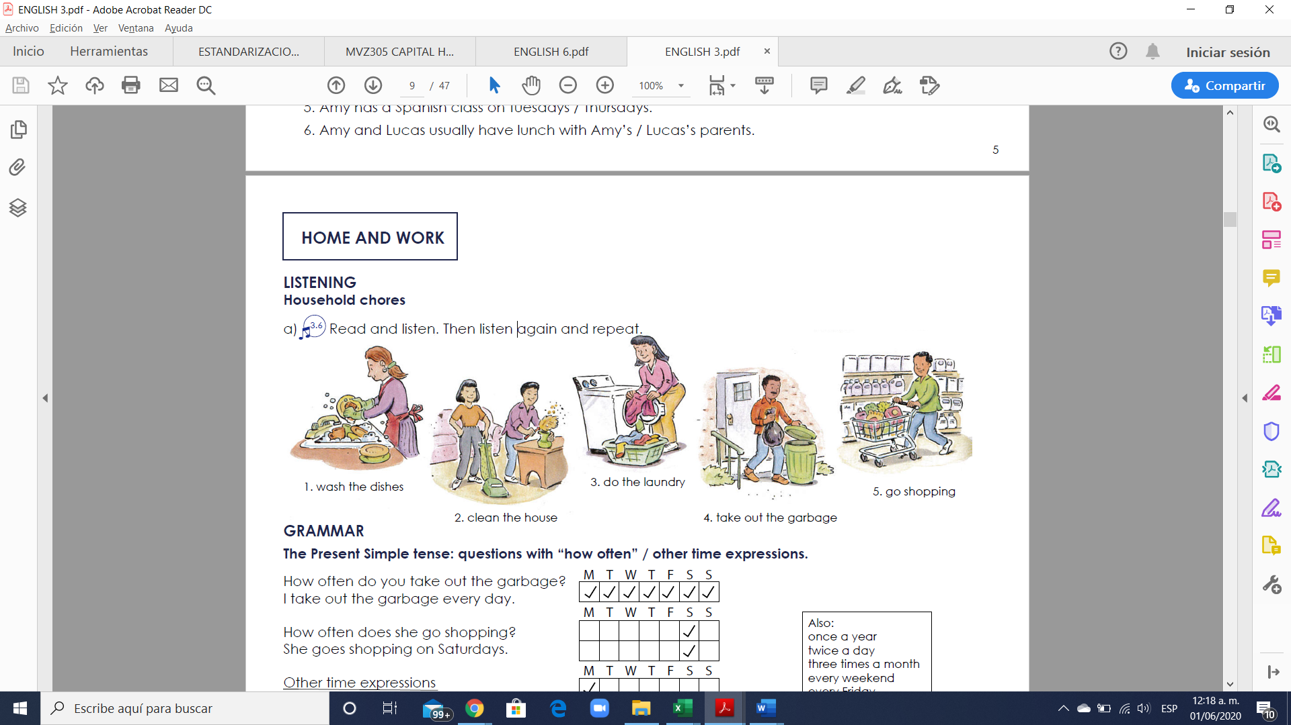

**VOCABULARY**



**Exercise 1.** Translate the vocabulary. (Traduce el vocabulario de la parte de arriba)

1.

2.

3.

4.

5.

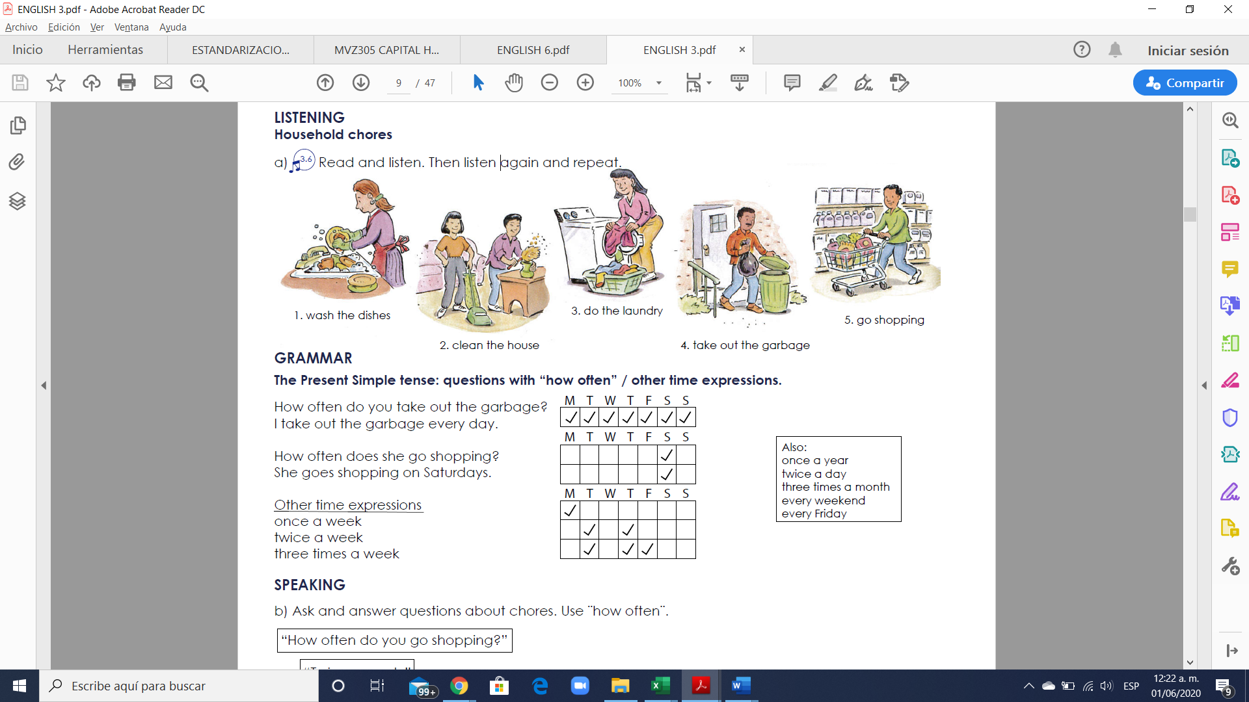

**Exercise 2.** Write 5 questions using questions with “how often” in present simple (Escribir 5 oraciones usando las preguntas “how often” en presente simple usando el vocabulario debajo)



Example: How often do you travel to Tuxtla?

1.

2.

3.

4.

5.

**Exercise 3.** Answer your questions using the time expressions (once a year, twice a day, three times a month, every weekend, every Friday, once a week, twice a week, three times a week). Contesta las pregunats que tu elaboraste usando las expresiones de tiempo.

Answers

1.

2.

3.

4.

5.

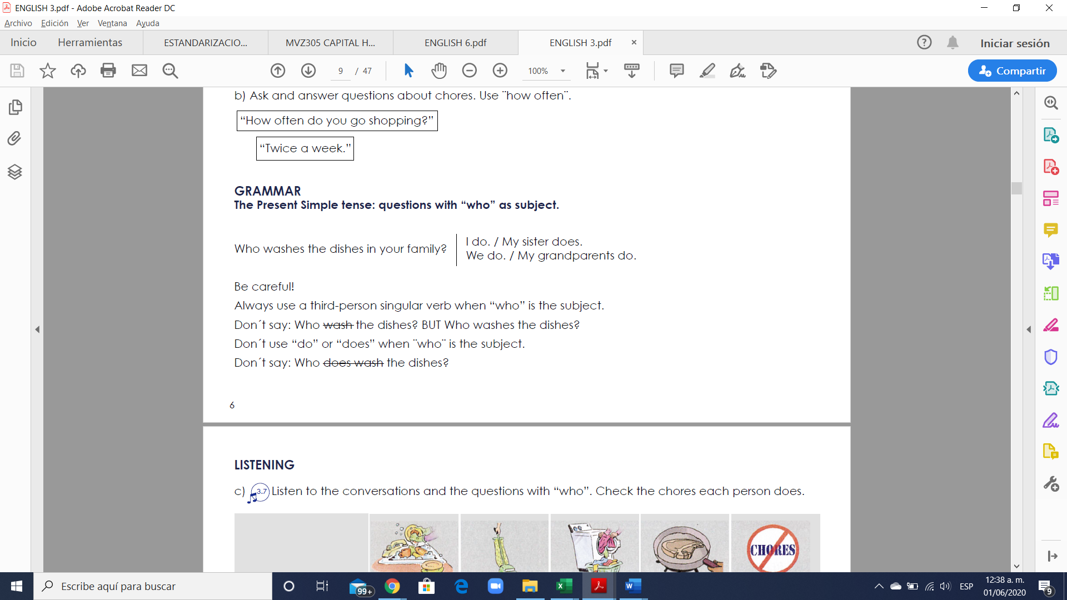

**Exercise 4.** Write 5 questions using questions with “who” in present simple (Escribir 5 oraciones usando las preguntas “who” en presente simple usando el vocabulario anterior)

Example: Who travels to Tuxtla every weekend?

1.

2.

3.

4.

5.

**HOME AND NEIGHBORHOOD**

**VOCABULARY - Buildings**

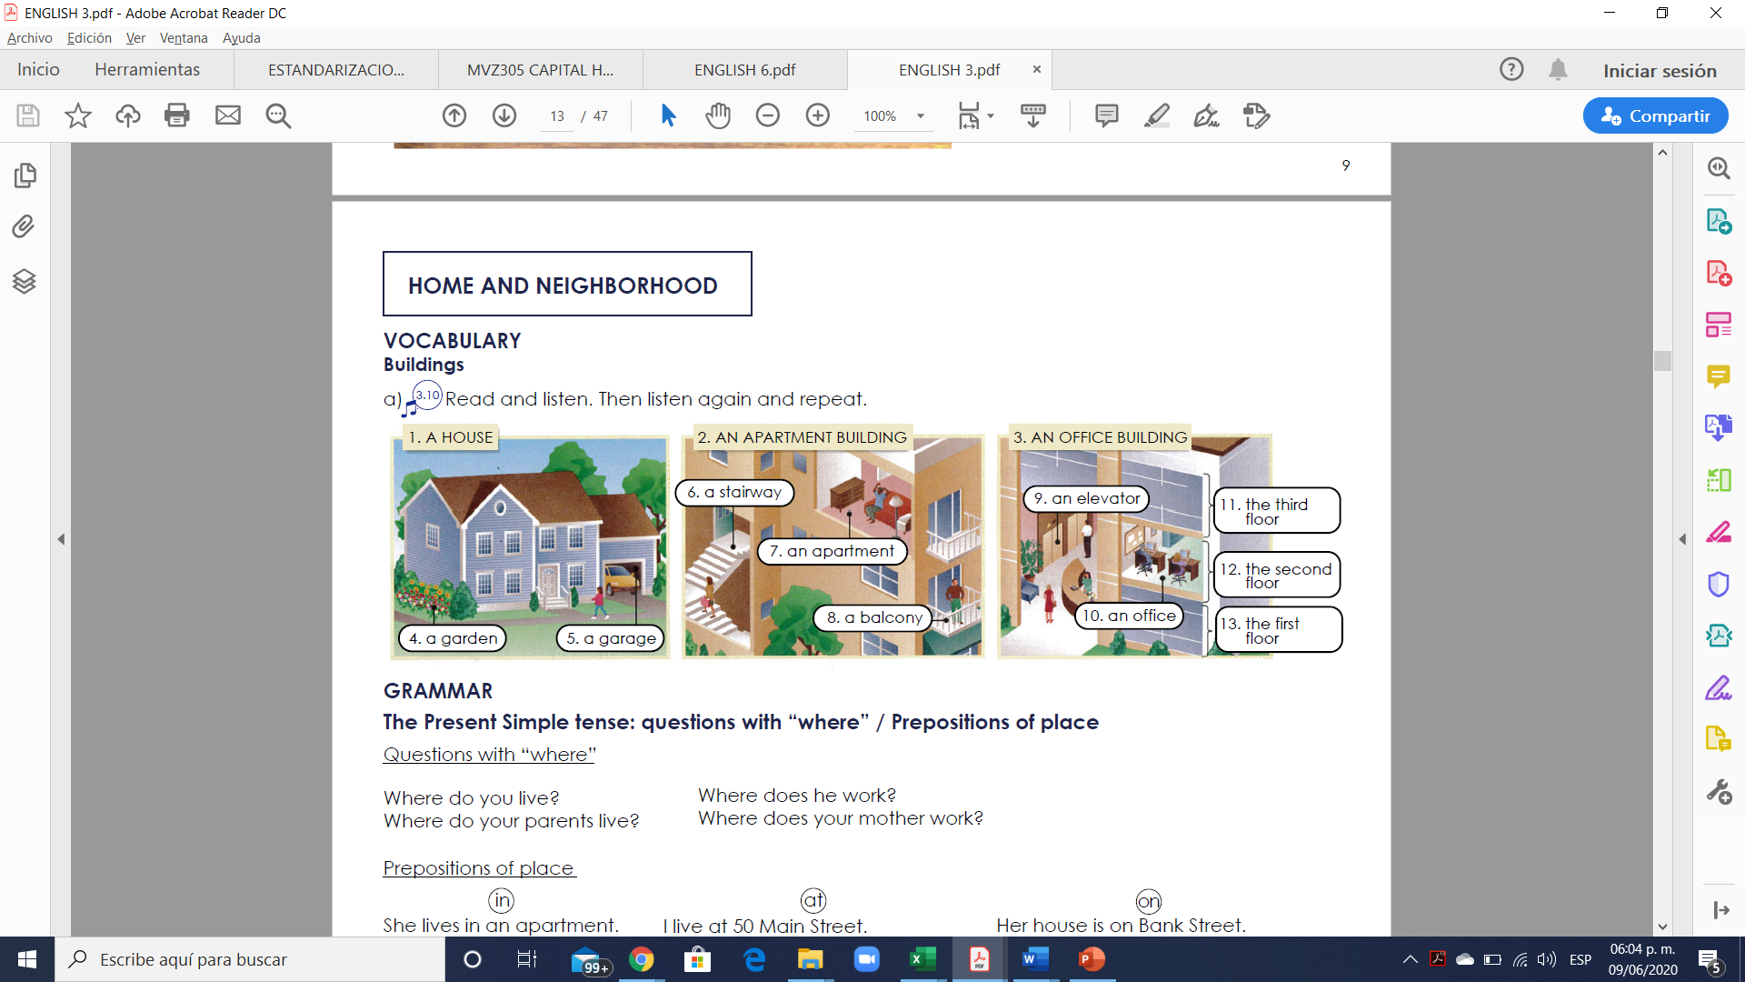

**Exercise 1.** Translate the vocabulary. (Traduce el vocabulario de la parte de arriba)

1.

2.

3.

4.

5.

6.

7.

8.

9.

10.

11.

12.

13.

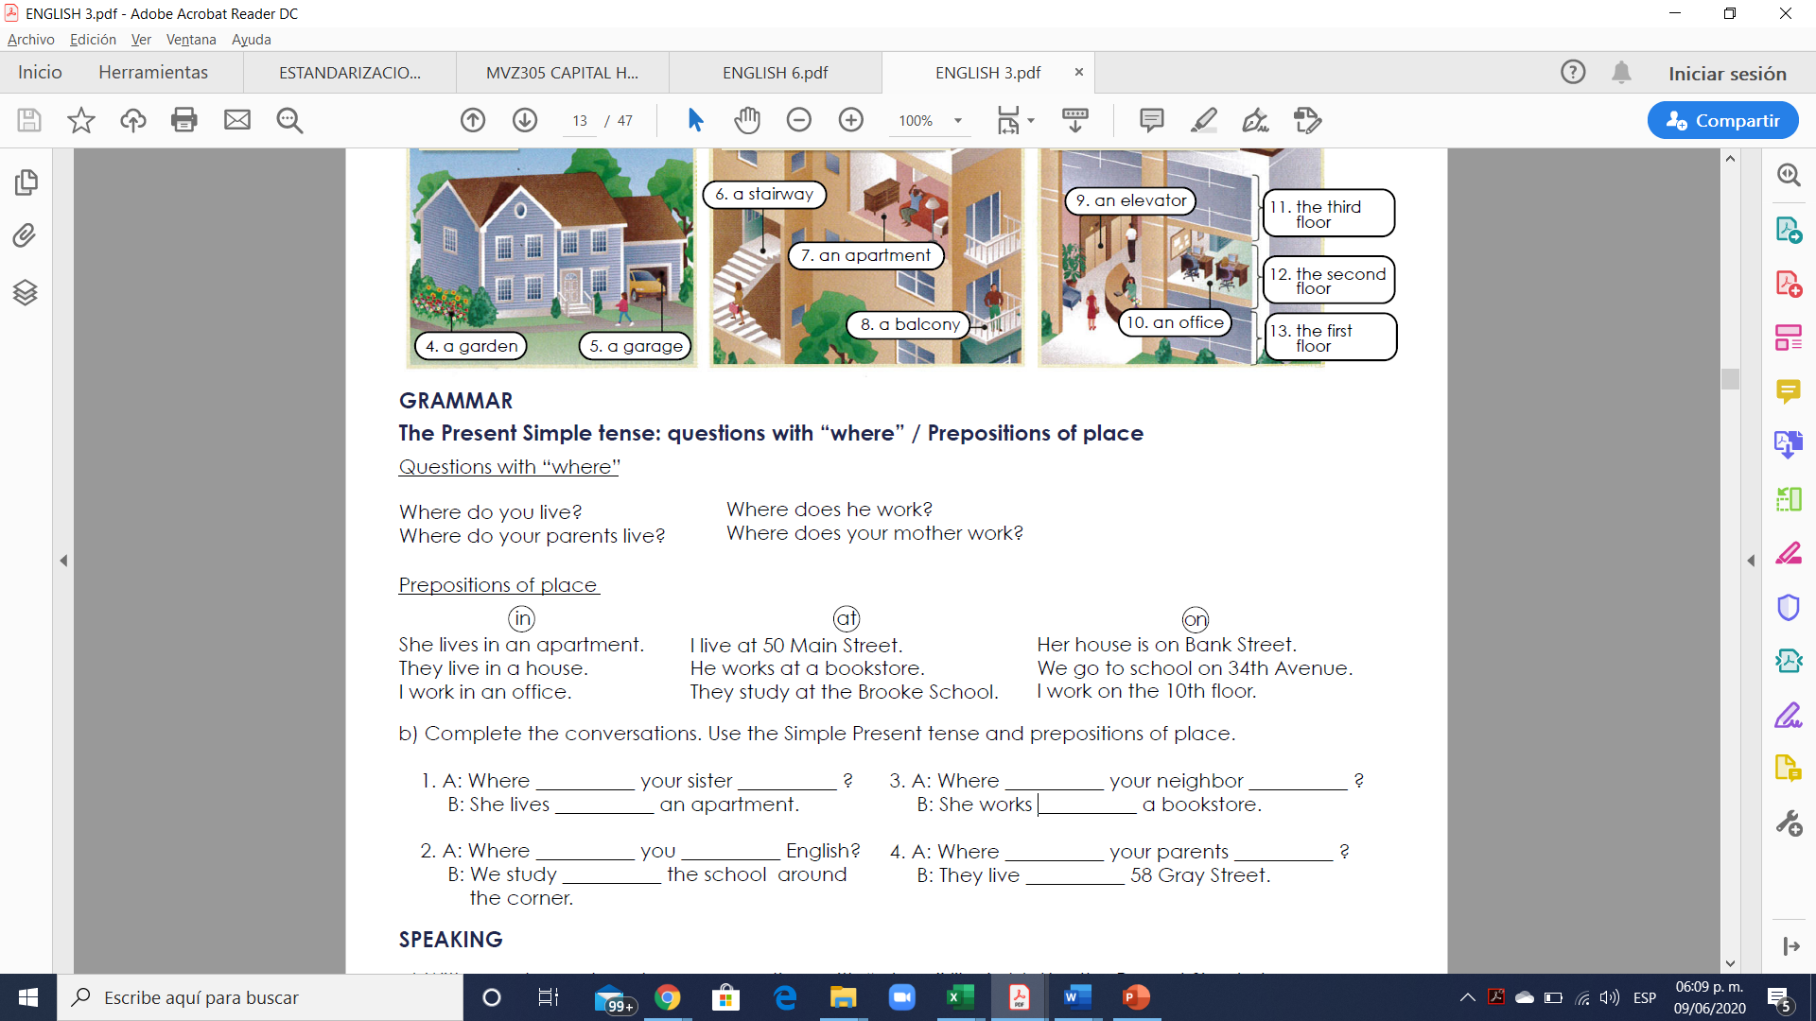

**A preposition of place** is a word which helps to describe where something or somebody is. A preposition of place describes the location of something.

There are many prepositions of place in the English language and each of them has several uses.

In this lesson, we will study 3 prepositions of place:

at

in

on

**at**

**Specific point or place**

We can use “at” to describe a very specific point or place.

Examples:

“There is a dog at the top of the steps.”

"She's waiting at the entrance."

"He's sitting on his chair at his desk."

"I work at a bank."

**in**

**Enclosed space / a large place with boundaries**

We use the preposition “in” for an enclosed space (surround or closed off on all sides). Basically, when something is inside something.

Examples:

“The dog is in the garden.”

“The apple is in a box.”

“The students are in a classroom”.

“That people live in China”.

**on**

**For a surface**

The preposition “on” is often used to describe a surface.

Examples:

“There’s a clock on the wall.”

“The apple is on the table.”

“That cat is on the floor.”

“My book is on the chair.”

**Exercise 2.** Complete the conversations. Use the Simple Present tense and prepositions of place

1. A: Where __________ your sister __________ ?

B: She lives __________ an apartment.

2. A: Where __________ you __________ English?

B: We study __________ the school around the corner.

3. A: Where __________ your neighbor __________ ?

B: She works __________ a bookstore.

4. A: Where __________ your parents __________ ?

B: They live __________ 58 Gray Street.

**Exercise 3.** Write 6 questions with “where” and answer the questions using the Present Simple tense and the vocabulary below.

Escribe 6 preguntas con sus repuestas usando “Where” y el vocabulario debajo.

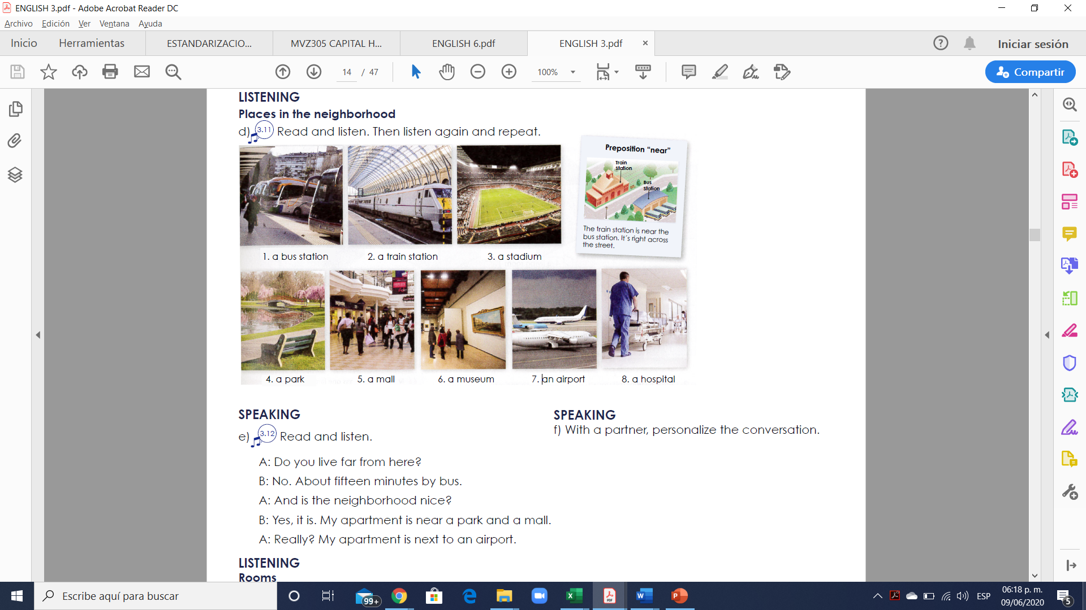

1.

2.

3.

4.

5.

6.

**Exercise 4.** Write 6 sentences using **the preposition of place** “in” “on” “at” using the present simple (Escribir 6 oraciones usando las preposiciones de lugar “in” “on” “at” en presente simple)

1.

2.

3.

4.

5.

6.