**Unit Activity #1 – U4**

*Nombre del Alumno:*

*Nombre del tema: Unit IV*

*Parcial: Fourth*

*Nombre de la Materia: English IV*

*Nombre del profesor: Juan Manuel Jaime Díaz*

*Nombre de la Licenciatura:*

*Cuatrimestre: Fourth*

*Lugar y Fecha de elaboración*

Comitán de Domínguez Chiapas a 23 de junio de 2024.

**GRAMMAR - Would like**

- We use “would like” (contraction: I’d like) to politely express what we want, likes and dislikes. We use it either with verbs and nouns.

Example (verb): I would like to eat a pizza now. WOULD LIKE + TO + VERB

Example (noun): I would like a Coke now. WOULD LIKE + NOUN

- We also use “would like” to make polite offers and requests.

Example (offer): Would you like some tea?

Example (request): I would like to get a return ticket for tomorrow.

- Questions and answers

Would you like to go to the concert with me? Yes, I would. / No, I would not or I wouldn’t (contraction).

Be careful!

Don’t contract “would” in affirmative short answers.

Example: Would you like to listen to music? Yes, I would NOT Yes, I’d.

**Exercise 1.** Complete the sentences using a comparative form.

1. Sara: “_____ some cake?” Marta: “ Yes, please!”.

a. do you like b. would you like

2. Steve: “What sort of music _____?”. Andy: “ Dance music”.

a. do you like b. would like

3. Jana: “_____ a banana?” Nick: “No, thanks I’m not hungry”.

a. would you like b. do you like

4. Liz: “_____ bananas?” Paul: “Yes, I love them!”.

a. would you like b. do you like

5. Tony: “do you play tennis?” Mike: “ Yes, I do”. Tony: “ _____ to play a game now?” Mike: “Yeah, sure!”

a. do you like b. would you like

6. I’m hot and thirsty. _____ a cold drink.

a. I’d like b. I like

7. I’m tired. _____ to go to bed now.

a. I’d like b. I like

8. “_____ an apple, please!”.

a. I’d like b. I like

9. _____ apples. They’re my favorite fruit.

a. I like b. I’d like

10. I _____ to go to Italy for a holiday next year.

a. like b would like

**Exercise 2.** Form sentences with “would like to” and one of the verbs from the list below.

go have make see talk visit

1. We __________________________ dinner.

2. We __________________________ a pizza.

3. I _____________________________ to a restaurant.

4. Jane _________________________ the film.

5. They _________________________ London.

6. I _____________________________ to you.

**GRAMMAR - The past tense of “be”.**

**Affirmative/ negative**

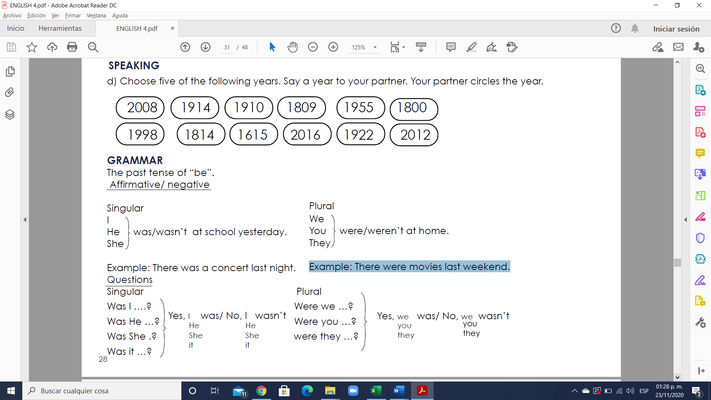

Example: There was a concert last night. Example: There were movies last weekend.

**Questions**

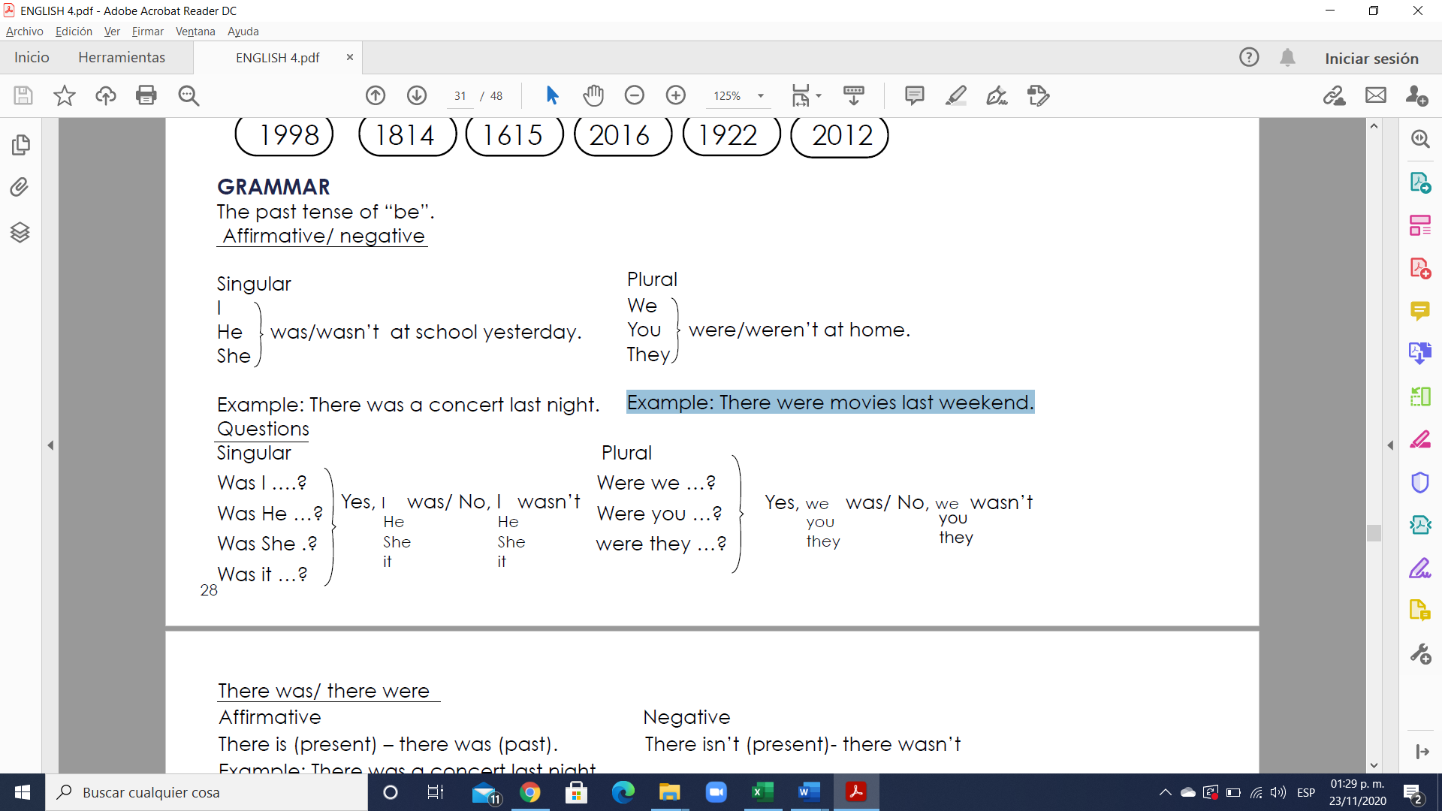

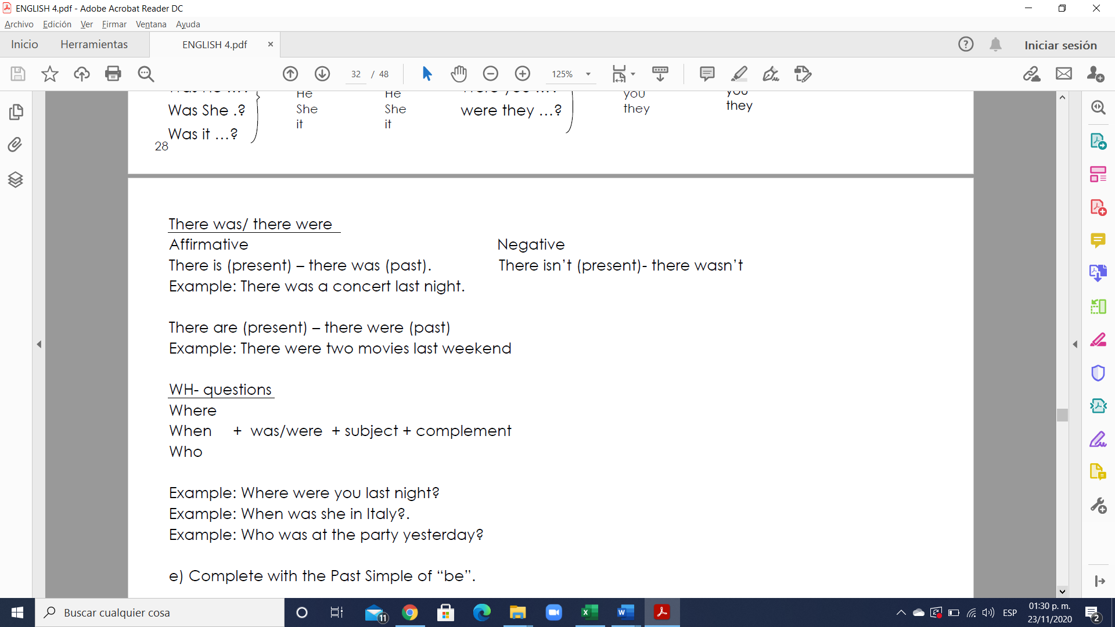

**Exercise 3.** Complete with the Past Simple of “be”.

1. A: Where were Paul and Jackie last night?

B: I don’t know, but they __were____ here.

2. A: __________ she at school yesterday?

B: No. She _________ at home.

3. A: When __________ you in Italy? Last year?

B: Last year? No, we _________ in Italy last year.

4. A: What time _________ the movie?

B: It _________ at 7:00.

5. A: _______ your parents at home at 10:00 last night?

B: No. They _________ at a play.

6. A: Who __________ at work on Monday’

B: Barry and Anne _________ . But I __________.

**Exercise 4.** Fill in the blanks with “was” or “were”.

1. We ________ the champions last year.

2. Where is James? He ________ here just now.

3. Mom and Dad ________ on vacation last week.

4. The weather ________ fine this morning.

5. There ________ a lot of people at our party yesterday.

6. There ________ a small lake here many years ago.

7. He ________ sick yesterday.

**GRAMMAR - The Past Simple tense**

- We use the Past Simple to talk about completed actions or situations that took place at a specific time in the past.

Example: I visited Berlin last week.

Example: Andrew watched TV yesterday.

- Sometimes the speaker may not mention the specific time, but they do have a specific time in mind.

Example: When I went to Japan I enjoyed it a lot.

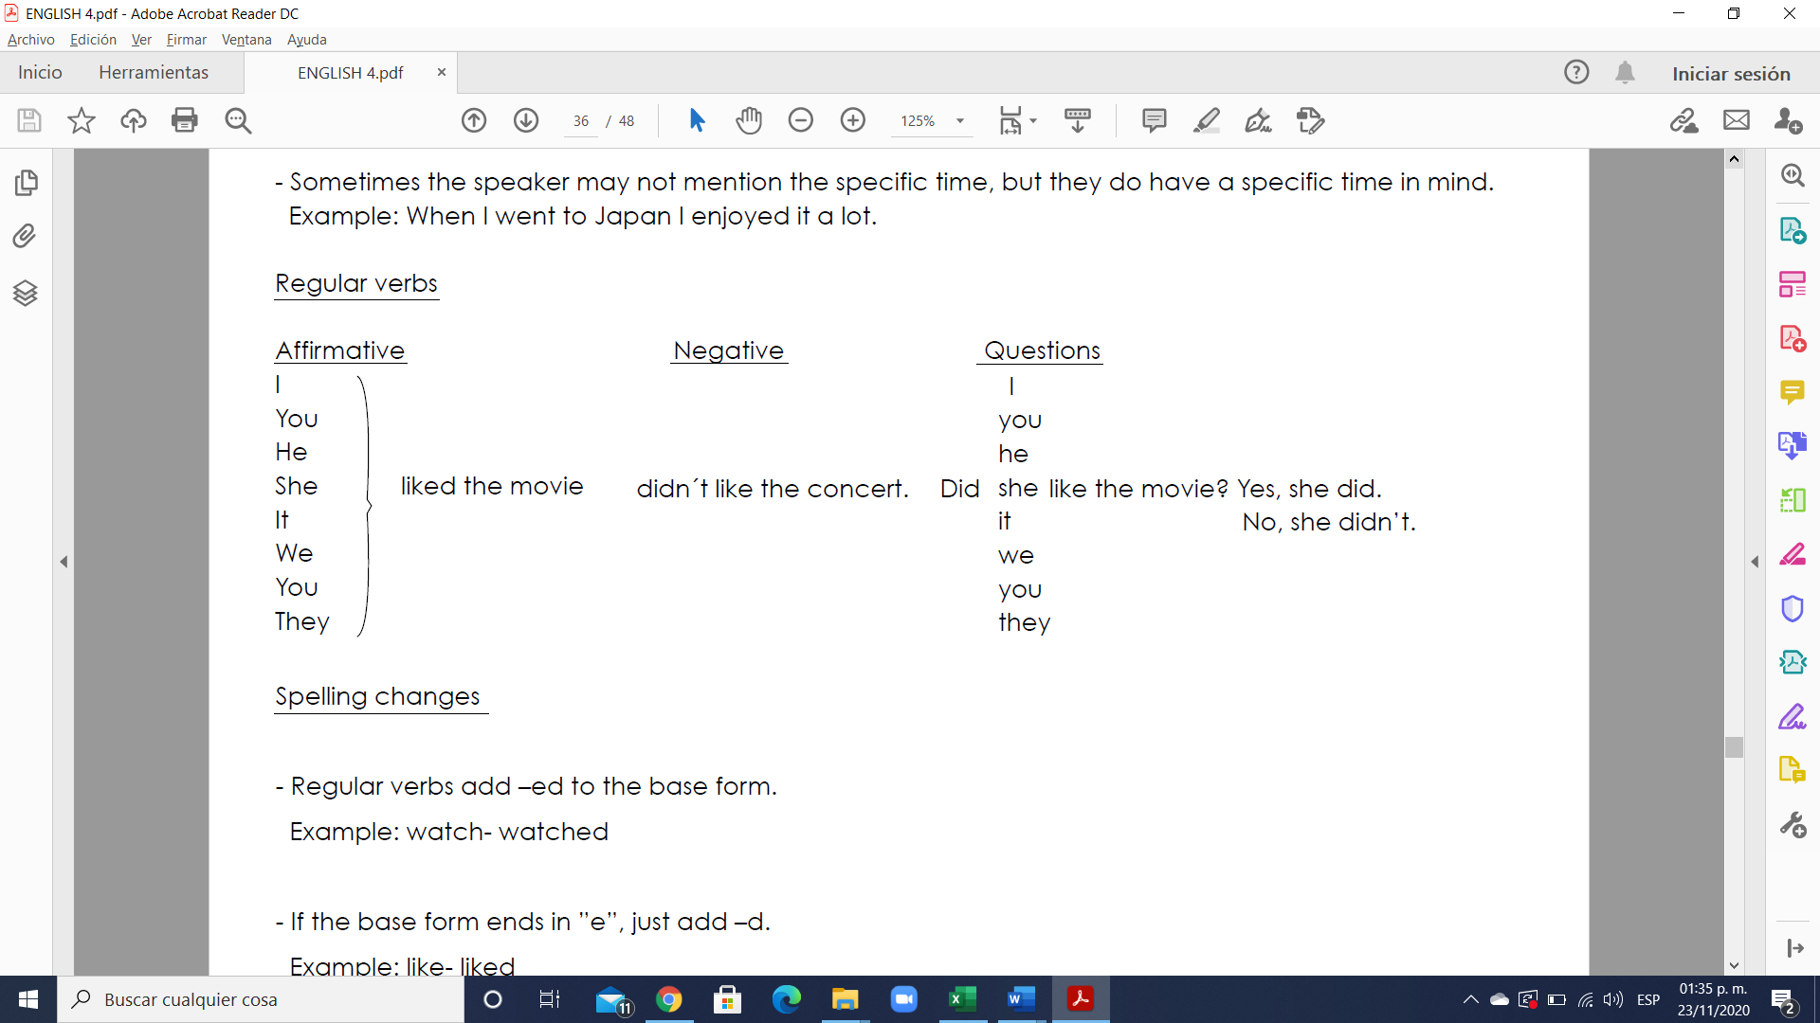

Spelling changes

- Regular verbs add –ed to the base form.

Example: watch- watched

- If the base form ends in ”e”, just add –d.

Example: like- liked

- If the base form ends in a consonant + “y”, add –ied.

Example: study- studied

- If the base form ends in a vowel + “y”, add –ed.

Example: play- palyed

- If the base form ends in a consonant after a stressed vowel at the end of the word, double the consonant and add –ed.

Example: stop- stopped

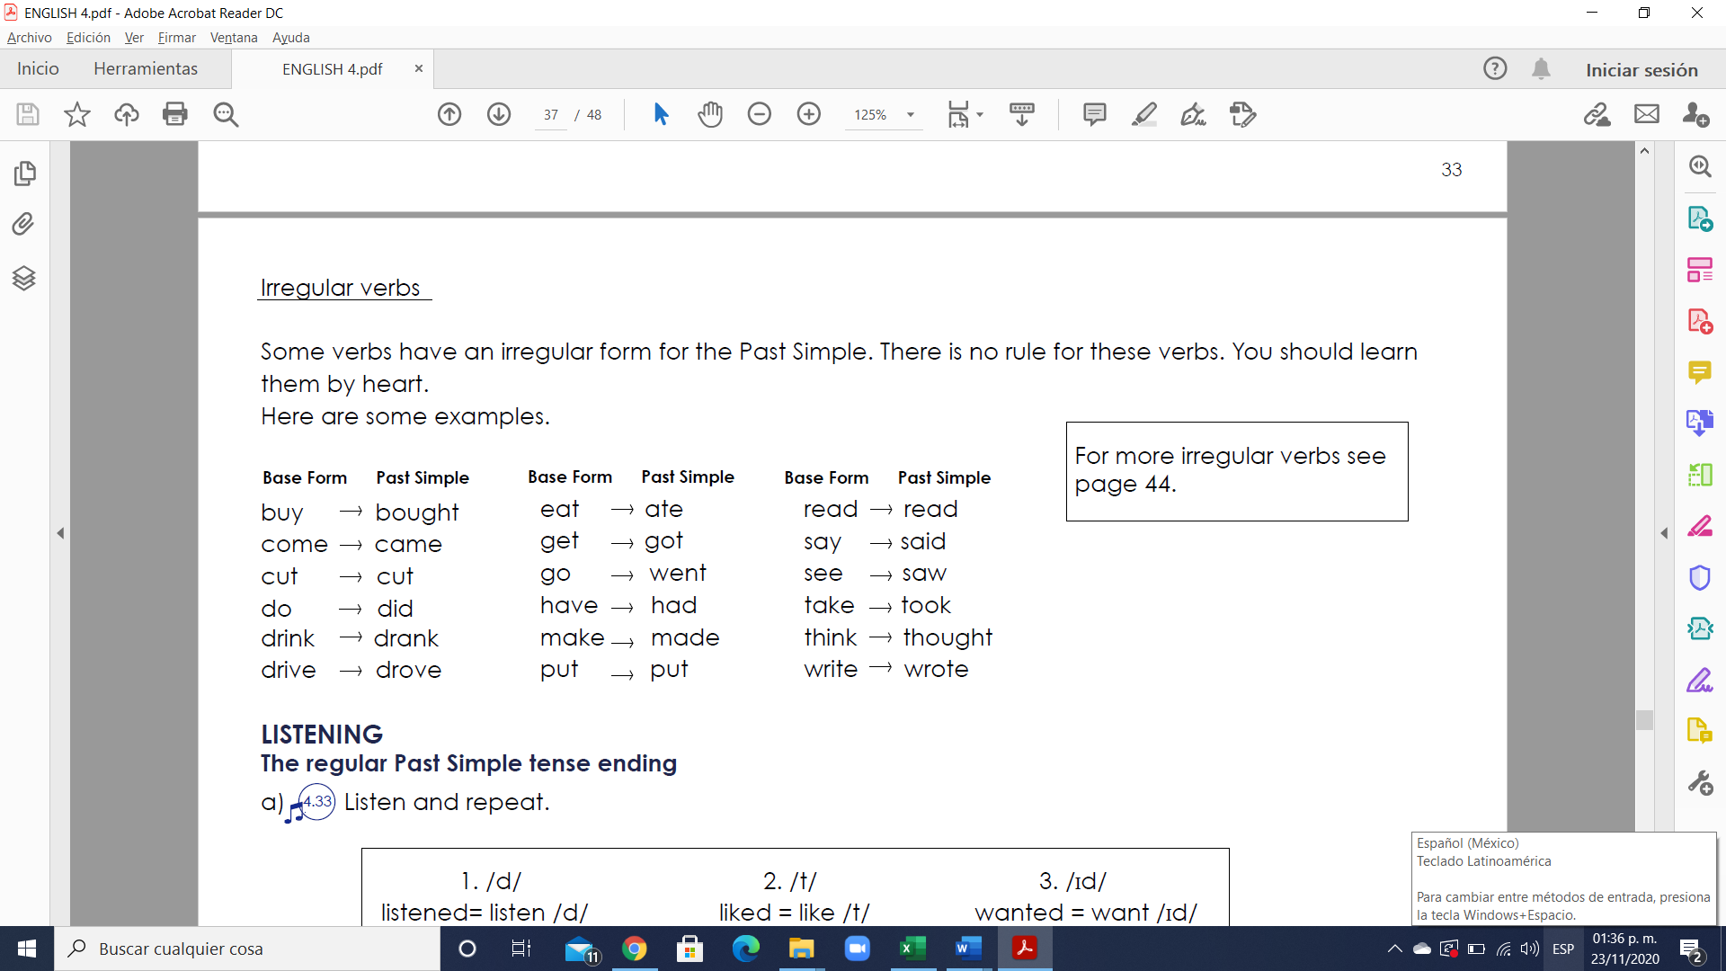

**Exercise 5.** Complete the conversations with the Simple Past tense.

1. A: Where ___did your family go________ (your family / go) on Saturday?

B: _________________________ (we / go) to the movies _________________________ (we / see) a good family movie.

A: _________________________ (you / go) out to eat afterwards?

B: Yes, we _________________________ (we / eat) Indonesian food. _________________________ ( it / have) a lot of pepper.

A: But ___I thought your husband didn´t like____________ (I/ think) (your husband / not like) peppery food.

B: Actually, _________________________(he / eat) a little and _______________________ (he / say) it was good.

2. A: _________________________ (who / take) out he garbage this morning?

B: Actually, _________________________ (Laura / do).

A: And _________________________ (who / do) the laundry?

B: I’m not sure. But I think _________________________ (Laura / do) the laundry this morning, too.

A: That’s great, but _________________________ (you / do) any household chores?

B: Me? Last week _________________________ (I / do) all the chores:

_________________________ (I / go) shopping, and _________________________ (I / come) home

early, and _________________________ (I / make) dinner every night.

**Exercise 6.** Fill in the blanks with the correct Past Simple tense of the verbs in brackets.

1. She ___________ home alone. (go)

2. The wind ___________ throughout the night. (blow)

3. An apple ___________ o his head. (drop).

4. The princess’ ball ___________ into the well. (roll)

5. A frog ___________ into the well and ___________ it back to her. (jump / bring).

6. Jack ___________ the highest grade in his English class. (get)

7. The party ___________ at 8:00 P.M. (begin)

8. He ___________ his old car and ___________ a new one. (sell/ buy)

9. Jackie ___________ up the ladder carefully. (climb)

10. Who ___________ all the windows? (close)