

**Nombre de alumno:**

**Nombre del profesor:**



**Nombre del trabajo: Unit Activity #1 - Unit 2**

**Materia:**

**Grado:**

**Grupo:**

Comitán de Domínguez Chiapas a 10 de Octubre de 2022.

**VOCABULARY**

**Abilities**

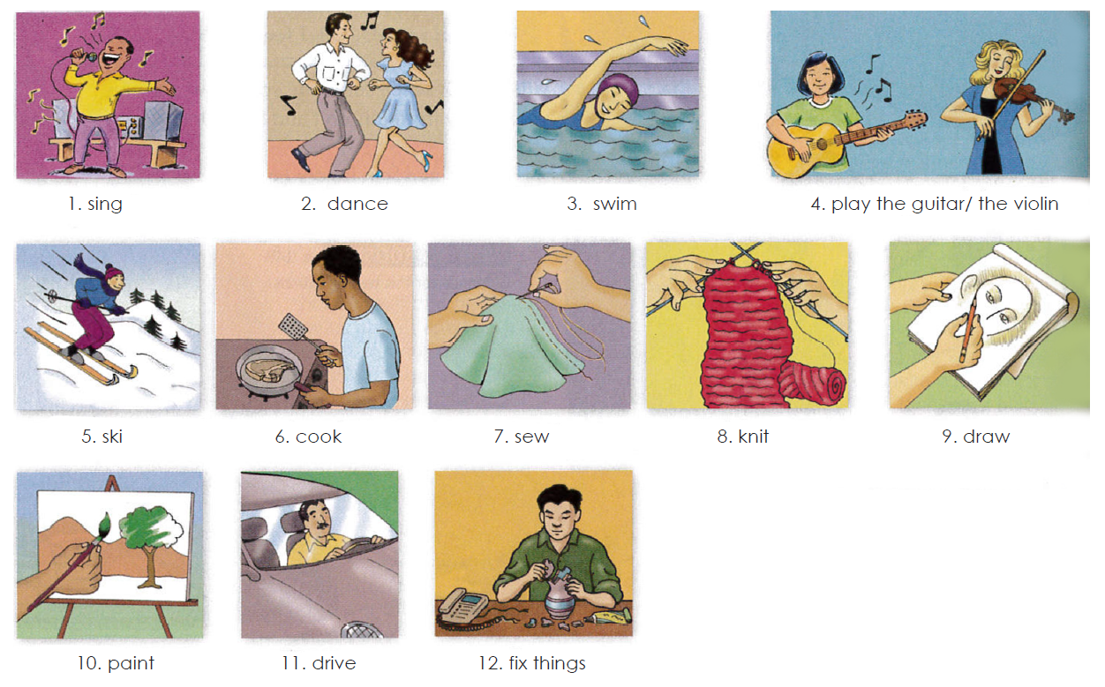

**Exercise 1.** Translate to Spanish the vocabulary above. Traduce al español el vocabulario de arriba.

1. 7.

2. 8.

3. 9.

4. 10.

5. 11.

6. 12.

**Grammar - Adverbs “well” and “badly”**

Use **“badly”** if your sentence is active. You should determine if your sentence involves how an action is/was performed. This means it is active and requires an adverb, such as "badly."

For instance, in the sentence “I feel badly since my fingers were burned,” the word “feel” is used actively as an action. Instead of describing an emotional state, the sentence now describes a person’s ability to touch. Therefore, the adverb “badly” is used.

**Badly** es un adverbio, lo que significa que describe los verbos o las acciones además de otros adjetivos y adverbios. Por ejemplo, cuando alguien “habla mal”, cuando alguien “cocina mal”, cuando alguien “conduce mal” etc, usamos badly. Es decir, Badly cataloga lo mal que se realiza algo.

Ejs: Su novia canta bastante mal. His girlfriend sings pretty badly.

Él juega muy mal al fútbol. He plays football very badly*.

Él está mal vestido He’s badly dressed.

Use **“well”** if your sentence is active. Once you understand that the meaning of your sentence is active in nature, use the adverb “well” to further your explanation of how an action is/was performed.

For instance, in the sentence “I feel well now that my fingers have healed,” the word “feel” is used actively as an action. Instead of describing an emotional state, the sentence now describes a person’s ability to touch (or to “do” something well—which is an action). Therefore, the adverb “well” is used.

Un adverbio nos dice de que manera se hace la acción. Cuando **WELL** se usa como adverbio significa que la acción se hace bien, de manera adecuada, con claridad, etc.

I could not hear the teacher well. - No pude escuchar el profesor con claridad.

Things are going well. - Las cosas van bien.

He did his job well. - El hizo su trabajo bien/adecuadamente.

**Exercise 2.** Escribe 3 oraciones usando well y 3 oraciones usando badly usa el vocabulario de arriba

**Well**

1.

2.

3.

**Badly**

1.

2.

3.

**Grammar - “Can” and “can´t” for ability**

We use “can” or “can’t” + the base form of a verb to talk about ability.

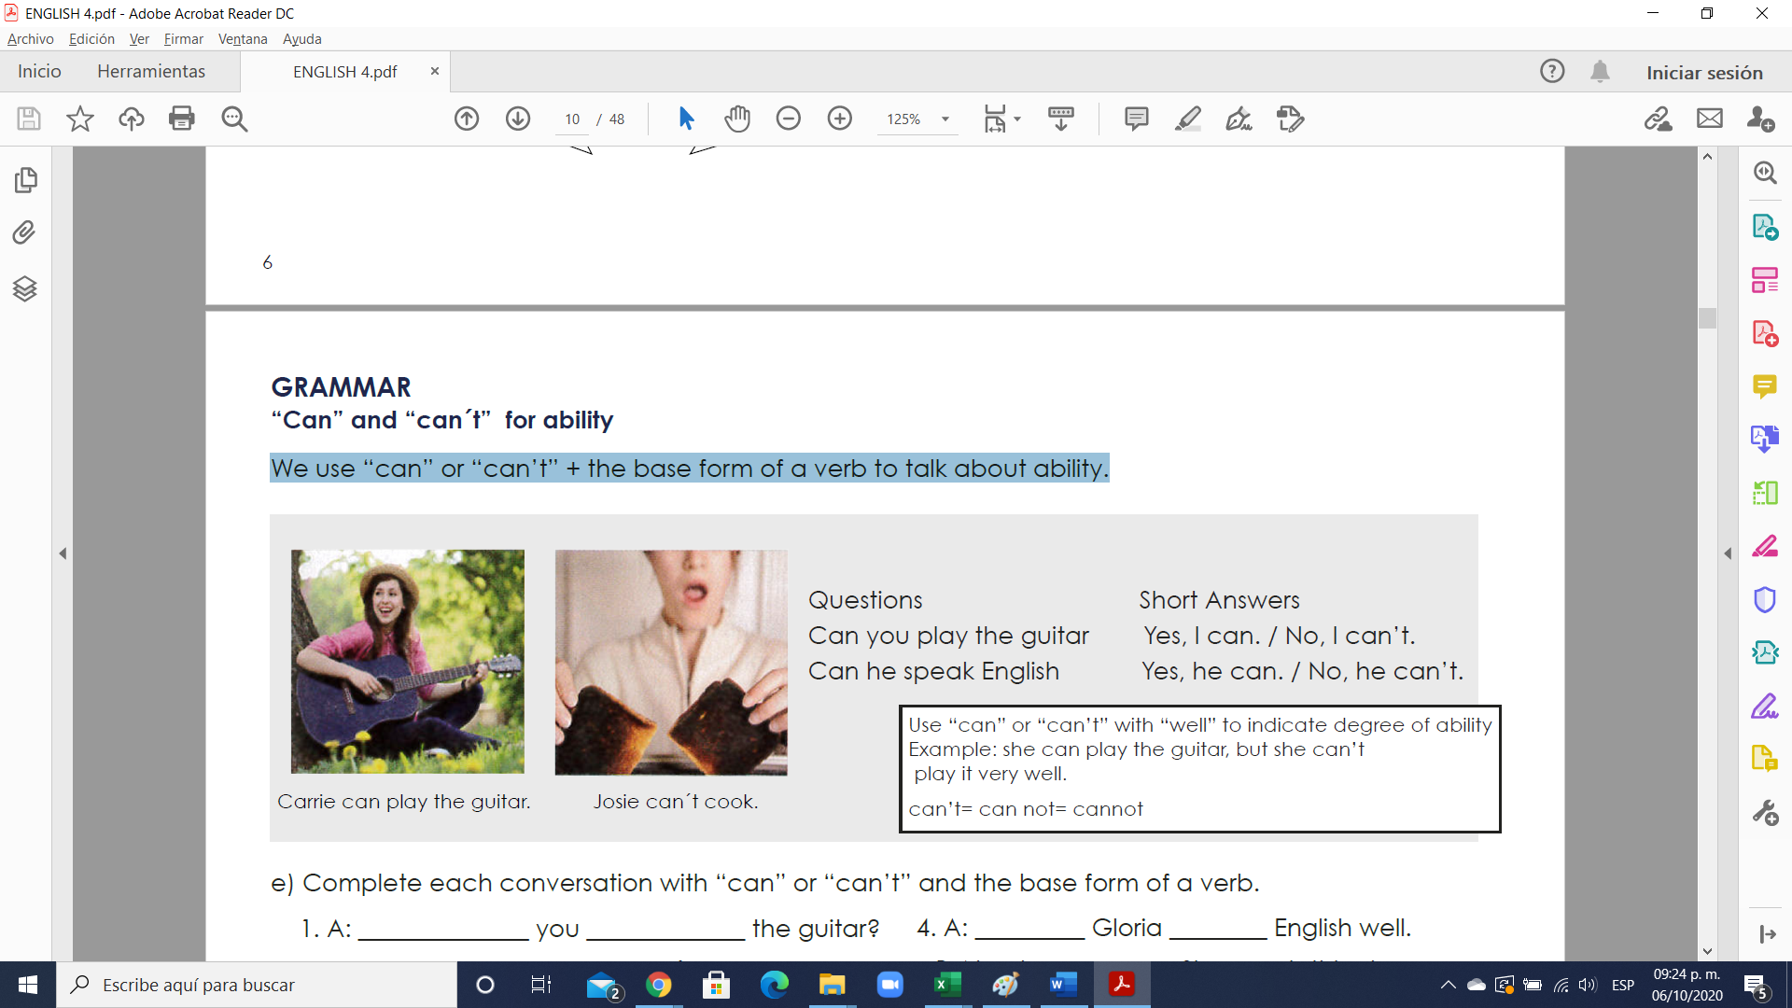

**Exercise 3.** Complete each conversation with “can” or “can’t” and the base form of a verb.

1. A: ______________ you _____________ the guitar?

B: Yes, I ___________. But I don´t play well.

2. A: ___________ Gwen ________ well?

B: Yes, she __________. She swims very well.

3. A: ______________ your brother __________?

B: My brother? No. He _______ cook at all.

4. A: _________ Gloria ________ English well.

B: No, she _________. She needs this class.

5. A: _________ your mother __________?

B: Yes. She knits very well.

6. A: _______________ your sisters ___________?

B: Yes. They go skiing every weekend.

**Exercise 4.** Answer the questions with true information. Use short answers with “can” or “can’t”.

1. Can you play the piano? ________________________________________________________________

2. Can you ski? ____________________________________________________________________________

3. Can your parents sing well? ______________________________________________________________

4. Can your friend speak English? ___________________________________________________________

5. Can you draw? _________________________________________________________________________

6. Can your father fix things? _______________________________________________________________

**Grammar - Too + adjective**

“Too” makes an adjective stronger. It usually gives it a negative meaning.

Example: I’m too busy. I can’t talk right now.

Example: I’m too tired. Let’s not go to the movies.

Example: It’s too late. I should go to bed.

**Exercise 5**.

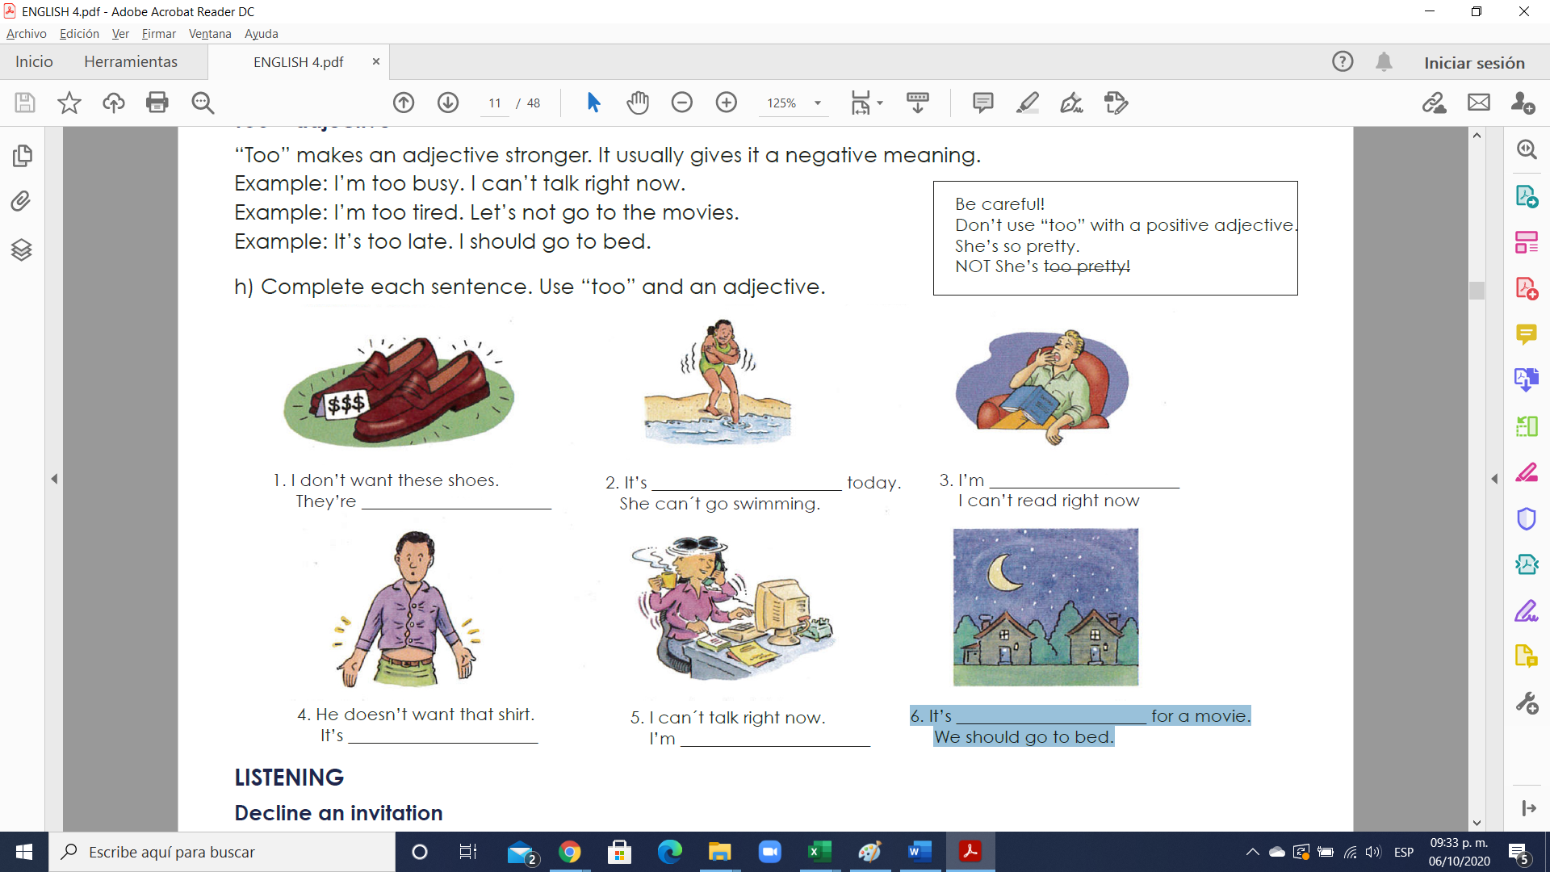1. I don’t want these shoes. They’re ______________________.

 2. It’s ______________________ today. She can´t go swimming.

 3. I’m ______________________ I can’t read right now.

 4. He doesn’t want that shirt. It’s ______________________.

 5. I can´t talk right now. I’m ______________________.

 6. It’s ______________________ for a movie. We should go to bed.

**Exercise 6.** Complete each sentence. Use “too” and an adjective.

1. I need a new dress. This dress is too old.

2.This skirt is ________________ I want a short skirt.

3. His shirt is ________________ . He needs size small.

4. I don’t want that suit. It’s ________________.

5. He needs size medium. This shirt is ________________.