**Unit Activity #1 – U3**

*Nombre del Alumno:*

*Nombre del tema: Unit I1I*

*Parcial: Third*

*Nombre de la Materia: English IV*

*Nombre del profesor: Juan Manuel Jaime Díaz*

*Nombre de la Licenciatura:*

*Cuatrimestre: Fourth*

*Lugar y Fecha de elaboración*

Comitán de Domínguez Chiapas a 13 de mayo de 2024.

**GRAMMAR - The comparatives**

Comparatives are used to compare two things and to highlight the superiority, inferiority or equality of one term to another.

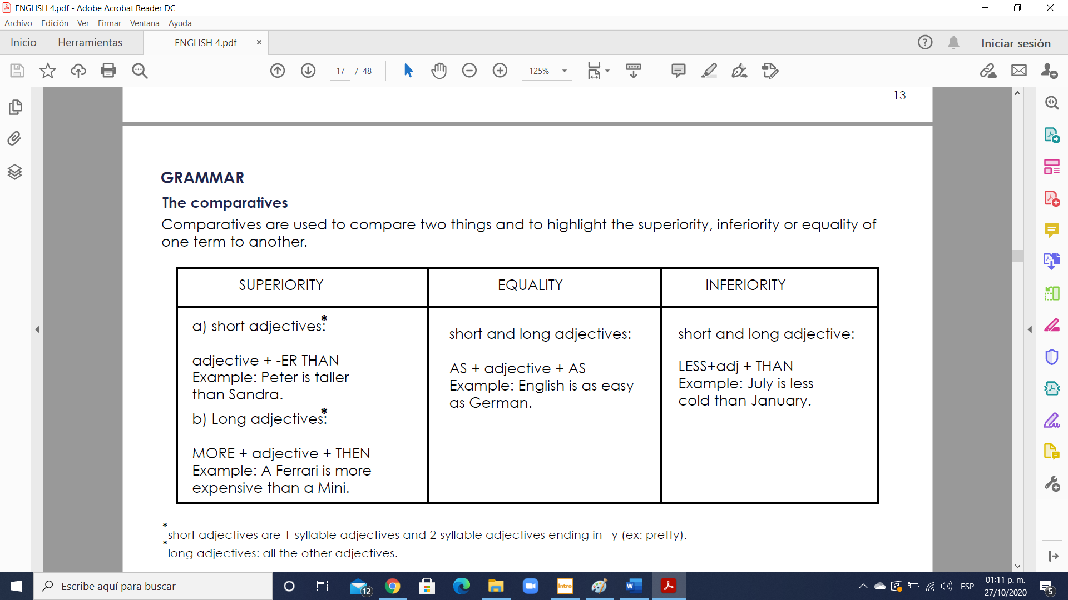

* **short adjectives**: are 1-syllable adjectives and 2-syllable adjectives ending in **–y (ex: pretty).**

* **long adjectives:** all the other adjectives.

**Orthographic changes:**

- If the adjective ends in **“y”** the **“y”** becomes **“i”**: **heavy- heavier.**

- If the adjective ends in **“e”** only an **“r”** is needed: **wise- wiser.**

- If the adjective ends with a **“single vowel + consonant”** the consonant is doubled and you add **“er”**: **big-bigger.**

**Irregular forms:**

These adjectives and adverbs have irregular comparative forms.

- **Good/ well- better**. Example: the garden looks better now.

- **Bad/ badly- worse**. Example: is your teacher better? No, she is worse.

- **Far/ further**. Example: It’s a long walk form here to the station. Further than I think.

* further= can also mean **“more”** or **“additional”**. Example: for further information check the website.

**Exercise 1.** Complete the sentences using a comparative form.

1. It’s too noisy here. Can we go somewhere (quiet) ___quieter___?

2. The coffee is very weak. I like it a bit (strong) ________________.

3. The hotel is surprisingly big. I expected it to be (small) ________________.

4. The hotel is surprisingly cheap. I expected it to be (expensive) ________________.

5. The weather is too cold in this country. I’d like to live somewhere (warm) ________________.

6. My job is a bit boring sometimes. I’d like to do something (exciting) ________________.

7. I’m surprised how easy it is to use the computer. I thought it would be (difficult) ________________.

8. Your work isn’t very good. I’m sure you can do (good) ________________.

9. Don’t worry. The situation isn’t so bad. It could be (bad) ________________.

10. I’m surprised we got here so quickly. I expected the journey to take (long) ________________.

11. You’re talking very loudly. Can you speak a bit (quietly) ________________?

12. You’re standing too near the camera. Can you move a bit (far) ________________ away?

13. You were a bit depressed but you look (happy) ________________ today.

**Exercise 2.** Complete the sentences using as…as.

1. I’m quite tall but you are taller. I’m not **___as tall as___** you.

2. My salary is high but yours is higher. My salary isn’t _______________________________.

3. You know a bit about cars but I know more. You don’t __________________________.

4. I’m very nervous but you are more. I’m not ______________________________________.

5. I feel tired and you too. I’m _____________________________________________________.

**Exercise 3.** Rewrite these sentences so that they have the same meaning.

1. Jack is younger than he looks. Jack isn’t ___**as old as___** he looks.

2. I don’t spend as much money as you. You _______________________________________.

3. The station is nearer than I thought. The station isn’t _______________________________.

4. The meal doesn’t cost as much as I expected. The meal __________________________.

5. I go out less than before. I don’t _________________________________________________.

6. Her hair isn’t as long as it was. She has __________________________________________.

**Exercise 4.** Write the adjectives in brackets in the comparative form.

1. John Lennon was (old) _____**as older as**_________ Paul McCartney.

2. Some people think the Met is (good) _______________ the Louvre.

3. Eric was (afraid) _______________ in Harlem _______________ in the Subway.

4. Cats are (nice) _______________ dogs.

5. Cartoons are (good) _______________ music programmes.

6. The Empire State is (big) _______________ the Chrysler Building.

7. Barcelona is (small) _______________ Madrid, but (big) _______________ Valencia.

8. Scotland is _______________ (cold) than the South of England.

9. I like cats - they're _______________ (interesting) than dogs.

10. Charity shops are _______________ (cheap) than other shops.

11. Buy that MP3 player. It's _______________ (good) than the other one.

12. I spend a lot of time with Petra - she's _______________ (friendly) than the other students.

13. In winter, Venice is _______________ (quiet) than in summer.

14. The maths exam was bad, but physics was even _______________ (bad)!

**GRAMMAR - The superlatives**

Superlatives are used to express the highest degree of quality. We use a superlative adjective to describe

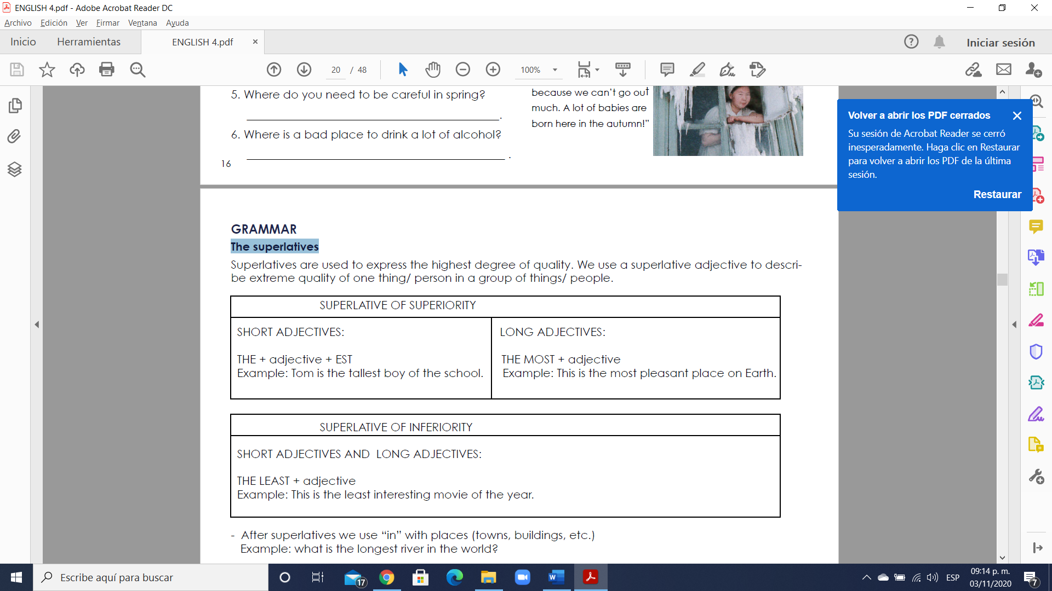

- After superlatives we use “in” with places (towns, buildings, etc.)

Example: what is the longest river in the world?

- We also use “in” for organizations and groups of people (a class/ team/ company)

Example: Who is the best student in the class?

- We use “of” for a period of time.

Example: What is the hottest month of the year?

Irregular forms

Good the best

Example: She’s the best singer in the world.

Bad the worst

Example: He’s the worst football player.

Far farthest

Example: Seattle is the farthest city form here.

**El grado superlativo**

El grado superlativo denota la calidad en el grado más alto y como en español, se usa “the” delante del adjetivo en la forma superlativa (véase más adelante).

Ejemplos:

Juan is the fastest .(Juan es el más rápido.)

Angela’s room is the cleanest.(La habitación de Angela es la más limpia.)

I am the tallest.(Soy el más alto.)

New York is the biggest city in the United States.(Nueva York es la ciudad más grande de los Estados Unidos.)

Nota: Si el adjetivo es posesivo, no se usa “the”. Además no se usa “the” si comparamos algo con si mismo.

Ejemplos:

His smartest student is Lisa.(Su estudiante más lista es Lisa.)

New York is coldest in January.(Nueva York es más frío en enero.)

**Form (Forma)**

Hay unas reglas para formar el comparativo y superlativo.

1. Para adjetivos de una sílaba:

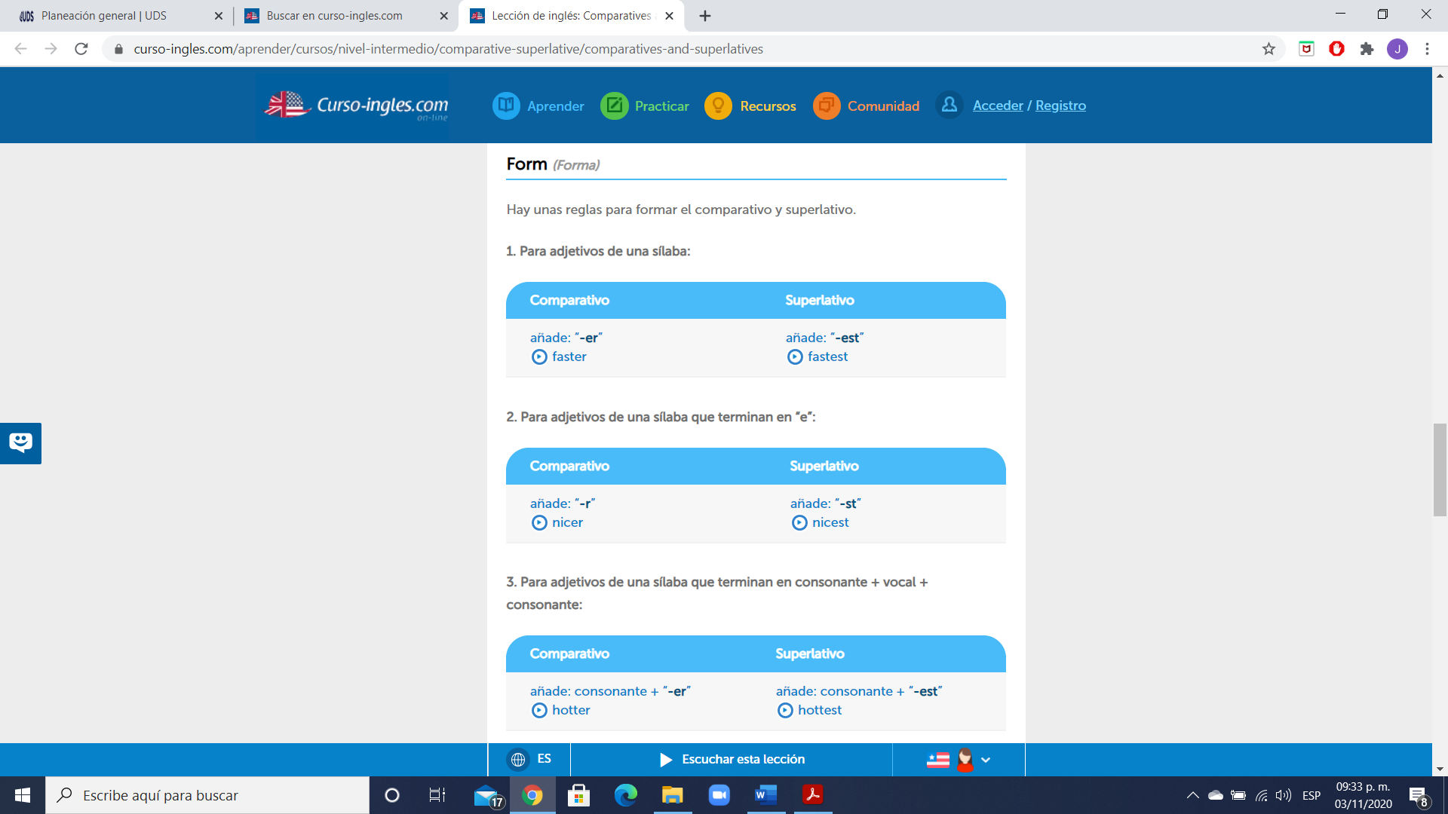

2. Para adjetivos de una sílaba que terminan en “e”:



3. Para adjetivos de una sílaba que terminan en consonante + vocal + consonante:

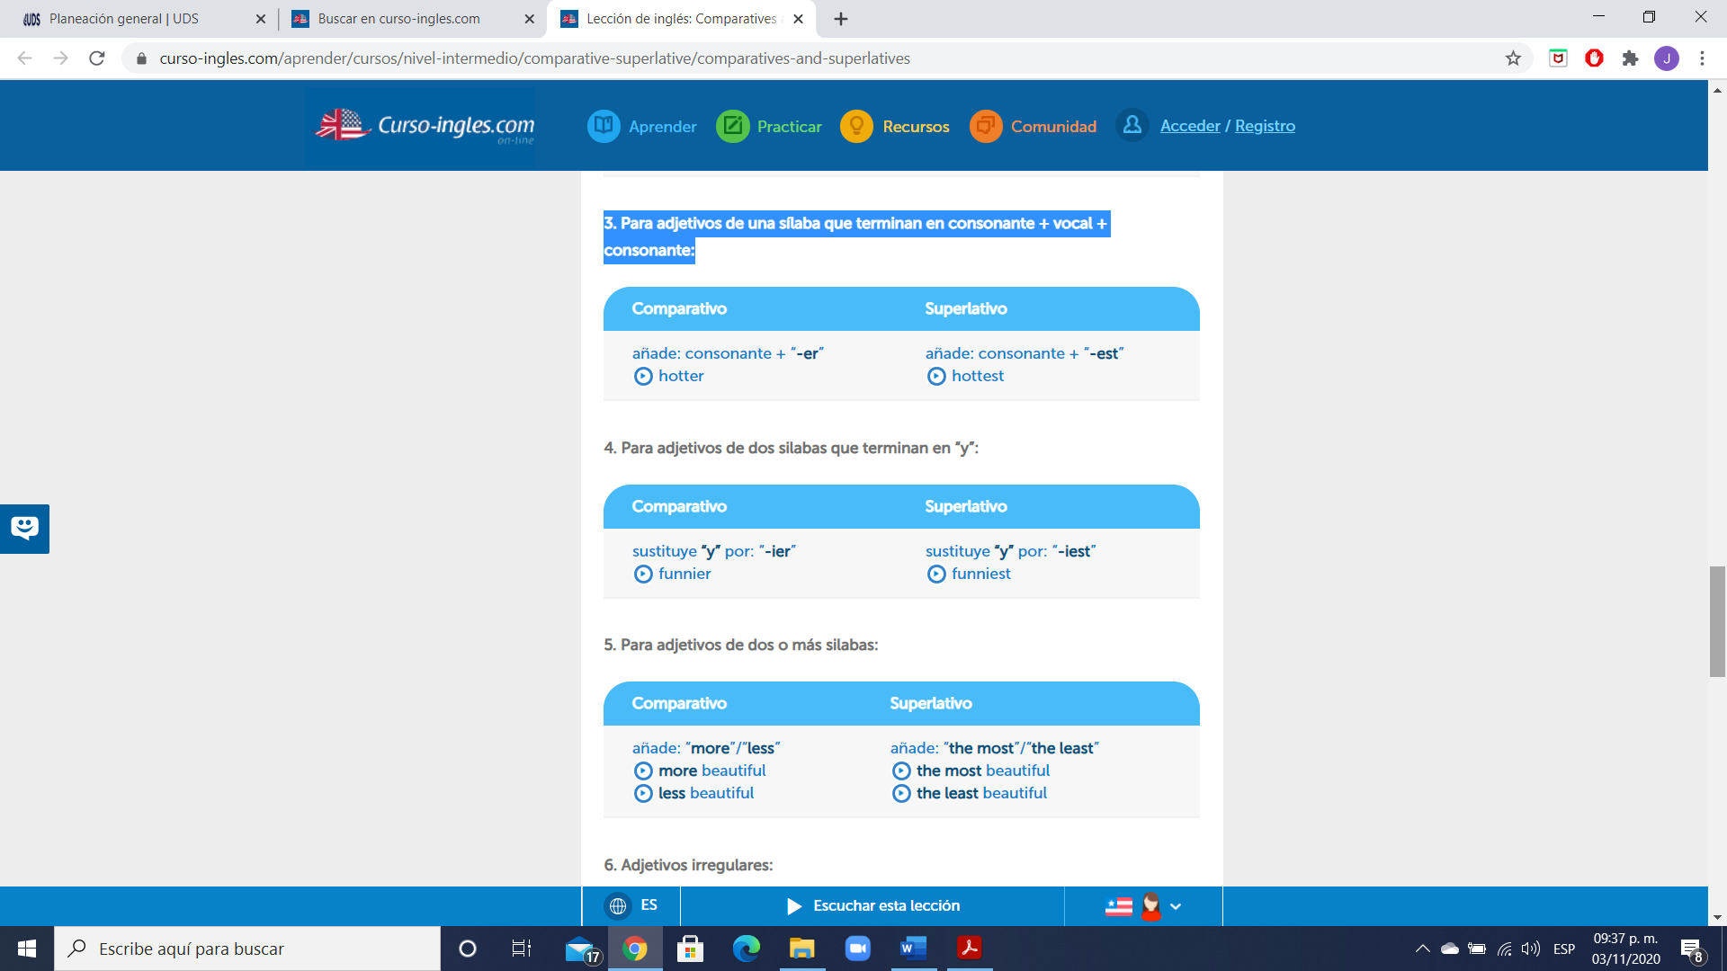

4. Para adjetivos de dos silabas que terminan en “y”:



5. Para adjetivos de dos o más silabas:



6. Adjetivos irregulares:

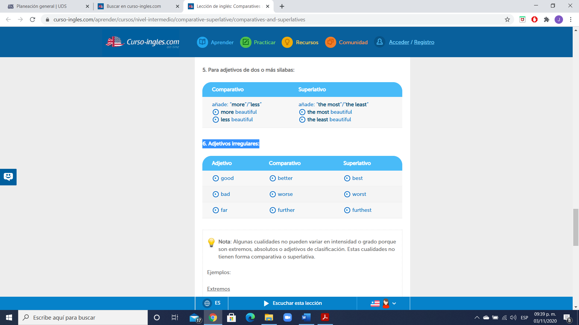

**Exercise 1.** Complete the sentences. Use a **superlative or comparative**. Completa las oraciones usando superlativos o comparativos.

1. We stayed at _____________________________________ hotel in the town (cheap).

2. Our hotel was _______________________________ than all the others in the town (cheap).

3. The United States is very large but Canada is _______________________________ (large).

4. What’s ________________________________________________ river in the world? (long).

5. He was a bit depressed yesterday but he looks _________________________ today (happy).

6. Today it’s an awful day. It is __________________________________ day of my life (bad).

7. What is ________________________________________ sport in your country? (popular).

8. Everest is _________________________________________ mountain in the world (high).

9. This is ___________________________________ holidays we have ever had (enjoyable).

10. I prefer this chair to the other one. It’s _____________________________ (comfortable).

**Exercise 2.** Complete the chart. Completa la table con el **comparativo o superlativo** faltante.

|  |  |  |
| --- | --- | --- |
| **Adjective** | **Comparative** | **Superlative** |
| cold |  | the coldest |
| high | higher |  |
| hot |  | the hottest |
| dangerous | the most dangerous |  |
| good |  | The best |
| bad | worse |  |

**Exercise 3.** Write the adjectives in brackets in the **superlative form**.

1. Samantha is the (pretty) _______________ girl that Paul has ever met.

2. I think that King Kong was the (bad) _______________ film ever!

3. Mounth Everest is the (high) _______________ mountain in the world.

4. Our English teacher is the (good) _______________ teacher ever!

5. My room is the (clean) _______________ room in my house.

6. Ron is the (clever) _______________ person I’ve ever met.

7. The Millenium Star is one of the (expensive) _______________ diamonds in the world.

8. David is _______________ (nice) of the three brothers.

9. Why do you always buy _______________ (expensive) dress in the shop?

10. What's _______________ (quick) way to get to the town centre?

11. I think Venice is _______________ (beautiful) city in the world.

12. Sarah is _______________ (friendly) girl in my office.

13. Chemistry is my _______________ (bad) subject.

14. I think Imagine is _______________ (good) song John Lennon wrote.

**GRAMMAR - Too and enough**

- “Too” and “enough” modify adjectives, adverbs and nouns.

“Too” means more than what is needed. “Enough” means sufficient.

Examples (adjectives): He is too old to play football with the kids.

Dave is intelligent enough to do the right thing.

Examples (adverbs): You’re not working fast enough.

I don’t have enough time.

Examples (nouns): He has too many friends.

He has too much patience.

- “Enough” comes after adjectives and adverbs:

Example (adjective): He isn’t old enough to watch this program.

Example (adverb): We’re not walking quickly enough.

- “Enough” may also precede nouns:

Example: We have enough money.

- “Too” comes before adjectives and adverbs:

Example (adjective): It’s too hot to wear that coat.

Example (adverb): I was driving too fast.

- “Too” may also come before nouns when it is used with the expressions “too much” and “too many”.

“Too much” is used before uncountable nouns.

Example: There is too much salt in this food.

- “Too many” is used before countable nouns.

Example: There are too many students in this classroom.

**Exercise 4.** Complete the sentences with “too” or “enough”.

1. I’m leaving the coffee to cool for a minute because it is ________ hot to drink.

2. He isn’t strong ________ to lift that heavy box.

3. There aren't ________ policemen in our town.

4. Do you have ________ information to help me with this problem?

5. It is ________ difficult to do for a little child.

6. I do not have ________ time to prepare dinner.

7. I ‘m not buying the car because it is ________ expensive.

8. He isn’t working hard ________ to pass the exam.

9. My mum can't sleep because she drinks ________ much coffee.

10. She isn't old ________ to start driving.

**GRAMMAR - Adverbs**

- An adverb is a word used to modify a verb, an adjective, or another adverb.

For example:

She swims quickly.

(Here, the adverb “quickly” modifies the verb swims.)

She swims extremely quickly.

(Here, the adverb “extremely” modifies the adverb quickly.)

She is an extremely quick swimmer.

(Here, the adverb “extremely” modifies the adjective “quick”.)

- Many adverbs are formed from adjectives. The basic rule is that -ly is added to the end of the adjecttive:

For example: slow- slowly.

- If the adjective already ends in –y. the –y usually changes to –i.

Example: unnecessary- unnecessarily.

- If the adjective ends with a consonant followed by -le, replace the final -e with -y on its own:

Example: terrible- terribly

**Exercise 5.** Complete the sentences with and adverb or an adjective. Use the words in the box.

quickly safe brilliant loudly late careless hard happy easy slowly

1. The bus drove _____________ over the bridge.

2. You mustn't talk _____________ in a theatre.

3. A _____________ person drove into that tree yesterday.

4. Many people think Pierce Brosnan is a _____________ actor.

5. If you're _____________, I'm happy.

6. Gretchen works ____________ on her homework every night.

7. The train leaves at 6.00. Don't be__________!

8. I can smell gas. Is it ____________ in here?

9. I couldn't do the first question, but the second question was ___________.

10. The girl walked __________through the park.

**Exercise 6.** Write a sentence with each one of the adverbs given.

1. loudly _____________

2. politely ______________

3. early ________________

4. well _________________