

**Nombre de alumno:**

**Nombre del profesor:**



**Nombre del trabajo: Weekly Activity #2 Unit 3**

**Materia:**

**Grado:**

**Grupo:**

Comitán de Domínguez Chiapas a 06 de julio de 2020.

**GRAMMAR**

**The Present Continuous with present and future time expression.**

The Present Continuous can refer to the future. It shows that we have already decided something and that we have already made arrangements.

**Actions in the present**

Are you watching TV right now?

I`m not studying English this year.

Shes`s working at home this week.

**Future plans**

Are you watching TV right now?

I`m not studying English this year.

Shes`s working at home this week.

**SUBJET + AUXILIARY VERB + PRINCIPAL VERB "ING" + COMPLEMET.**

**Exercise #1. Complete the sentences using the Present Continuous. (no olvides colocar el verbo “to be” antes del verbo, exemple: is playing, are singing)**

Today is Monday, and right now it’s raining.

It’s windy and cold, so Marissa ____is staying____(stay) home. But later she has plans. She _______________(meet) her mom at the mall, and in the afternoon, she______________ (do) the laundry- a good plan for a rainy day! What about the rest of the week? Tomorrow, she ______________(work), and at 5:30, she _______________(meet) Sandy at the city Bookstore. The day after tomorrow, she _______________ (work) and she ____________ (call) her dad at 1:00. Then, at 3:30 on Thursday afternoon, she ___________ (do) to Chinese class.

Later she _____________ (meet) her brother James at Rossini’s Restaurantt. On Friday, Marissa ______________ (work) from 9:00 to 12:00. After work, she and Colin _______________ (make)dinner together at his house. On Saturday, Marissa_____________ (exercise) in the park with Sarah. That evening, she and Scott _____________ (go) to a concert. On Sunday, she _______________ (study) for her driving test and _______________ (clean) the kitchen.

**GRAMMAR**

**the Present Continuous: information questions.**

What is he watching? (A TV program.)

Where is he driving? (To work.)

What are you doing? (We`re checking e-mail.)

Where are they going? (They´re going to the movies.)

BUT: Note the different word order when “who” is the subject.

Example: Who is working? (Ben.)

**Exercise # 2.** Write 6 sentences in Present continuous using **information questions (what, where, who)**.

1.

2.

3.

4.

5.

6.

**Exercise # 3.** Select the correct answer, according to the correct sentence.

1. I ____________ football.

a) am playing

b) is playing

c) are playing

2. You _______ tennis.

a) am playing

b) is playing

c) are playing

3. He ___________ video games.

a) am playing

b) is playing

c) are playing

4. It _____ golf.

a) am playing

b) is playing

c) are playing

5. We ________ the guitar.

a) am playing

b) is playing

c) are playing

**VOCABULARY - Love, like, don’t like, hate**

After love, like, don’t like and hate we can use a noun or verb + ing.

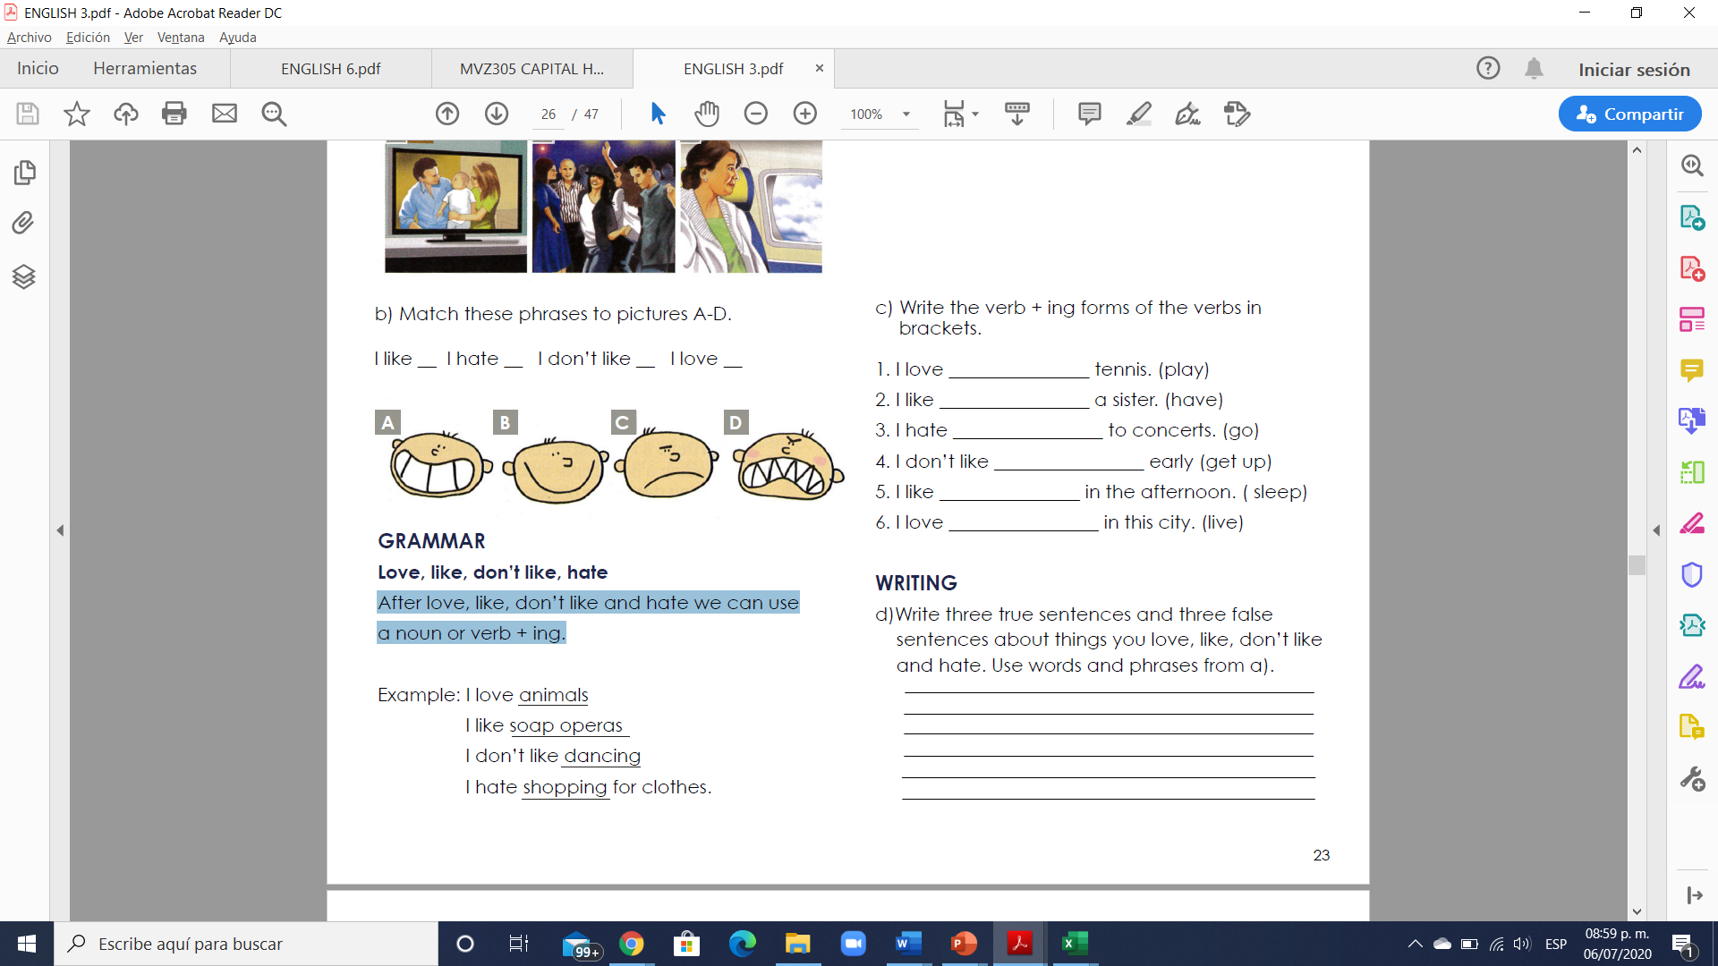

**Exercise #4.** Escribe el significado en español de:

1. Love -

2. Like -

3. Don’t like -

4. Hate

**Exercise #5.** Write the verb + ing forms of the verbs in:

1. I love _______________ tennis. (play)

2. I like ________________ a sister. (have)

3. I hate ________________ to concerts. (go)

4. I don’t like ________________ early (get up)

5. I like _______________ in the afternoon. (sleep)

6. I love ________________ in this city. (live)

**Exercise #6.** Translate the next text to Spanish:

Family Celebration in Ecuador

Hello this is Jack reporting from the Annual Family Celebration in Quito, Ecuador. People are having a wonderful time. Most men are cooking a traditional dish called Fanesca. Some women are playing hide-and-seek with their children. The elderly are listening to old music and telling stories from the past.

**Translation:**