

**Nombre de alumno:**

**Nombre del profesor:**



**Nombre del trabajo: Unit Activity #2 – U3 2BRH**

**Materia:**

**Grado:**

**Grupo:**

Comitán de Domínguez Chiapas a 07 de marzo de 2022.

**GRAMMAR - The Present Simple tense: affirmative statements with “like”, “want”, “need” and “have”.**

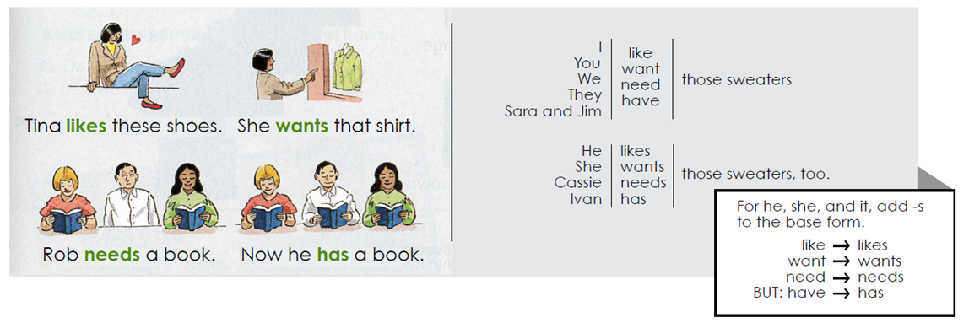

**Exercise 3.** Complete each statement with the correct form of the verb.

1. I ________________ (like/likes) your tie.

2. My friends ________________ (want/ wants) this suit.

3. Janet ________________ (need / needs) this skirt.

4. Peter _________________ (have / has) that jacket.

5. We ________________ (like / likes) our dresses.

6. Sue and Tara ________________ (want/ wants) those suits.

**VOCABULARY – Colors and Sizes**

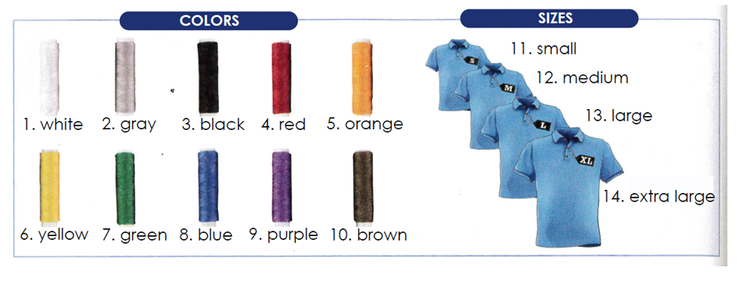

**Exercise 4.** Complete the sentences with the correct form of the verb. Use contractions.

1. A: _____________ (Do/Does) your children _____________ (have) sweaters for school?

B: My daughter _____________ (do/does), but my son _____________(don´t/doesn´t).

2. A: _____________ (Do/Does) your husband _____________ (need) a black tie?

B: No, he _____________ (don´t/doesn´t). He ____________ (have) two black ties.

3: A: I _____________ (need) a blue suit for work. _____________ (Do/Does) you _____________ (need) one too?

B: Yes, I _____________(do/does).

4. A: _____________ (Do/Does) you _____________ (like) that green shirt?

B: Actually, no, I_____________(don´t/doesn´t).

5. A: We _____________ (not like) the clothes in this store.

B: Really? that`s too bad. We _____________(do/does).

6. A: _____________ (Do/Does) you _____________ (have)this black jacket in size 34?

B: No, I’m sorry. We _____________(don´t/doesn´t).

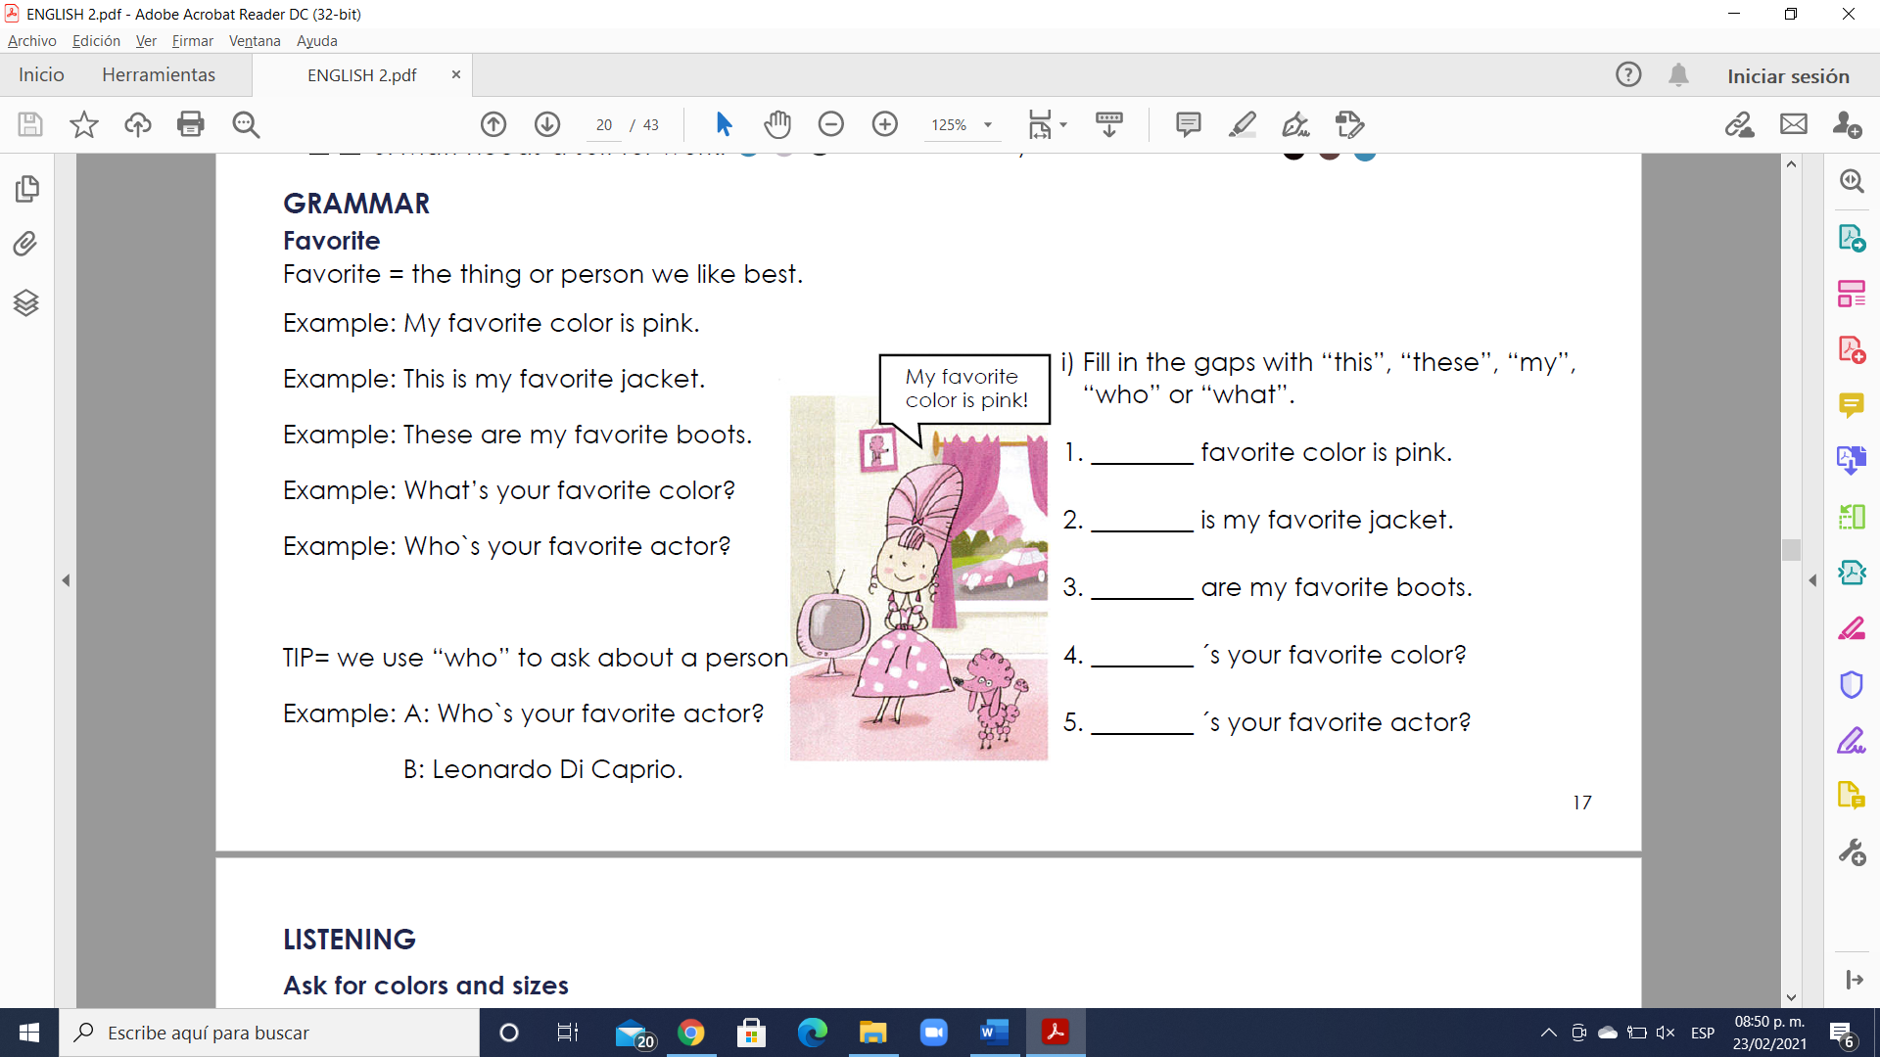

answer

answer

answer

answer

answer

**VOCABULARY- Opposite adjectives to describe clothes**

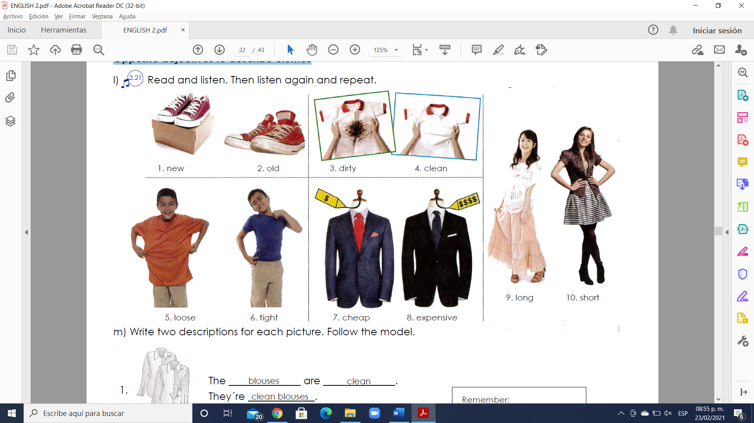

**GRAMMAR - The Present Simple tense: questions with “what”, “what color”, “what size”, “why”, “which one” and “which ones”.**

- Use a question word and “do” or “does” to ask information questions in the Present Simple tense.

Example: What do you need? (A blue and white tie).

Example: What does she want? (New shoes).

- Use “because” to answer questions with “why”.

Example: Why do they want that suit? (Because it’s nice).

- Use “what color” or “what size” to ask about color and size.

Example: What color do you want? (Black).

Example: What size does he need? (Extra large).

- Use “which” to ask about choice. Answer with “one” or “ones”.

Example: Which sweater do you want? (The blue one).

Example: Which shoes does he like? (The black ones).

**Exercise 5.** Complete the conversations in your own words.

1. A: Which skirt _______________________ (she / want)?

B: The __________________________one.

2. A: What ______________________ (your friend / need)?

B: _____________________________.

3. A: What color shoes _______________________ (you / like)?

B: ________________________________________.

4. A: Why _______________________ (you / want) new shoes?

B: ______________________________________.

5. A: Which shirts ______________________ (you / like)?

B: The __________________________.

6. A: What size shoes _______________________(you / need)?

B: ______________________________________